|  |
| --- |
| http://montanaioe.org/sites/default/files/msuhorizreverse200.png The Universityi of Montana Montana University System  .   IOE, CAIHRE, MT HealthCare Foundation, MT Health Professionals for a Healthy Climate |

Climate Change and Human Health in Montana

**A Special Report of the Montana Climate Assessment**

Alexandra Adams, Rob Byron, Bruce Maxwell, Lori Byron, Mari Eggers, Sue Higgins, Cathy Whitlock

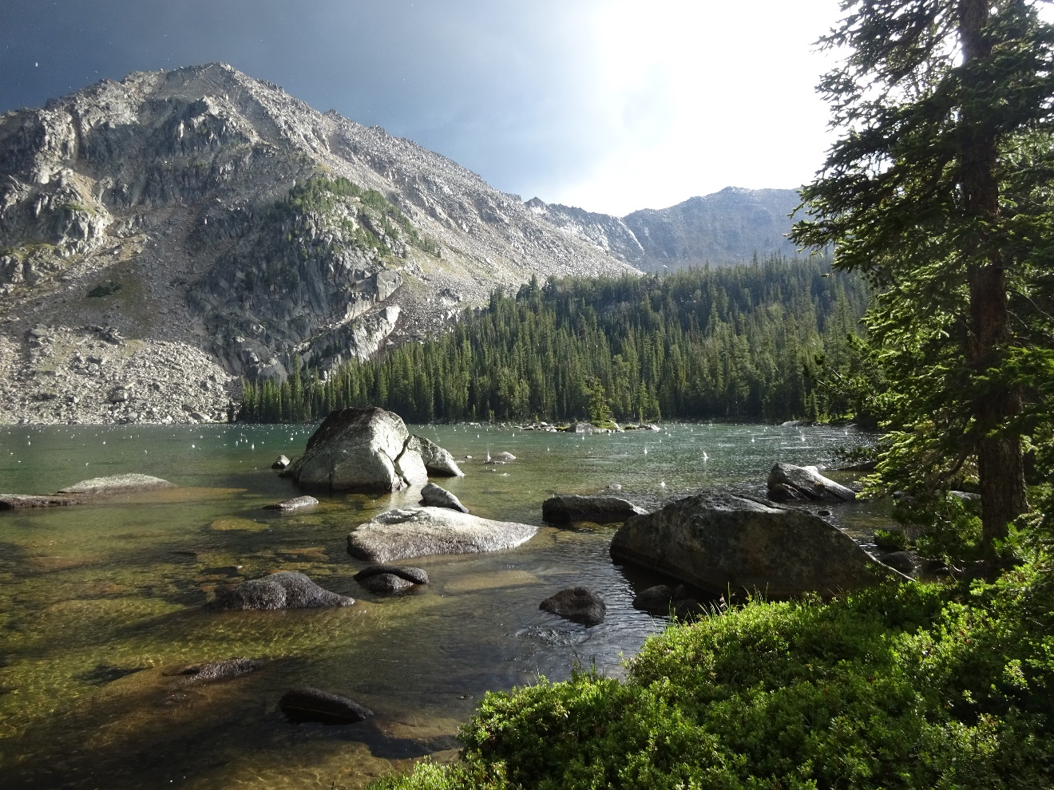

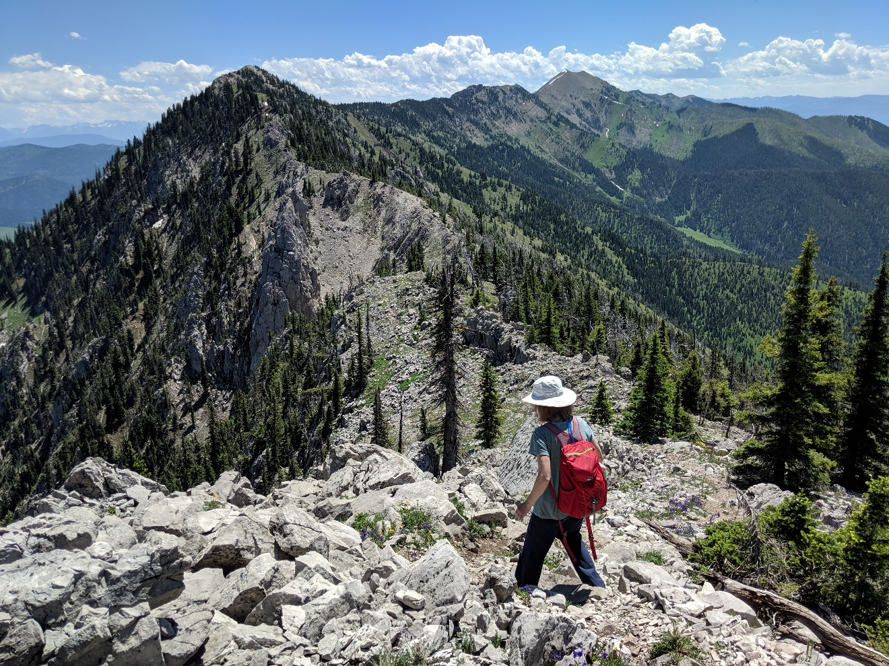

**ON THIS PAGE**

Bridger Mountains near Bozeman.

Photograph courtesy of Scott Bischke.

**ON THE COVER**

Hailstorm, Pioneer Mountains in southwest Montana.

Photograph courtesy of Scott Bischke.

Assessing Climate Change & Human Health in Montana

**A Special Report of the Montana Climate Assessment**

Alexandra Adams1, Rob Byron2, Bruce Maxwell3, Lori Byron4, Mari Eggers5, Sue Higgins6, Cathy Whitlock7

1 Professional title or position

Affiliation

City, State

2 Professor of Agroecology and Applied Plant Ecology, Department of Land Resources and  
 Environmental Science, and co-Director of the Montana Institute on Ecosystems

Montana State University

Bozeman, MT

3 Professional title or position

Affiliation

City, State

4 Professional title or position

Affiliation

City, State

5 Professional title or position

Affiliation

City, State

6 Professional title or position

Affiliation

City, State

7 Regents Professor of Earth Sciences, Fellow of the Montana Institute

on Ecosystems

Montana State University

Bozeman, MT

**September 2020**

This material is based upon work supported in part by the National Science Foundation (NSF) Experimental Program to Stimulate Competitive Research (EPSCoR) Cooperative Agreement #EPS-1101342 and the Montana Healthcare Foundation. Any opinions, findings, and conclusions or recommendations expressed in this material are those of the authors and do not necessarily reflect the views of these organizations.

The Montana Climate Assessment is available in digital format at montanaclimate.org.

Please cite this publication as:

Adams A, Byron R, Maxwell B, Byron L, Eggers M, Higgins S, Whitlock C. 2020. Assessing climate change and human health in Montana: a special report of the Montana climate assessment. Bozeman and Missoula MT: Montana State University and University of Montana, Montana Institute on Ecosystems. __ p. doi:__.

Scott Bischke of MountainWorks Inc. (www.emountainworks.com) served as the science editor for this report.

Contents

Page

Contents iii

Figures and Sidebars vi

Tables ix

Acknowledgments x

List of Acronyms xii

Foreword xiii

Key Messages and Recommendations 1

Literature Cited 4

Section 1. Introduction *— Cathy Whitlock* 5

Literature Cited 8

Section 2. Climate Change and Human Health in Montana *— Cathy Whitlock*  9

Montana’s Unique Geography 9

Climate Differs From Weather 10

Historical Climate Trends and Modeling the Future 11

Temperature 12

Precipitation 14

Climate Concerns for Human Health 17

Extreme heat 17

Smoke 17

Climate “surprises” 18

Montana’s Health Profile 20

Montana is a rural state 21

Health-wise, where you live matters 23

Leading causes of death in Montana 25

Summary 27

Literature Cited 27

Section 3. Climate-Change Related Health Impacts *— Rob Byron, Bruce Maxwell, Nicholas Silverman, Phil Higuera, and Madison Boone* 32

Exposure Pathways and Health Outcomes 32

Extreme Heat in Montana 36

Human impacts from excessive heat 36

Assessing heat impacts in Montana 38

Air Quality and Climate Change 45

Wildfires and Wildfire Smoke 45

Water-related Illnesses 50

Food Safety and Nutrition Concerns 50

Vector-borne Disease 52

Lyme disease 53

West Nile virus 53

Special concerns for young people 55

Other concerns of note 55

Mental Health Concerns 55

Literature Cited 56

Section 4. Who is Most Vulnerable to Climate Change Impacts? *— Alex Adams, Sue Higgins* 70

People threatened by increased heat 71

People living in proximity to wildfire and smoke 73

People facing food and water insecurity 74

People who are very young or very old 76

People with limited access to health services 76

People living in poverty 77

American Indians 77

People without adequate health insurance 80

People with existing chronic conditions 80

People with mental health issues 81

What conclusions can we draw? 81

Literature Cited 82

Section 5. Climate Health Actions for Individuals, Communities, and Healthcare Practitioners and Clinics *— Alex Adams, Sue Higgins, Mari Eggers* 86

Personal Actions: Preparing Yourself for Health Risks 87

Extreme events and disaster planning 87

Heat 88

Air quality 89

Flood and drought 91

Food security 92

Vector-borne disease 92

Mental health: getting involved and finding support 94

Community Actions: Teaming Up for Success 94

Planning Ahead 95

Heat 100

Air quality 100

Flooding and water-related illness 102

Food security 102

Vector-borne disease 103

Mental health 103

Community tools and resources 104

Strategies and Actions for Practitioners and Clinical Systems 108

Practitioners 109

Healthcare institutions 109

What Professional Health Organizations are Saying 113

~~Sarah Blessing~~ and Paul LaChapelle possibly Kristin Blackler 114

Literature Cited 115

Glossary 118

List of Contributors 126

Figures and Sidebars

Page

Figure Key Messages-1. A depiction of evidence and agreement statements and their relationship to confidence. Confidence increases towards the top-right corner as suggested by the increasing strength of shading. Generally, evidence is most robust when there are multiple, consistent independent lines of high-quality evidence (figure and caption text from IPCC Fifth Assessment Report [IPCC 2014]). 4

Figure 2-1. Montana’s seven climate divisions. 11

Figure 2-2. The projected increase in annual average daily maximum temperature (°F) for each climate division in Montana for the periods 2049-2069 and 2070-2099 for (A) stabilization (RCP4.5) and (B) upper-bound (RCP8.5) emission scenarios (Whitlock et al. 2017). 13

Figure 2-3. The Montana Drought & Climate report from the Montana Climate Office showing snowpack in 2018 as measured by the April 1 snow water equivalent (MCO 2018). The Upper Missouri River Basin above Fort Peck Reservoir was 127% of normal in 2018, and unusually high snowpack contributed to soil moisture recharge and good growing conditions in summer. 15

Figure 2-4. Projected monthly change inaverage precipitation (inches) for each climate division in Montana in the mid-century projection (2040 and 2069) for (A) stabilization (RCP4.5) and (B) upper-bound (RCP8.5) emission scenarios (Whitlock et al. 2017). 16

*Sidebar:* The 2017 Northern Great Plains Drought 19

*Sidebar:* Montanan’s Opinions on Climate Change 20

*Sidebar:* Populations Vulnerable to Climate Change in Montana 21

Figure 2-5. Population status of Montana’s 56 counties.Tribal reservation boundaries are shown in red. The three statistical areas shown are defined as follows: *Rural* areas are counties with an urban cluster having less than 10,000 people. *Micropolitan* areas have at least one urban cluster of at least 10,000 but less than 50,000 population, plus adjacent territory that has a high degree of social and economic integration with the core as measured by commuting ties. *Metropolitan* areas have at least one urbanized area of 50,000 or more population, plus adjacent territory that has a high degree of social and economic integration with the core as measured by commuting ties. Analysis here created from from OMB (2010) and US Census Bureau (2018) data. 22

Figure 2-6. Range of percent change in population for Montana’s 56 counties. Tribal reservation boundaries are shown in red. 24

Figure 3-1. This conceptual diagram illustrates the exposure pathways by which climate change could affect human health. Exposure pathways exist within the context of other factors that positively or negatively influence health outcomes (gray side boxes). Key factors that influence vulnerability for individuals are shown in the right box and include social determinants of health and behavioral choices. Key factors that influence vulnerability at larger scales, such as natural and built environments, governance and management, and institutions, are shown in the left box. The extent to which climate change could alter the burden of disease in any location at any point in time will depend not just on the magnitude of local climate change but also on individual and population vulnerability, exposure to changing weather patterns, and capacity to manage risks. Source: Balbus et al. 2016. 33

*Sidebar:* Climate Change and Mental Well-being— Perspectives from Montana Farmers and Ranchers 35

Figure 3-2. Killer heat in the United States: climate choices and the future of dangerously hot days. Figure used with permission from The Union of Concerned Scientists (UCS 2019). 37

Figure 3-3. The 95th percentile historical land surface temperatures for each county in Montana, for the period of xxxx-yyyy. The scale to the right shows temperature in oF. 39

Figure 3-4. Montana weather station maximum temperature trends in summer months (June, July, August) based on daily average temperatures from 1990-2019. Station locations are solid red dots. Stations showing increasing trends have black squares and those showing decreasing trends have blue circles. No square or circle indicates no trend at a station. 40

Figure 3-5. Montana weather station minimum nighttime temperature trends in summer months (June, July, August) based on daily average temperatures from 1990-2019. Station locations are solid red dots. Stations showing increasing trends have black squares and those showing decreasing trends have blue circles. No square or circle indicates no trend at a station. 41

Figure 3-6. Montana weather station minimum winter (December, January, February) temperature trends based on daily average temperatures from 1990-2019.Station locations are solid red dots. Stations showing increasing trends 1990-2019 have black squares and those showing decreasing trends have blue circles. No square or circle indicates no trend at a station. 42

Figure 3-7. Montana counties ranked by heat vulnerability index for humans (the higher the index value or darker the shading the more vulnerable). Vulnerability was based on a combination of the top 5% land surface temperatures in each county, the average income for people in the county, the percent of county population under a poverty line, the percent of poverty households with children, the percent of population employed in construction and production (implying predominantly outdoor workers with greatest exposure to heat), and percent of population unemployed, all from the 2016 US Census (ref?). The temperatures were weighted higher than the socioeconomic factors used to create the vulnerability index. 43

*Sidebar:* Which is More Deadly—Extreme Heat or Extreme Cold? 44

Figure 3-8. Projected mean percent change in the number of days per summer with “very high” fire danger, conditions associated with widespread burning, for the period 2040-2069, under the upper-bound (RCP 8.5) emissions scenario. Percent change is relative to the period 1971-2000, using multi-model mean derived from 17 downscaled CMIP5 models. 47

Figure 3-9. Number of days with extreme fire danger over time in Montana. From top to bottom we show the historic pattern, the mid-century projection under RCP8.5 (upper-bound emission scenario), and the change in number of extreme fire days from the 1971-2000 to the mid-century projection. 48

Figure 3-10. The number of communities, counties, and regions in Montana where wildfire smoke led to varying air quality ratings (MDEQ data 2019). 49

*Sidebar:* Climate Impacts on Agricultural Production 52

Figure 3-11. Occurrence of West Nile virus in Montana (MTDPHHSc undated). (A) Map showing 2019 (last update 10/3/19) detections in both humans and horses, by county. (B) Plot of human cases for the entire state from 2014-2019. 54

Figure 4-1. Montana’s 56 counties ranked with respect to the presence of health factors (factors that drive how long and how well we live including, for example, personal behaviors, socioeconomic factors, and the physical environment). The higher the rank, the greater the health challenge (Givens et al. 2019). 71

Figure 4-2. Heat-related illness rate by industry (used with permission from Moyce and Nealy 2019). 72

*Sidebar:* Seeley Lake fires 74

*Sidebar:* Changes Rippling Through Our Waters and Lives 79

Figure 5-1. Recognize the difference between heat exhaustion and heat stroke, and respond quickly. Note that heat stroke requires immediate medical attention (image courtesy NWS undated). 89

Figure 5-2. Summary of tickborne diseases as reported by Montana residents between 2003-2018. The figure is an example of vector-borne disease tracking that citizens can access from the Montana Department of Public Health and Human Services website—start at https://dphhs.mt.gov/publichealth/cdepi/surveillance . 93

Figure 5-3. The CDC’s Climate-Ready States and Cities Initiative competitively funds states and large cities to implement the five-step BRACE framework18 shown here. 96

*Sidebar:* Stories of Climate Change, Health, and Indigenous Ways 98

**Confederated Salish and Kootenai Tribes of the Flathead Indian Reservation** 99

*Sidebar:* Community Climate Action Planning for Health Resilience—Tips from Missoula 101

*Sidebar:* Greener Healthcare Ideas 112

*Sidebar:* Millenial and Gen Z Climate Change Actions 114

Tables

Page

Table 2-1. Counties in Montana showing most growth, by population change, 2010-2018 (ref?). 23

Table 2-2. Differences in health outcome measures among counties and racial/ethnic groups in Montana (table taken from ref). 25

Table 2-3. Comparisons of Montana and US rate for incidence of five priority health issues. See text for a description of each issue. 27

Table 4-1. Percentage of Montana residents with health insurance in 2017 (US Census Bureau undated) 80

Table 5-1. Resources for state and local governments, communities, tribes, faith organizations, and teachers to help plan for, address, and educate about climate-change impacts. Note: websites associated with each numbered description can be found at the end of the table. 104

Table 5-2 Information sources useful for healthcare providers, be they individuals or institutions.* 108

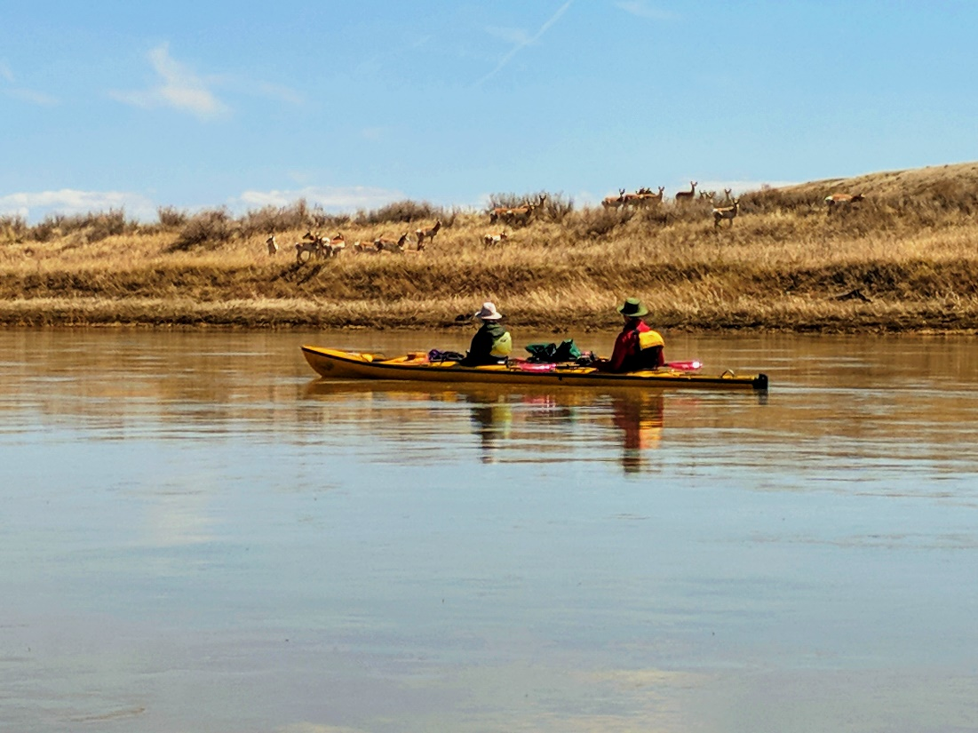

Missouri River near Loma, Montana. Photograph courtesy Scott Bischke.

Acknowledgments

The following individuals and/or groups assisted in the creation of this document by providing strategic guidance, contributing to the literature review process, offering insight on stakeholder needs, or helping out administratively. Many of these people were a part of the writing teams’ listening sessions that occurred early in the process—a focused effort to get out into the state and ask Montanans, “What do you know about climate change in the state, what do you need that you don’t already have, and how would you like information delivered?

Name1, position, affiliation

**Section 1**

Name1, position, affiliation

Name2, position, affiliation

*Add Box Authors*

**Section 2**

Mari Eggers

Sue Higgins

Eliza Webber

*Box Authors*

**Section 3**

Name1, position, affiliation

Name2, position, affiliation

*Add Box Authors*

**Section 4**

Rob Byron

Mari Eggers

Greg Holzman

Paul LaChappelle

Sally Moyce

Rich Ready

Lisa Ritchdt

*Add Box Authors*

**Section 5**

Rob Byron

Angelina Gonzalez-Aller

Meredith Howard

Paul LaChapelle

Jennifer Robohm

Nick Silverman

*Add Box Authors*

List of Acronyms

CDC—Center for Disease Control and Prevention

ENSO—El Niño-South Oscillation

GCM—general circulation model

HEPA—high-efficiency particulate air (filters)

IPCC—Intergovernmental Panel on Climate Change

MCA—Montana Climate Assessment

MTDPHHS—Montana Department of Public Health and Human Services

PM—particulate matter

PTSD—post traumatic stress disorder

RCPs—representative concentration pathways

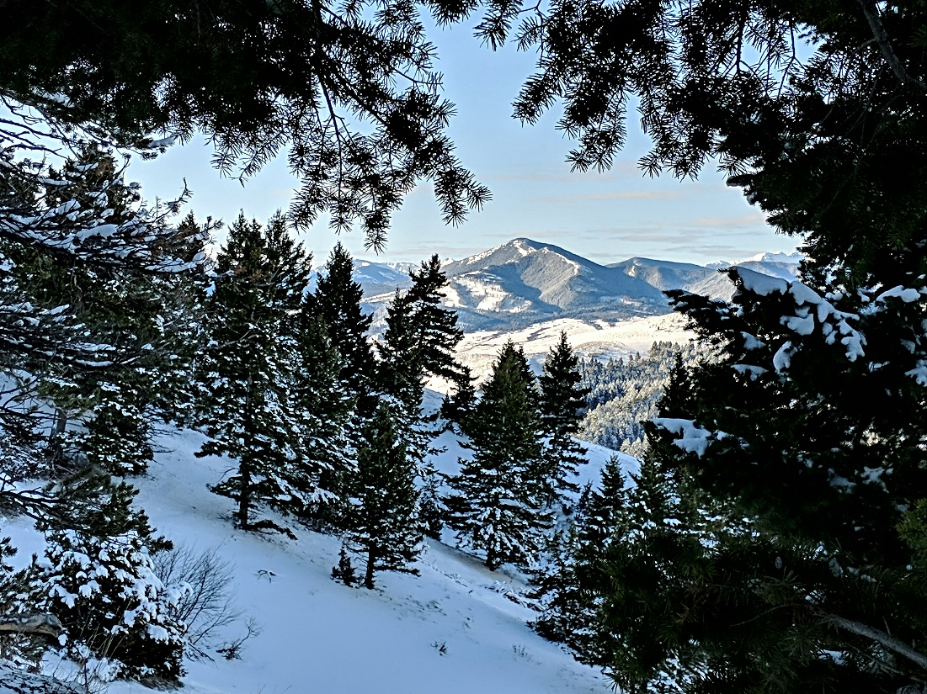

Looking south from the M Trail near Bozeman, Montana. Photograph courtesy Scott Bischke.

Foreword

Author—affiliation

Xyz xyz xyz

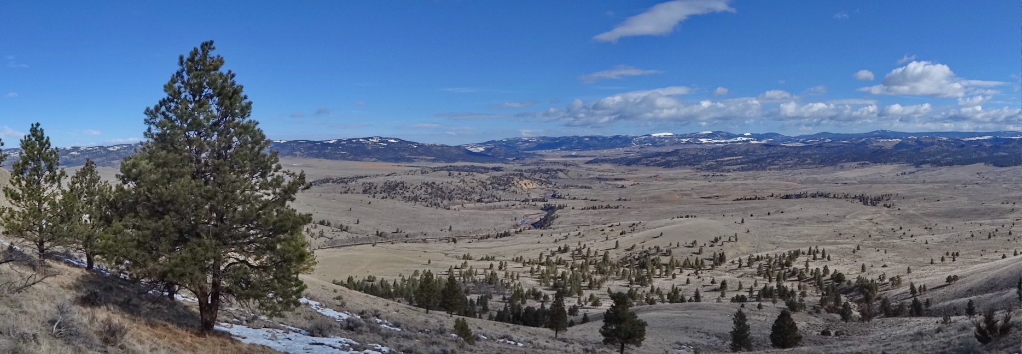

Smith River country near White Sulphur Springs, MT. Photograph courtesy Scott Bischke.

Key Messages and Recommendations

|  |
| --- |
| ***Key Messages***   * Annual temperatures have risen 2-3oF since 1950, and our growing season is now 12 days longer. Montana has experienced an increase in warm days and nights, both in summer and winter. There is no trend in precipitation since 1950. [high agreement, robust evidence] * Climate models project that temperatures will continue to increase in the coming decades and average annual temperature may be 9.8oF higher than those recorded between 1971-2000, given our present rate of greenhouse gas emissions. [high agreement, robust evidence] * Precipitation levels may increase slightly in the future, but these gains will be offset by evaporation and transpiration due to higher temperatures. More precipitation will be received in winter, spring, and fall, and summers will become drier than at present. [moderate agreement, moderate evidence] * Rising temperatures will result in a shift from snow to rain earlier in the year than at present. In turn, this shift will result in earlier dates for the onset of snowmelt and associated peak stream run off by the end of the century. [high agreement, robust evidence] * The number of days >90oF will increase significantly by the end of the century, with the greatest warming in eastern Montana. The eastern part of the state will also experience more extreme heat (i.e., days when the heat index exceeds 105oF. [high agreement, moderate evidence] * Increased wildfires are expected as wetter springs result in increased fuel accumulation, and drier summers lead to fuel desiccation. The size of fires and the length of the fire season will increase in forest and grassland. [high agreement, robust evidence] * Unforeseen climate-related weather events will occur with projected increases in temperature and drought in the coming decades, including greater likelihood of spring flooding, severe summer drought, and extreme storm events. [high agreement, moderate evidence]   These ideas copied here from Section 1 Introduction:   * Increased temperatures and wildfire occurrence will cause heat- and smoke-related health problems, such as asthma and cardiopulmonary illness, and are of most immediate concern. [XXX agreement, YYY evidence] * Early snowmelt, intense precipitation events, and projected increases in floods will lead to more gastrointestinal disease due to contamination of water supplies, as well as increased opportunities for food-, water-, and vector-borne diseases. Allergies and asthma associated with mold contamination of homes in water-saturated regions will increase. [XXX agreement, YYY evidence] * Late-summer drought poses challenges to food security and public water supplies, especially those relying on surface water. [XXX agreement, YYY evidence] * Projected changes in water resources will impact the availability of many traditional subsistence, ceremonial, and medicinal plants, which in turn threatens food security, community health, and cultural well-being for tribal communities. [XXX agreement, YYY evidence] * Extreme weather, higher temperatures, and uncertainty in livelihoods related to agriculture, forestry, and tourism may cause or exacerbate stress and/or mental illness. People on certain medications to treat mental illness may be at increased risk for side effects with higher temperatures. [XXX agreement, YYY evidence]   These ideas from Section 3:  Climate change is already impacting the health of Americans and those impacts are expected to increase. [XXX agreement, YYY evidence]  The most direct climate-change-related impacts on human health result from extreme temperatures, which are expected to increase in intensity, frequency, and duration. Adaptation strategies to cope with extreme temperatures need to be developed and implemented across Montana, for both rural and urban populations. [XXX agreement, YYY evidence]  Vector-borne diseases are spreading in the United States in general, though the extent of their impact in Montana cannot be currently determined. [XXX agreement, YYY evidence]  Warmer days and nights in summer are likely to influence public health. [XXX agreement, YYY evidence]  Forest fires resulting in public health impacts from smoke are likely to double by mid century. [XXX agreement, YYY evidence]  A need exists for increased monitoring of air quality (smoke as particulate matter) across Montana. [XXX agreement, YYY evidence]  A need exists for recording health facility visits due to patient smoke- and heat-related issues across Montana. [XXX agreement, YYY evidence]  These ideas from Bruce submission from Sec3 (some likely repeats, just capturing here)  Increasing summer high temperature in the day and nights are likely to influence public health.  Forest fires resulting in public health impacts from smoke are likely to double by mid-century  There is a need for increased monitoring of air quality (smoke as particulate matter) across Montana.  There is a need for monitoring health facility visits due to patient smoke and heat related issues across Montana. |

Each section begins with key messages to familiarize the reader with the most important findings of this Climate Change and Human Health in Montana report. For each key message we provide a statement of confidence in our findings. We categorically rate the certainty of key messages based on evidence and agreement following the approach used by the Intergovernmental Panel on Climate Change’s (IPCC’s) Fifth Assessment Report (IPCC 2014). For each key message, the authors of the relevant section rate evidence as “limited,” “medium,” or “robust,” depending on the type, amount, and quality of the scientific evidence supporting the message. Authors also rate the agreement—the consistency of the evidence among scientific reports—as “low,” “medium,” or “high.” The authors offer their expert judgement in these assignments based the level of evidence and agreement and provide details in the text to support their ratings. The greater the evidence and agreement, the higher the level of confidence the authors have in the certainty of the key message.

For the assessments of climate impacts made herein, we follow guidance from the National Climate Assessment and Intergovernmental Panel on Climate Change on how to standardize confidence levels and uncertainty characterization in our key messages (Figure Key Message-1).

Each key message provided in the Montana Climate Assessment is followed by a parenthetical expression of confidence. We asked our authors to assess their confidence in the key message by considering a) the quality of the evidence and b) the level of agreement among experts with relevant knowledge used to craft the message. We then used these two factors and the criteria used in the National Climate Assessment (see graphic below) to assign the confidence ratings expressed in the MCA.

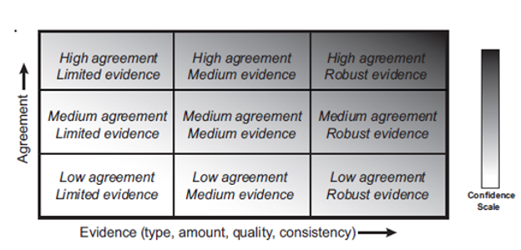

Figure Key Messages-1. A depiction of evidence and agreement statements and their relationship to confidence. Confidence increases towards the top-right corner as suggested by the increasing strength of shading. Generally, evidence is most robust when there are multiple, consistent independent lines of high-quality evidence (figure and caption text from IPCC Fifth Assessment Report [IPCC 2014]).

Literature Cited

[IPCC] 2014. Intergovernmental Panel on Climate Change. Climate change 2014: synthesis report: contribution of working groups I, II and III to the fifth assessment report of the Intergovernmental Panel on Climate Change. Pachauri RK, Meyer LA, Eds. Intergovernmental Panel on Climate Change, Geneva Switzerland. 151 p.

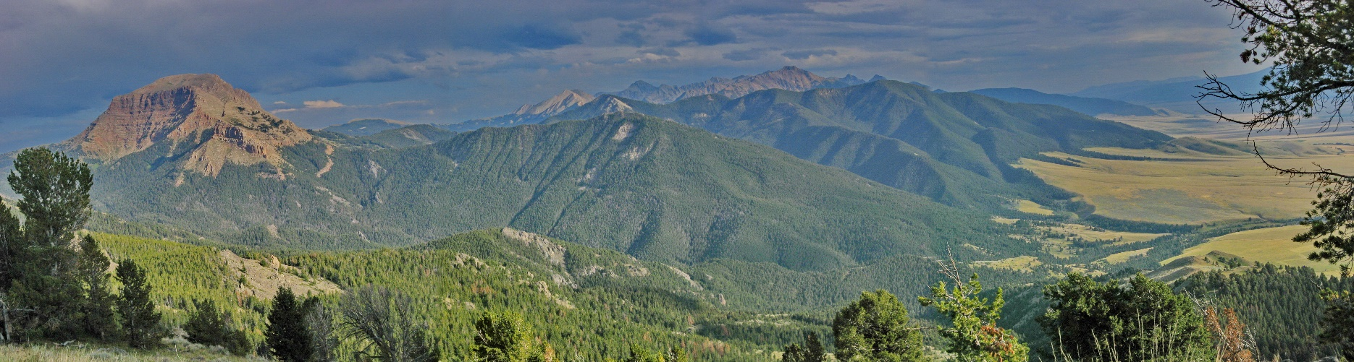

Section 1. Introduction  
— Cathy Whitlock

The purpose of this assessment is to a) present understandable, science-based, Montana-specific information about the impacts of climate change on the health of Montanans; and b) describe how our state can best prepare for and respond to those impacts in the coming decades. This assessment draws from, and is an extension to, the 2017 Montana Climate Assessment (MCA) (Whitlock et al. 2017)[1], which provides the first detailed analysis of expected impacts to Montana’s water, forests, and agriculture from climate change. MCA explains historical, current, and prospective climate trends for the state based on the best-available science.

Section 2 of the current report, Assessing Climate Change and Human Health in Montana, summarizes key findings from the MCA (Whitlock et al. 2017). Foremost are that average temperatures in Montana have increased across the state by 0.42°F per decade since 1950, which is faster than the US average (0.26°F), and that climate projections indicate continued warming in the coming decades with temperature increases of 4.5-6.0°F by mid century, depending on the scenario of global greenhouse gas emissions. One aspect of warming is an anticipated increase in days above 90°F by 5-35 days, with greatest increase in days occurring in the southeastern part of the state.[2] MCA also finds that, although there has been no significant change in statewide mean annual precipitation since 1950, summer precipitation has decreased, while spring and fall precipitation have slightly increased. Projections indicate more year-to-year variability in precipitation, early loss of snow, and drier summers.

|  |  |
| --- | --- |
| Related image | *The purpose of this assessment is to a) present understandable, science-based, Montana-specific information about the impacts of climate change on the health of Montanans; and b) describe how our state can best respond to and prepare for those impacts in the coming decades.* |

While the MCA analyzes expected impacts to water, agriculture, and forests from climate change in Montana, its scope does not include impacts to human health. National-level studies, however, have outlined a number of linkages between climate change, exposure, and health outcomes with projected health impacts that have direct implications for Montana (USGCRP 2016). The certainty of changes in Montana’s climate in the decades ahead calls for a deeper understanding of the potential impacts on people, as well as the capacity of Montana's healthcare community to respond to emerging climate-related challenges. A need, thus, exists for increased collaboration between healthcare practitioners and scientists to gather data on health and climate trends, examine potential health impacts of projected climate changes, and communicate the need for monitoring and action to the broader community of Montana healthcare providers, policy makers, and public. This report serves as the informational foundation for such collaboration.

Climate change is a global phenomenon, and the anticipated impacts to human health and well-being affect all humankind to some degree. In Montana, both harm and benefits will result, depending on location and individual. Harms may include increased mortality rates related to cardiovascular and respiratory conditions and heat stress, elevated gastrointestinal diseases, spread of infectious disease, increased premature births, higher morbidity, and more. Particular aspects of climate change may be positive in some regions initially (e.g., warmer winters will benefit some), but over the long term the consequences of warming are less positive and of great concern. Impacts on individuals vary based on where they live, as well as on their age, gender, occupation, socioeconomic status, and underlying medical conditions. The most vulnerable populations to climate change are children, the sick, the poor, the elderly, individuals working outdoors, and isolated populations far from healthcare services.

|  |  |
| --- | --- |
| Related image | *A need, thus, exists for increased collaboration between healthcare practitioners and scientists and to gather data on health and climate trends, examine potential health impacts of projected climate changes, and communicate the need for monitoring and action to the broader community of Montana healthcare providers, policy makers, and public. This report serves as the informational foundation for such collaboration.* |

Given its northern and interior location, Montana will avoid many of the health impacts of climate change facing other parts of the US and the world. Nonetheless, some of the health consequences experienced here will likely be *more* serious than elsewhere. While little explored for our state to date, the climate issues of greatest concern are:

* Increased temperatures and wildfire occurrence.
* Early snowmelt, intense precipitation events.
* Late-summer drought.
* Projected changes in water resources.
* Extreme weather, higher temperatures, and uncertainty in livelihoods.

To date we have little understanding about these variables will affect the health of Montanans. Assessing Climate Change and Human Health in Montana, a special report of the Montana Climate Assessment, seeks to fill such gaps in our knowledge. Scientific assessments are essential tools for linking knowledge to decision-making, by surveying and synthesizing peer-reviewed scientific information across disciplines, sectors, and regions. Assessments highlight key information that can improve understanding of complex issues and identify topics where study is needed. The work presented here will be a sustained effort, updated and expanded on a regular basis as part of the overall MCA program.

Climate Change and Human Health in Montana is intended to help communities, healthcare professionals, and other decision makers understand the climate-health connection and evaluate different strategies for response. The flow of information should also go in the opposite direction, with this report helping decision makers identify critical information gaps that require new scientific investigation, tool development, and future assessment. Along with its statewide focus, Climate Change and Human Health in Montana contributes to the larger flow of information regarding climate change and human health between national, regional, state, and local levels.

Assessing Climate Change and Human Health in Montana is the product of a diverse partnership of over 40 scientists and healthcare professionals who first met in August 2018 to discuss the issue and plan the report. Before its release in 2020, the report received public comment and rigorous scientific review by health and climate experts at the local and national level.

The report that follows is broken into four additional sections:

* projected climate change in Montana as it relates to human health (Section 2);
* linkages between climate change and human health, both globally and in Montana, with descriptions of the health consequences and uncertainties posed by climate projections for mid and end of century (Section 3);
* a survey of those Montanans expected to be most impacted by a changing climate (Section 4); and
* recommended actions, research needs, and policy changes to ensure positive health outcomes for Montanans in the face of climate change (Section 5).

This report makes it clear that Montana’s changing climate will have measurable impact on our state’s human health and well-being in the future. We hope that this report motivates much-needed discussion on this topic, one that leads to greater awareness, considers multiple sources of knowledge, and helps planning efforts and action in this important area.

Literature Cited

[CDC] Center for Disease Control and Prevention. [undated]. <https://www.cdc.gov/nchs/pressroom/sosmap/suicide-mortality/suicide.htm> Accessed 22 November 2019.

[UCS] Union of Concerned Scientists. 2019. Killer heat in the United States; climate choices and the future of dangerously hot days [report]. Dahl K, Spanger-Siegfried E, Licker R, Caldas A, Abatzoglou J, Mailloux N, Cleetus R, Udvardy S, Declet-Barreto J, Worth P, authors. Available online <https://www.ucsusa.org/sites/default/files/attach/2019/07/killer-heat-analysis-full-report.pdf>. Accessed 15 September 2019.

[USGCRP] US Global Change Research Program. 2016. The impacts of climate change on human health in the United States: a scientific assessment. Crimmins A, Balbus J, Gamble JL, Beard CB, Bell JE, Dodgen D, Eisen RJ, Fann N, Hawkins MD, Herring SC, Jantarasami L, Mills DM, Saha S, Sarofim MC, Trtanj J, Ziska L, eds. Washington DC: U.S. Global Change Research Program. 312 p. Available online https://health2016.globalchange.gov. Accessed 1 Mar 2020. <http://dx.doi.org/10.7930/J0R49NQX>.

Whitlock C, Cross W, Maxwell B, Silverman N, Wade AA. 2017. 2017 Montana Climate Assessment. Bozeman and Missoula MT: Montana State University and University of Montana, Montana Institute on Ecosystems. 318 p. DOI:10.15788/m2ww82. Available online <http://montanaclimate.org>. Accessed September 2019.

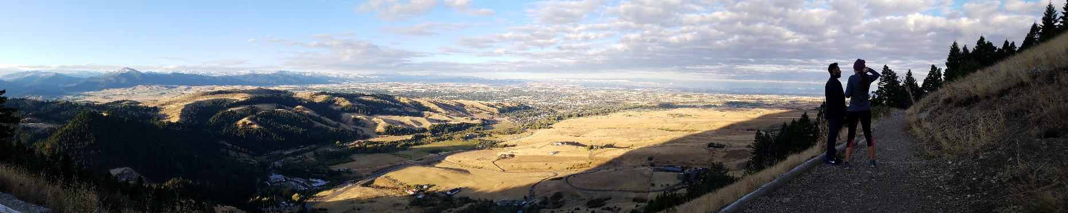

Section 2. Climate Change and Human Health in Montana  
**— Cathy Whitlock** *[3]*

As noted in the Introduction, this assessment brings scientifically based information about the impacts of climate change on human health to the people of Montana in an organized and understandable manner. In this section, we begin with a short description of Montana’s geography. We then describe how climate and weather differ, as well as past trends and future projections for temperature and precipitation. We next review how the changing climate will impact the health of Montanans. We conclude this section by reviewing the health profile of Montanans, a critical basis to build an understanding of the health impacts of climate change, who in our state is most vulnerable to those impacts, and what actions we can take to protect our citizens, the final three sections of this report.

Montana’s Unique Geography

Montana’s climate is as diverse as its landscapes, which vary from high plains grasslands to alpine rock and ice. As the nation’s fourth largest state and given our location in the interior of North America, Montana is exposed to diverse weather systems that arise from air masses in the Arctic, Pacific, and Gulf of Mexico. The strength and location of these air masses shifts seasonally, creating differences in the climate and weather across the state and throughout the year. Montana’s complex topography modifies weather systems as they travel over our western mountain ranges and onto the Great Plains. Montana tends to be wetter in the west because of the proximity to Pacific moisture sources and the cooling and condensing effects that result as air masses rise to cross the Continental Divide. The state is generally drier in the east where heating and evaporation are stronger and elevations are lower.

Montana’s mountains are headwaters to three of the continent’s major river systems: the Missouri, Columbia, and Saskatchewan. As such, snow levels in our region affect water availability far beyond the state’s border. Our mountain snowpack comes largely from Pacific storms. This winter precipitation is the primary water supply serving our state’s waterways, ecosystems, municipalities, farms and ranches, and recreational industry.

Climate Differs From Weather

An assessment of climate change in Montana is a description of a region’s average weather conditions as they vary over multiple decades. Weather, in contrast, refers to the short-term changes, occurring over minutes to months in the atmosphere, as measured by temperature, humidity, precipitation, atmospheric pressure, and other variables (NOAAa undated). While Montana’s climate has become warmer in recent decades, weather patterns have shown considerable variability on a day-to-day and month-to-month basis.

|  |  |
| --- | --- |
| Related image | *An assessment of climate change in Montana is a description of a region’s average weather conditions as they vary over multiple decades. Weather, in contrast, refers to the short-term changes, occurring over minutes to months in the atmosphere, as measured by temperature, humidity, precipitation, atmospheric pressure, and other variables (NOAAa undated).* |

In addition to relatively rapid changes in weather, Montana has also experienced interannual variability in climate that relates to global-scale fluctuations in ocean circulation and its influence on the atmosphere. The El Niño-South Oscillation (ENSO) is an example of a climate pattern in our region that varies from year to year depending on ocean-atmospheric patterns in the tropical Pacific Ocean and their influence on storm tracks and pressure systems at higher latitudes. MCA (Whitlock et al. 2017) describes three such scenarios:

* *El Niño phase.—*During an “El Niño” phase the tropical Pacific Ocean is warmer than normal and Montana, especially the northwestern region, tends to experience warmer winters.
* *La Niña phase.—*During the opposite “La Niña” phase the tropical ocean is cooler than normal and Montana tends to experience cool, often wet winters (MCO 2019).
* *ENSO neutral phase.—*When the tropical Pacific Ocean experiences near-average temperatures circulation conditions in Montana are less predictable.

The important point is not to confuse weather and interannual climate variability with long-term climate trends. The former describes short-term, continually shifting conditions observed over days and years; the latter describes climate trends observed over decades, and beyond.When we discuss climate change, we usually refer to a baseline or “normal” period for comparison. In the 2017 Montana Climate Assessment (Whitlock et al. 2017) and in this report, that “normal” period is a 30-year time span from 1971-2000.

Historical Climate Trends and Modeling the Future

The 2017 Montana Climate Assessment shows Montana’s recent climate trends and future projections for seven climate divisions (Whitlock et al. 2017). These climate divisions are the Montana subset of the 344 divisions identified by the National Oceanic and Atmospheric Administration (NOAAb undated) to report climate for the US. NOAA established the divisions based on climatic, political, agricultural, and watershed boundaries. For Montana, the MCA identifies the seven NOAA divisions as the northwestern, southwestern, north central, central, south central, northeastern, and southeastern climate divisions (Figure 2-1).

|  |
| --- |
| Figure 2-1. Montana’s seven climate divisions. |

The MCA (Whitlock et al. 2017) analysis of *historical* climate trends started with the mid-20th century and drew on direct measurements of temperature and precipitation from weather stations across the state. These point observations were statistically interpolated to describe the climate trends between stations and the results aggregated to the seven climate divisions.

MCA *future projections* were based on an ensemble of 20 climate models, selected from a larger suite of general circulation models (GCMs) developed by scientists to simulate global climate (Whitlock et al. 2017). GCMs are complex mathematical depictions of the global circulation of the atmosphere and oceans (including the cryosphere, i.e., the Earth’s frozen waters). The models provide ten-day weather forecasts, as well as projections of past and future climate. The 20 GCMs employed in the MCA—all included in the fifth phase of the Coupled Model Intercomparison Project (WCRP undated)—were chosen for their ability to accurately provide daily outputs of climate variables important in this region. Output from these GCMs was statistically downscaled to a high spatial resolution, and the results were aggregated spatially to provide projections for each Montana climate division.

Future climate projections based on GCMs consider different scenarios (or pathways) of greenhouse gas increase in the coming decades. These scenarios, referred to as Representative Concentration Pathways (RCPs), have been developed by the international science community based on different assumptions about changing energy sources (fossil fuel or renewable), economic trajectories, population growth, and technological advancements in the coming decades at a global scale. While multiple RCPs have been investigated, MCA (Whitlock et al. 2017) focuses on two scenarios for Montana’s future climate: RCP4.5 and RCP8.5 (the number refers to projected watts/m2 of greenhouse-gas-derived heating by AD 2100). RCP4.5, often termed the "stabilization" scenario, describes a future trajectory that involves some level of greenhouse gas mitigation, resulting in a near-term rise in the rate of greenhouse gas emissions, maximum levels being reached at about 2040, and a decline in the rate of emissions in the last half of the century (Clarke et al. 2007). For RCP8.5, currently the "upper bound" of expected carbon use, the greenhouse gas emissions are allowed to rise at a high rate through the century. The primary difference between the scenarios is that RCP8.5 is more extreme in its projections of climate change at the end of the century, reflecting an inability to curb fossil fuel use and hence an increasing release of greenhouse gases (CO2, CH4, and others) to the atmosphere.

Given time and funding limits, the MCA (Whitlock et al. 2017) focused on the impact of climate change for only three vital sectors—water, forests, and agriculture—although the team recognized that other sectors of the state’s environment and economy were equally important. This report covers an important gap in the MCA (Whitlock et al. 2017), namely addressing how future climate change may impact the health of people in our state. A key goal of this assessment is to identify those aspects of temperature and precipitation most likely to have consequences on the physical and mental health of Montanans.

|  |  |
| --- | --- |
| Related image | *A key goal of this assessment is to identify those aspects of temperature and precipitation most likely to have consequences on the physical well-being and mental health of Montanans.* |

Temperature

Increasing temperatures, the most direct consequence of increasing greenhouse gases, are a major health concern for Montana, the nation, and the globe. Air temperature has increased in recent decades and that warming will continue in the future. MCA (Whitlock et al. 2017) shows that the decadal rate of change in average annual temperature for the period from 1950-2015 was about 0.4oF statewide, which equates to 2-3oF warming in the last 65 years. More recently, the years 2015 and 2016 were the second and third warmest of the last 70 years, with average annual temperatures 3.2 and 2.9oF above the base period of 1971-2000. Likewise, 2017 had average annual temperatures 1.5oF above this base period, though average annual temperatures for 2018 and 2019 were average or slightly below average (NOAAc undated).

A 70-year warming trend since 1950 is evident across the state, with greatest warming in the south central climate division (Figure 2-1). Since 1895, Montana’s rate of warming (0.20oF/decade) has been greater than that of the US (0.15oF/decade), and this condition reflects the state’s location far from the moderating effects of an ocean. Average maximum and minimum temperatures have also risen across the state since 1950 by 0.3-0.6oF/decade, amounting to an increase of approximately 3.3oF for the hottest and coldest conditions (Whitlock et al. 2017).

Temperature projections for 2040-2069 (mid century) and 2070-2099 (end of century) indicate that current warming trends will continue (Whitlock et al. 2017) (Figure 2-2). By mid century, annual average temperatures are 4.5oF higher under the RCP4.5 scenario and 6oF higher under RCP8.5 than the base period (1971-2000). All models show these general projections. End-of-century average annual temperatures for the state are more dramatic: increases of 5.6oF in RCP4.5 and 9.8oF in RCP8.5, again with full model agreement. Temperature projections show small differences across the climate divisions, but overall warming is evident across the state. Projections of average monthly temperatures show temperature increases in all seasons and for all divisions, with summer and winter experiencing the greatest warming. August, in particular, has the greatest monthly change for all divisions.

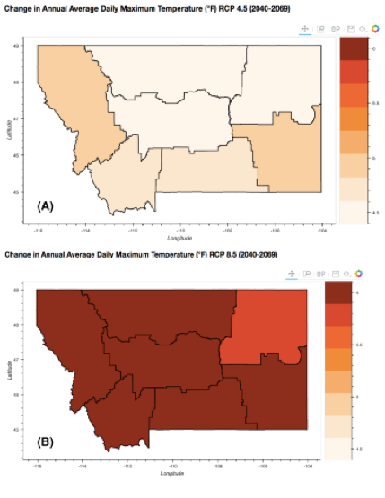 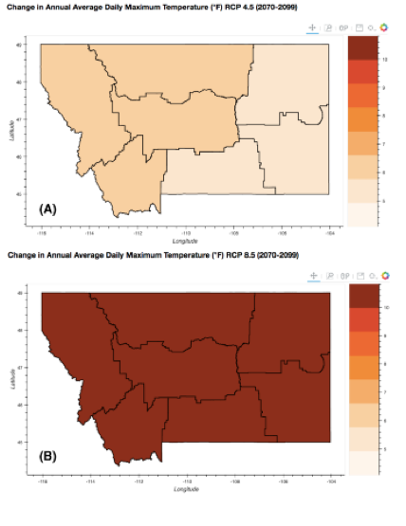

***Mid century End of century***

Figure 2-2. The projected increase in annual average daily maximum temperature (°F) for each climate division in Montana for the periods 2049-2069 and 2070-2099 for (A) stabilization (RCP4.5) and (B) upper-bound (RCP8.5) emission scenarios (Whitlock et al. 2017).

Daily minimum and maximum temperatures also show a similar magnitude of increase in the coming decades. The number of frost-free days (days where the temperature does not reach 32oF) is projected to increase by 24-44 days, particularly in the western division. Extreme heat days (where the daily temperature exceeds 90oF) also increases in the model projections. In the stabilization scenario (RCP4.5), the western and north central climate divisions experience an additional five extreme-heat days, and the northeastern, southeastern, and south central divisions have an increase of 25 extreme heat days by mid century as compared to the base period (1971-2000). The upper-bound scenario (RCP8.5) elevates the number of days above 90oF days by mid century: 11 additional extreme heat days in the northwest and north central divisions and 33 additional extreme heat days in the northeastern, southeastern, and south central divisions. These numbers increase further by the end of the century, where the stabilization scenario indicates 9 to 29 additional days. The upper-bound emission scenario shows approximately 34 additional days exceeding 90oF in the northwestern, southwestern, and north central divisions and 54 additional extreme heat days in the south central, northeastern, and southeastern divisions. The significant increase in the number of extremely warm days in summer and the reduction of cold days in winter by the end of the century is a significant projection in the MCA (Whitlock et al. 2017).

|  |  |
| --- | --- |
| Related image | *The upper-bound emission scenario shows approximately 34 additional days exceeding 90oF in the northwest and north central divisions and 54 additional extreme heat days in the southern and eastern parts. The significant increase in the number of extremely warm days in summer and the absence of cold days in winter by the end of the century is a significant projection in the MCA (Whitlock et al. 2017).* |

Precipitation

Montana is a semi-arid region. Thus, the availability and quality of water are critical for the health of the state’s communities and ecosystems. The amount of precipitation varies widely across the state, with elevation, topography, and distance from the Pacific Ocean determining the timing and form of precipitation received. Generally, the western part of the state receives the highest levels of precipitation (average of 22-30 inches), and more of it falls in the form of winter and early-spring snow from Pacific storms. The eastern part of the state receives only half the level of precipitation (average of 12-14 inches), with moisture sources coming from a combination of Pacific storms in winter and convective storms from the subtropical Pacific and Gulf of Mexico in spring and summer. These convective storms are associated with hail, lightning, and sometimes tornados in eastern and central Montana.

Annual precipitation levels have not changed significantly since 1950, although there is considerable variability in the amount received each year. In general, since 1950 northwestern Montana has become slightly drier in winter, while eastern Montana has become slightly wetter in spring. The year-to-year variation reflects the influence of topography on individual storm tracks, as well as large-scale climate patterns that vary interannually (e.g., ENSO) and can set up persistent weather conditions. In the winter of 2017-2018, Montana’s weather was influenced by a persistent La Niña pattern in the tropical Pacific. Prevailing upper-level winds directed Pacific storms to our region, resulting in record snow accumulation in Montana while leaving the southwestern US in relative drought. Places in western and central Montana received from 111 to over 152 percent of normal snow pack, as measured by April 1 snow water equivalent (Figure 2-3).

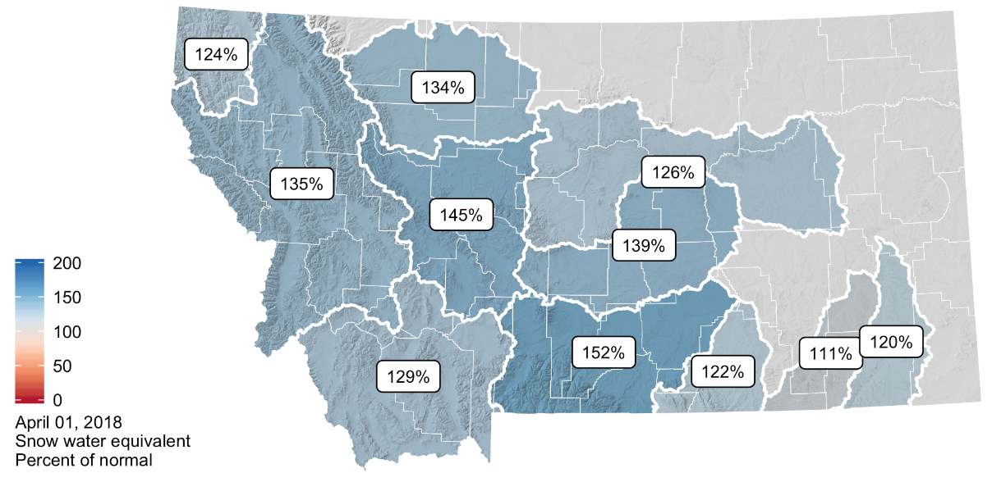

Figure 2-3. The Montana Drought & Climate report from the Montana Climate Office showing snowpack in 2018 as measured by the April 1 snow water equivalent (MCO 2018). The Upper Missouri River Basin above Fort Peck Reservoir was 127% of normal in 2018, and unusually high snowpack contributed to soil moisture recharge and good growing conditions in summer.

Precipitation is a complex phenomenon to simulate in climate models because a number of interactive components in the atmosphere, land, and ocean govern where, when, and how much precipitation falls. These components must be incorporated correctly for the GCM to accurately portray current conditions and provide credible projections for the future. As a result, GCM projections show less agreement about future precipitation levels than they do for future temperature; this is true at a global scale and also for Montana. MCA (Whitlock et al. 2017) suggests that by mid century, precipitation will increase slightly across the state, with 1.3 inch/yr more in the northwestern and north central regions and 0.9 inch/yr more in the southwestern, central, and eastern climate divisions, as compared to the base period (1971-2000). The upper-bound scenario (RCP8.5) for mid-century projections suggests an increase of 2.0 inch/yr in the western half of the state and 1.8 inch/yr in the eastern half. For this scenario, model agreement ranges from 65% for the mid-century summer projections to 95% for the spring projections.

|  |  |
| --- | --- |
| Related image | *MCA (Whitlock et al. 2017) projections indicate that winters, springs, and fall will get wetter and summers will get drier in the coming decades, with the likelihood of effective moisture decreasing in all seasons because of rising temperatures.* |

It is important to caution that projected increases in precipitation will likely be offset by the coincident rise in temperature. Warming will increase the rates of evaporation from soils and water bodies, and transpiration (water loss) from plants (Collins et al. 2013). While we may receive more precipitation, especially in the form of rain, effective moisture (that which is actually experienced) will be reduced by the consequences of heat.

Seasonal differences in the projected changes in precipitation are striking, as analyzed in the MCA (Whitlock et al. 2017) (Figure 2-4). In all regions and under both scenarios for the mid century and end of century, precipitation increases markedly in spring (March-May) and less markedly in winter (December-February) and fall (September-October). In contrast, summers (June-August, and in some regions, September) receive less precipitation in the future. The combination of wetter conditions in winter, spring, and fall, coupled with drier summers, both as compared with the base period (1971-2000), is especially striking in the upper-bound emission scenario (Figure 2-4). In the end-of-the-century projection, for example, increases in winter and spring precipitation of 0.4 inch/month and decreases in summer precipitation of -0.2 inch/month are indicated, with 75% model agreement. MCA (Whitlock et al. 2017) projections thus indicate that winters, springs, and falls will get wetter and summers will get drier in the coming decades, with the likelihood of effective moisture decreasing in all seasons because of rising temperatures.

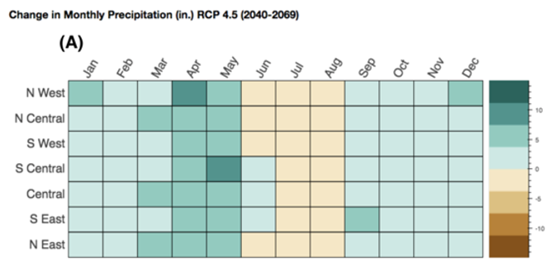

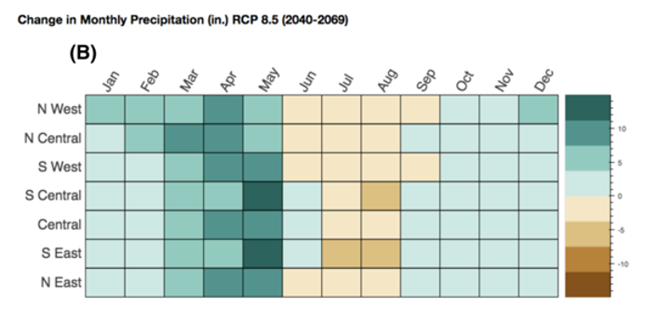

Figure 2-4. Projected monthly change inaverage precipitation (inches) for each climate division in Montana in the mid-century projection (2040 and 2069) for (A) stabilization (RCP4.5) and (B) upper-bound (RCP8.5) emission scenarios (Whitlock et al. 2017).

Climate Concerns for Human Health

Given this background in how climate change has and is expected to impact Montana, we turn to an overview of how those impacts may affect the health and well-being of Montanans. Three elements of projected climate change are of particular concern for human health in our state and, thus, deserve close attention from the health community. In subsequent sections of this report, we address the health consequences directly, but first the nature of the climate threats themselves deserves a brief explanation, as follows.

Extreme heat

Extreme heat is the most pervasive issue of health concern, with statewide increases in annual temperature of potentially 4-6oF by mid century and possibly as great as 9.8oF by the end of the century, based on RCP8.5 (upper-bound) emission scenario (Whitlock et al. 2017)[4]. This rise in temperature continues a warming trend that the state has already experienced during most of the last 120 years, and especially since 1950 (Whitlock et al. 2017). The coldest temperatures during winter will become warmer in the future, which may have positive consequences for some communities and livelihoods. However, the number of extremely warm days in summer will also increase, by over a month in most places and with rural areas of eastern Montana projected to experience the greatest heat stress. Across the US and world, populations living in areas that have experienced extreme heat have suffered from a variety of heat-related health issues, and even death.

Given the state’s northerly location, Montanans have not lived through the summer heat experienced in other regions, but this situation will likely change in the future. Some areas of the world have already experienced the heat index[5] levels that the MCA projects for Montana. People living in those areas have suffered from heat stress and worse. In France, for example, heatwaves are blamed for the death of 1500 people in the summer of 2019 (Guardian 2019). Montanans likewise are at risk as we can expect as many as 2.5 weeks of 105oF in the northeastern and southeastern climate divisions by the end of the century (Figure 2-1). These two areas include a large sector of the population who work outdoors in agriculture. Most of the rest of the state is projected to experience <10 days reaching 105oF by the end of the century.

Smoke

Smoke is likely to become a persistent feature of our climate, as wildfires become ever larger across the western US. Smoke fills our valleys from local wildfires, as well as those fires burning in other western states and Canada. Ash particles from these fires trap heat and reduce transparency creating dangerous air quality. High levels of particulate matter from recent fires have increased emergency admissions for asthma, respiratory, and cardiopulmonary problems in many regions (see Section 3). Since the 1970s, Montana’s fire season has lengthened from 5 to over 7 months/yr (see Section 5), and parts of the country now experience wildfires year-round. The link between rising temperature and fire activity is clear: warmer summers dry fuels (both grass and woody), setting the stage for fires to ignite and spread. Learning to live with fire has become a priority for Montanans. Likewise, making our communities better adapted and more resilient to fire is now a priority in planning efforts (Schoennagel et al. 2017; McWethy et al. 2019).

Climate “surprises”

Climate “surprises” are the extreme or unexpected events that cause the most damage to human health and property. The list includes abrupt and marked changes in average temperature or altered patterns of storms, floods, droughts, and wildfire. These events take place so rapidly and unexpectedly that human or natural systems often have difficulty adapting.

Rising spring temperatures, for example, have led to a shift from snow to rain in early spring (Whitlock et al. 2017). In addition, snowpack melts more rapidly in spring, resulting in ice jams and streams overflowing their banks, with sometimes disastrous consequences. Severe spring floods have occurred in snow-fed streams in Montana throughout history (NOAAd undated), but recent years have seen unusually large floods on the Missouri, Musselshell, Poplar, Powder, and Yellowstone rivers (Whitlock et al. 2017). These events have led to extensive property and infrastructure damage, as well as loss of human lives. Although it is difficult to predict spring flood events with certainty, they are likely to increase in frequency and severity in the future. Climate projections suggest that the seasonal shift from snow to rain will occur earlier, as will the date of peak spring runoff. Peak runoff on most headwater streams in Montana now occurs 10-20 days earlier than in 1948, and by the end of the century, the date of peak run off is projected to occur 5-35 days earlier than during the period from 1951-1980 (Stewart et al. 2004).

Another consequence of earlier snowmelt is less available water in late summer, increasing the risk of drought. Drought can be long term—Montana suffered a 307-week drought starting May 2000 (NIDIS undated)—or short. In the latter category are “flash droughts,” a recently coined phrase that describes a rapid shift from wet to dry conditions following just a few weeks of hot, dry weather.

Regardless of length of drought, the impacts to human health can range from respiratory issues due to poor air quality from fires or dust storms; to gastrointestinal strife due to declining drinking water quality and/or sanitation services; to increased disease carried by vectors such as mosquitos that are better able to breed in stagnant waters (CDCa undated).

|  |  |  |
| --- | --- | --- |
|  | Sidebar: The 2017 Northern Great Plains Drought  The 2017 Northern Plains drought sparked wildfires, destroyed livestock, and reduced agricultural production (Jensco et al. 2019). It was the worst drought to impact North Dakota, South Dakota, eastern Montana, and the Canadian prairies in decades.  Neither the drought’s rapid onset—sometimes called a “flash” drought—nor its severity was forecast. In May 2017, the northern Great Plains region was mostly drought free, and at least average summer precipitation was forecast. By July 2017, the region was experiencing severe to extreme drought, resulting in fires that burned 4.8 million acres across both countries. US agricultural losses alone exceeded $2.6 billion dollars.  The unique circumstances of this drought provided an opportunity to evaluate the evolution of this type of climate event, as well as improve the effectiveness of drought-related coordination, communication, and management in preparation for future droughts. National Integrated Drought Information System and partners published two reports that examine the evolution and impacts of the 2017 drought, as well as lessons learned, data needs, and information gaps.   |  | | --- | | Fires in ___  Photo courtesy of | |

Reduced stream flow in the late summer has also led to high temperatures in some waterways, stressing the region’s late-season water supplies and ecosystems. Montana Fish, Wildlife, and Parks closed a 184-mile stretch of the Yellowstone River in 2016 because of a massive fish kill attributed to the warm temperatures leading to a proliferative kidney disease (MFWP 2016); other rivers are regularly closed to fishing when water temperatures reach 73oF for three consecutive days. Reduced water availability threatens irrigation and water supplies for communities, as well as sets the stage for a host of health issues, including vector-borne diseases and mental health concerns (see Section 3).

Other climate surprises are likely but tougher to predict. Tornado and severe thunderstorm events currently cause significant property damage and loss of life every year. Of the US weather disasters that have incurred more than $1 billion in damage costs in the last 25 years, over one-third were due to severe storms (NOAAe undated). In Montana, a 2010 tornado in Billings, which caused city officials to declare a state of emergency, resulted in millions of dollars of property damage, including ripping the roof off the 12,000-seat Metra Park Arena (CBS News 2010, NOAA 2010). In May 2016, severe thunderstorms, tornados, and high winds in the Great Plains and Rockies, including Montana cost over $1.1 billion (NOAAe undated).

The link between severe storms (e.g., tornados, severe thunderstorms, hailstorms) and climate change is not well understood, in part because their documented record is relatively short, going back only to the 1950s. Past events have been responsible for lives lost and serious and costly property damage, especially for those living in substandard housing. The uncertainty of such events also creates enormous mental stress. Evidence exists that the number of days with tornados is increasing, and it is likely that a warmer world with more atmospheric instability will shift both the timing and extent of severe storm conditions (USGCRP 2017). The mechanisms that create these storms, however, are complex and difficult to model (Diffenbaugh et al. 2013; Seeley and Romps 2015). Still, one study suggests that storms in eastern Montana may be less frequent in the future, but will have larger hail and potentially be more damaging (Brimelow et al. 2017).

In summary, early snowmelt, large wildfires, spring flooding, late-season drought, and extreme weather events challenge all aspects of our economy, infrastructure, and well-being. The health effects of these climate extremes include direct injury and loss of life, as well as indirect consequences related to illness and stress (see Section 5). Human health issues derived from or exacerbated by climate change are now taken seriously by the health professionals around the world, and likewise require serious attention in Montana. The first step in developing such emphasis is to understand our state’s health profile, as described next.

|  |  |
| --- | --- |
|  | Sidebar: Montanan’s Opinions on Climate Change |
|  |
| Text from Lori’s thesis and Yale study |

Montana’s Health Profile

A community health profile describes access to and availability of health resources, social and demographic characteristics, current health status, health risk factors, and quality of life (Durch et al. 1997). Understanding Montana’s health profile before exploring how climate change drives human health concerns and responses—the topics of Sections 3 and 4—provides a good picture of the complexities already in place, even before adding climate-change-related complications.

|  |  |
| --- | --- |
|  | *Sidebar:* Populations Vulnerable to Climate Change in Montana  Ten sectors of Montana’s population are at special risk of having their health impacted by our warming climate. Section 4 provides details on each of these groups:   * People working outdoors or have poor access to air conditioning when needed * People living in proximity to wildfire and smoke * People facing food and water insecurity * People who are very young or very old people * People living in poverty with inadequate housing and air conditioning * People isolated from health services or without adequate health insurance * People with existing chronic conditions, including mental health issues |

Montana is a rural state

The most important aspect of Montana’s health profile is that *Montana is a rural state.* As such, many Montanans live in frontierareas[6] that lack of essential services like healthcare, and thus must travel long distances foror such services. Figure 2-5 shows the population status of Montana’s 56 counties and the boundaries of tribal reservations (OMB 2010).



Figure 2-5. Population status of Montana’s 56 counties.Tribal reservation boundaries are shown in red. The three statistical areas shown are defined as follows: *Rural* areas are counties with an urban cluster having less than 10,000 people. *Micropolitan* areas have at least one urban cluster of at least 10,000 but less than 50,000 population, plus adjacent territory that has a high degree of social and economic integration with the core as measured by commuting ties. *Metropolitan* areas have at least one urbanized area of 50,000 or more population, plus adjacent territory that has a high degree of social and economic integration with the core as measured by commuting ties. Analysis here created from from OMB (2010) and US Census Bureau (2018) data.

Montana averages just 6.9 people/mile2, making it the third most sparsely populated state in the country (US Census Bureau 2010). The 2018 census—the most recent—of Montana’s population identified that 33.1% of our 1,062,305 residents live in rural areas residents live in rural areas, as defined by Office of Management and Budget’s Core-Based Statistical Areas (OMB 2010; US Census Bureau 2018). In comparison, just 5.6% of the total US population resides in a rural area (US Census Bureau 2010; Ingram and Franco 2013). American Indian residents make up 6.6% of Montana’s population, one of the highest percentages of any state (US Census Bureau 2018).

|  |  |
| --- | --- |
| Related image | *The most important aspect of Montana’s health profile is that* ***Montana******is a rural state.*** *As such, many Montanans live in frontierareas that lack essential services like healthcare, and thus must travel long distances to access such services.* |

Between 2010 and 2018, Montana’s population grew 7.4%, faster than the average national growth rate of 5.9% during the same period. Yet even though Montana as a whole is growing quickly, its rural areas continue to lose numbers: 18 of 56 counties *lost* population (US Census Bureau 2018). Growth has been concentrated in Montana’s most highly populated counties, with urban county growth in Gallatin, Yellowstone, Flathead, Missoula, and Lewis and Clark accounting for 83% of the state’s total population increase (US Census Bureau 2018) (Table 1; Figure 2-6).

|  |  |  |  |
| --- | --- | --- | --- |
| Table 2-1. Counties in Montana showing most growth, by population change, 2010-2018 (ref?). | | | |
| Location | Population | Growth | Urban / Rural status |
| *MT net growth* | *72,890* |  |
| *Growth share by county* |  |  |  |
| Gallatin County | 22,363 | 30.7% | Urban |
| Yellowstone County | 12,165 | 16.7% | Urban |
| Flathead County | 11,178 | 15.3% | Urban |
| Missoula County | 9492 | 13.0% | Urban |
| Lewis and Clark County | 5305 | 7.3% | Urban |
| Other counties—rural | 3903 | 5.4% | Rural |
| Other counties—urban | 2853 | 3.9% | Urban |

Health-wise, where you live matters

It is not surprising that access to healthcare is a challenge to Montanans in low-population counties, and, combined with other risk factors, translates into poorer health outcomes when compared to those living in metropolitan areas, such as. Montana ranks higher than the national average in percent of people over the age of 65, housed in mobile homes, without health insurance, and with disabilities (Headwaters Economics 2019). Thirty-eight percent of adults in Montana report having two or more chronic health conditions, and the prevalence of multiple chronic conditions is significantly higher among adults living in frontier counties.

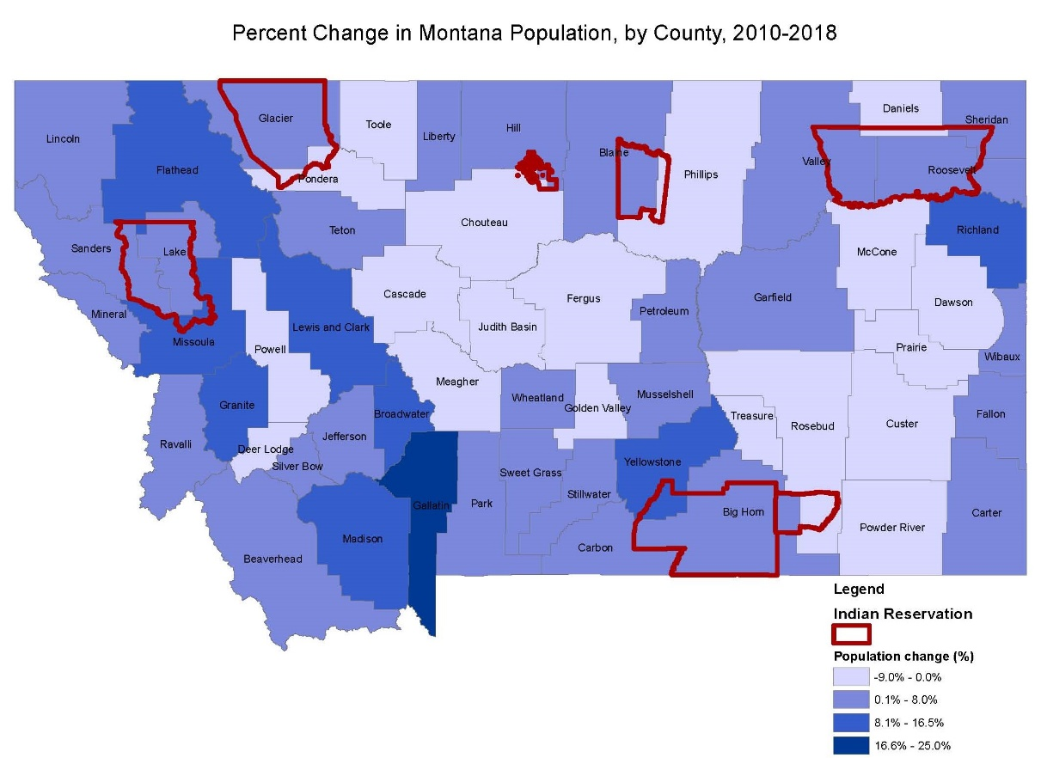

Figure 2-6. Range of percent change in population for Montana’s 56 counties. Tribal reservation boundaries are shown in red.

Health outcomes for Montana’s Native American? communities are worse than for other communities. For example, the rate of *premature* death is much higher for American Indians than for white residents (MTDPHHS 2017). The life expectancy for Montana American Indians is nearly 20 yr and rates of death from diabetes, cancer, heart disease, cirrhosis and injury are substantially higher than white residents (MTHCF undated). Table 2-2 compares the discrepancies in health outcomes for Montana’s different ethnic and racial groups (ref?).

|  |  |  |  |  |  |  |  |
| --- | --- | --- | --- | --- | --- | --- | --- |
| Table 2-2. Differences in health outcome measures among counties and racial/ethnic groups in Montana (table taken from ref). | | | | | | | |
|  | Healthiest MT county | Least healthy MT county | AI / AN * | Asian / PI * | Black | Hispanic | White |
| Premature death (yr lost/100,000) | 4900 | 21,000 | 19,400 | 2900 | 10,000 | 6800 | 6600 |
| Poor or fair health  (%) | 11% | 26% | 25% | NA* | NA* | 18% | 13% |
| Poor physical health (days, average) | 3.0 | 5.4 | 5.1 | NA* | NA* | 3.4 | 3.3 |
| Poor mental health (days, average) | 2.9 | 4.5 | 5.3 | NA* | NA* | 4.6 | 3.4 |
| Low birthrate  (%) | 5% | 7% | 9% | 10% | 12% | 8% | 7% |
| * AI = American Indian; AN = Alaskan Native; PI = Pacific Islander; NA = not applicable (data for all racial/ethnic groups may not be available due to small numbers) | | | | | | | |

Leading causes of death in Montana

The leading causes of death in Montana, in order of severity, are heart disease, cancer, respiratory disease, accidents, stroke, and suicide (CDC KK). Building from this knowledge, Montana’s State Health Improvement Plan identified five priority areas for focus (MTDPHHS 2020). We detail each of the five areas below, plus compare Montana to national averages in Table 2-3. Note that all declarations in the bullets that follow, unless otherwise credited, are derived from Montana’s State Health Improvement Plan (MTDPHHS 2020).

* *Behavioral health, including suicide prevention, depression, substance abuse, and opioid misuse.—*Suicide-related deaths in Montana are the highest per capita in the US —29.8 per 100,000 people—and twice the national average (World Population Review undated) . This rate is significantly higher in rural counties and in Native American populations. The path Montanan’s take toward suicide often includes depression and/or substance abuse. The number of adults treated with mental health illnesses in Montana between 2009 and 2013 was higher than the national average. One in ten Montana adults (nearly 84,000) report frequent mental distress with 14 or more days of poor mental or emotional health in the past month. In addition, nearly 64,000 Montana adults struggle with substance abuse. Alcohol is the most commonly abused substance in Montana, but opioids are the leading cause of drug-overdose deaths in Montana, accounting for 44% of all drug-overdose deaths.
* *Chronic disease prevention.—*Chronic disease in Montana is attributable in large part to smoking, obesity, physical inactivity, and poor nutrition. Tobacco use is the leading cause of preventable death, with 1600 tobacco-related deaths each year. Per capita, these deaths strike Montana’s American Indian population disproportionately (Campaign for Tobacco-free Kids 2017). Seventy-five percent of Montana adults and 72% of youth do not meet the national physical activity recommendations (MTOPI 2017). In addition, only 62% of Montanans are up to date with colorectal cancer screening (MTDPHHS 2016).
* *Healthy mothers, babies, and youth.—*Approximately 12,000 live births occur each year in Montana. In 2015, 32% of births in our state were unintended. Infant mortality in Montana is 5.7 per 1000 births for white populations, closely matching the rate for all races nationally of 5.8 per 1000 births. In contrast, infant mortality for American Indians in Montana is 10 per 1000 births (MTDPHHS 2017). This points to a disparity in birth outcomes for American Indians (CDCb undated).
* *Motor vehicle crashes.—*Motor vehicle crashes are one of the most common causes of fatal and non-fatal injuries in Montana. Multiple causes are at play: 1) From 2011–2016, 60% of all crash-related fatalities involved a driver impaired by alcohol or drugs (MTDPHHS 2020); 2) Young people living in rural Montana believe that drinking and driving is less dangerous in rural areas because there are fewer drivers on the road, but this is not the case (Greene et al. 2017); 3) Crashes associated with distracted driving—texting is a top cause—are also common. Although the rate of deaths due to crashes decreased from 27.1 to 19.4 per 100,000 people from 2004 to 2014, the rate in Montana is staggering compared to the national figure of 10.3 per 100,000 in 2014 (MTPHIS undated). It is higher among American Indians and for those living in rural rather than urban areas (MTDPHHS undated). 4) The non-governmental group Mothers Against Drunk Driving has declared Montana to have having the worst DUI laws in the nation (MADD 2019).
* Adverse childhood experiences.—The Center for Disease Control defines adverse childhood experiences as (CDCc undated)

*…potentially traumatic events that occur in childhood (0-17 years) such as experiencing violence, abuse, or neglect; witnessing violence in the home; and having a family member attempt or die by suicide. Also included are aspects of the child’s environment that can undermine their sense of safety, stability, and bonding such as growing up in a household with substance misuse, mental health problems, or instability due to parental separation or incarceration of a parent, sibling, or other member of the household.*

Adverse childhood experiences are directly related to negative outcomes in chronic disease, substance abuse, and mental health. In 2011, 60% of Montana adults reported having one or more adverse childhood experiences. That rate is similar to national trends, yet due to the established links between adverse childhood experiences and behavioral and health outcomes, this is an important area for health improvement in the state (CDCd undated). People with higher probability of encountering chronic disease and mental health issues are also vulnerable to climate-related health impacts, as detailed in Section 4.

|  |  |  |  |
| --- | --- | --- | --- |
| Table 2-3. Comparisons of Montana and US rate for incidence of five priority health issues. See text for a description of each issue. | | | |
| Priority health issue in Montana | Unit of measure | Montana rate | US rate |
| Suicide mortality1 | per 100,000 population | 28.9 | 14.0 |
| Chronic disease (e.g., asthma) | ?? | ?? | ?? |
| Infant mortality3 | per 1000 live births | 5.4 | 5.8 |
| Motor vehicle crash mortality4 | per 100,000 population | 17.1 | 11.2 |
| Adverse childhood experiences5 | % of adults experiencing one or more ACE | 60% | 61.5% |
| *1. https://www.cdc.gov/nchs/pressroom/states/montana/montana.htm*  *2. https://www.cdc.gov/nceh/information/state_factsheets/montana.htm*  *3.* [*https://www.cdc.gov/nchs/pressroom/states/montana/montana.htm*](https://www.cdc.gov/nchs/pressroom/states/montana/montana.htm) *;*  *4.* [*https://www.cdc.gov/nchs/pressroom/states/montana/montana.htm*](https://www.cdc.gov/nchs/pressroom/states/montana/montana.htm)  *5. Prevalence of adults experiencing 1 or more ACE Data source:* [*https://dphhs.mt.gov/ahealthiermontana/ACEs*](https://dphhs.mt.gov/ahealthiermontana/ACEs)*;* [*https://www.cdc.gov/violenceprevention/childabuseandneglect/acestudy/ace-brfss.html*](https://www.cdc.gov/violenceprevention/childabuseandneglect/acestudy/ace-brfss.html)  *Source:* [*https://www.cdc.gov/nchs/pressroom/states/montana/montana.htm*](https://www.cdc.gov/nchs/pressroom/states/montana/montana.htm) *;* [*https://dphhs.mt.gov/ahealthiermontana/ACEs*](https://dphhs.mt.gov/ahealthiermontana/ACEs)*;* [*https://www.cdc.gov/violenceprevention/childabuseandneglect/acestudy/ace-brfss.html*](https://www.cdc.gov/violenceprevention/childabuseandneglect/acestudy/ace-brfss.html) | | | |

Summary

The impact of climate change on human health in Montana is unique given, among many reasons, the state’s inland location, varied topography, and greatly differing access to health care available to its rural and urban populations. In the next section, we turn from the understanding created here to a more detailed exploration of current and potential health comes that are a result of our changing climate.

Literature Cited

Brimelow JC, Burrows WR, Hanesiak JM. 2017. The changing hail threat over North America in response to anthropogenic climate change. Nature Climate Change 7, 516-22.

Campaign for Tobacco-Free Kids. 2017. The toll of tobacco in Montana. ……. Retrieved from <https://www.tobaccofreekids.org/problem/toll-us/montana>.

CBS News. 2010 (Jun 1). Montana tornado rips roof off sports arena [news report]. Available online <https://www.cbsnews.com/news/montana-tornado-rips-roof-off-sports-arena/>. Accessed 1 Mar 2020.

[CDCa] Centers for Disease Control and Prevention. [undated]. Drought and health [website]. Available online <https://www.cdc.gov/nceh/drought/default.htm>. Accessed 1 Mar 2020.

[CDCb] Centers for Disease Control and Prevention. [undated]. Reproductive health: infant mortality [website]. Available online <https://www.cdc.gov/reproductivehealth/maternalinfanthealth/infantmortality.htm>. Accessed 1 Mar 2020.

[CDCc] Centers for Disease Control and Prevention. [undated]. Violence prevention: adverse childhood experiences (ACEs) [website]. Available online <https://www.cdc.gov/violenceprevention/childabuseandneglect/acestudy/index.html>. Accessed 1 Mar 2020.

[CDCd] Centers for Disease Control and Prevention. [undated]. Violence prevention: behavioral risk factor surveillance system ACE data [website]. Available online https://www.cdc.gov/violenceprevention/childabuseandneglect/acestudy/ace-brfss.html. Accessed 1 Mar 2020.

Clarke L, Edmonds J, Jacoby H, Pitcher H, Reilly J, Richels R. 2007. Scenarios of greenhouse gas emissions and atmospheric concentrations. Sub-report 2.1a of synthesis and assessment product 2.1 by the US Global Change Science Program and the Subcommittee on Global Change Research. Washington DC: Department of Energy, Office of Biological & Environmental Research. 164 pp. Available online <http://www.climatescience.gov/Library/sap/sap2-1/finalreport/default.htm>. Accessed 15 September 2019.

Collins M, Knutti R, Arblaster J, Dufresne J-L, Fichefet T, Friedlingstein P, Gao X, Gutowski WJ, Johns T, Krinner G, Shongwe M, Tebaldi C, Weaver AJ, Wehner M. 2013. Long-term climate change: projections, commitments and irreversibility. In: Climate Change 2013: The Physical Science Basis. IPCC Working Group I Contribution to AR5, Stocker TF, Qin D, Plattner G-K, Tignor M, Allen SK, Boschung J, Nauels A, Xia Y, Bex V, Midgley PM, eds. Cambridge University Press, pp. 1136.

Diffenbaugh NS, Scherer M, Trapp RJ. 2013. Global warming and severe thunderstorms. Proceedings of the National Academy of Sciences 110, 16361-16366; DOI:10.1073/pnas.1307758110.

Durch JS, Bailey LA, Stoto MA, eds. 1997. Measurement tools for community health improvement process [chapter]. In: Improving health in the community: a role for performance monitoring. Washington DC: [National Academies Press,](http://www.nap.edu/) Institute of Medicine, Committee on Using Performance Monitoring to Improve Community Health. Available online https://www.ncbi.nlm.nih.gov/books/NBK233014/. Accessed 1 Mar 2020.

Guardian. 2019. Summer heatwaves in France killed 1500, says health minister [article]. Available online <https://www.theguardian.com/world/2019/sep/09/summer-heatwaves-in-france-killed-1500-says-health-minister>. Accessed 1 Mar 2020.

Greene K, Rossheim M, Murphy S. 2017. Drinking and driving in the Big Sky state: key insights from young adults. CAIRHE, MSU

Headwaters Economics. 2019. Populations at risk [website]. Available online <https://headwaterseconomics.org/tools/populations-at-risk/>. Accessed 28 Feb 2020.

Howe PD, Mildenberger M, Marlon JR, Leiserowitz A. 2015. Geographic variation in opinions on climate change at state and local scales in the USA. Nature Climate Change 5:596–603. [doi:10.1038/nclimate2583](http://www.nature.com/nclimate/journal/vaop/ncurrent/full/nclimate2583.html).

Ingram DD, Franco SJ. 2013 NCHS urban–rural classification scheme for counties [report]. Hyattsvill MA: US Department of Health and Human Service, National Center for Health Statistics. Vital and Health Statistics 2(166). 81 p. Available online <https://www.cdc.gov/nchs/data/series/sr_02/sr02_166.pdf>. Accessed 29 Feb 2020.

Jensco K, Parker B, Downey M, Hadwen T, Howell A, Rattling Leaf J, Edwards L, and Akyuz A, Kluck D, Peck D, Rath M, Syner M, Umphlett N, Wilmer H, Barnes V, Clabo D, Fuchs B, He M, Johnson S, Kimball J, Longknife D, Martin D, Nickerson N, Sage J, Fransen T. 2019. Flash Drought: Lessons Learn from the 2017 Drought Across the U.S. Northern Plains and Canadian Prairies. National Atmospheric and Oceanic Agency, National Integrated Drought Information System. Available online <https://www.drought.gov/drought/sites/drought.gov.drought/files/NIDIS_LL_FlashDrought_2017_low-res_Final.pdf>. Accessed 15 September 2019.

[MADD] Mothers Against Drunk Driving. 2019. MADD Report Rates Every State on Drunk Driving Laws [website]. Available online https://www.madd.org/press-release/madd-report-rates-every-state-on-drunk-driving-laws/. Accessed on 1 Mar 2019.

Martin C, Doyle J, LaFrance J, Lefthand MJ, Young SL, Three Irons E, Eggers M. 2020. Change rippling through our waters and culture. Journal of Contemporary Water Research and Education. In review (accepted pending minor revisions).

[MCO] Montana Climate Office. 2019. Montana Climate & Drought, April 2019 Newsletter. Available online <https://climate.umt.edu/mtdrought/mtdrought-2019-april.pdf>. Accessed 15 September 2019.

McWethy DB, Schoennagel T, Higuera PB, Krawchuk M, Harvey BJ, Metcalf EC, Schultz C, Miller C, Metcalf AL, Buma B, Virapongse A, Kulig JC, Stedman RC, Ratajczak Z, Nelson CR, Kolden C. 2019. Rethinking resilience to fire. Nature Sustainability. doi:10.1038/s41893-019-0353-8.

[MTDPHHS] Montana Department of Public Health and Human Services. [undated]. Priority area 3: motor vehicle crashes [website]. Available online <https://dphhs.mt.gov/ahealthiermontana/mvcs>. Accessed 1 Mar 2020.

[MTDPHHS] Montana Department of Public Health and Human Services. 2016. 2016 Montana behavioral risk factor surveillance system annual report [report]. Helena MT: Montana DPHHS, Office of Epidemiology and Scienctific Support. 46 p. Available online <https://dphhs.mt.gov/Portals/85/publichealth/documents/BRFSS/Annual%20Reports/BRFSS_Annual_Report_2016.pdf>. Accessed 1 Mar 2020.

[MTDPHHS] Montana Department of Public Health and Human Services. 2017. Trends in Infant Mortality, Montana 2006-2015 [report]. Helena MT: Montana DPHHS, Office of Epidemiology and Scientific Support. 4 p. <https://dphhs.mt.gov/Portals/85/publichealth/documents/Epidemiology/VSU/VSU_InfantMortality_2006_2017.pdf>. Accessed 1 Mar 2020.

[MTDPHHS] Montana Department of Public Health and Human Services. 2020. Montana state health improvement plan 2109-2023 [report]. Helena MT: Montana DPHHS. 35 p. Available online <https://dphhs.mt.gov/Portals/85/ahealthiermontana/2019SHIPFinal.pdf>. Accessed 1 Mar 2020.

[MFWP] Montana Fish, Wildlife, and Parks. 2016 (Aug 19). Yellowstone River closed in response to ongoing fish kill [press release]. Available online http://fwp.mt.gov/news/newsReleases/headlines/nr_4277.html. Accessed 1 Mar 2020.

[MTHCF] Montana Healthcare Foundation. [undated] Improving the health and well-being and reducing disparities in health and life expectancy among American Indian people in Montana [webpage]. Available online <https://mthcf.org/focus-areas/american-indian-health-2/health-disparities/>. Accessed 1 Mar 2020.

[MTOPI] Montana Office of Public Instruction. 2017. Montana youth risk behavior survey ………….

[MTPHIS] Montana Public Health Information System. [undated]. ……….. <http://ibis.mt.gov/indicator/view/InjuryMVCDeath.Year.MT_US.html>

[NIDIS] National Integrated Drought Information System. [undated] ……. Website Drought.gov; page is called “Dought in Montana”. ……. <https://www.drought.gov/drought/states/montana>

[NOAAa] National Oceanic and Atmospheric Agency. [undated]. National Oceanic and Atmospheric Research Agency: What's the Difference Between Weather and Climate? Available online https://www.nasa.gov/mission_pages/noaa-n/climate/climate_weather.html. Accessed 15 September 2019.

[NOAAb] National Oceanic and Atmospheric Agency. [undated]. National Oceanic and Atmospheric Agency, National Centers for Environmental Information: U.S. Climate Divisions. Available online <https://www.ncdc.noaa.gov/monitoring-references/maps/us-climate-divisions.php>. Accessed 15 September 2019.

[NOAAc] National Oceanic and Atmospheric Agency. [undated]. National Oceanic and Atmospheric Agency, National Centers for Environmental Information: Climate at a Glance. Available online <https://www.ncdc.noaa.gov/cag/statewide/time-series>. Accessed 15 September 2019.

[NOAAd] National Oceanic and Atmospheric Agency. [undated]. National Oceanic and Atmospheric Agency, National Weather Service: Flooding in Montana. Available online <https://www.weather.gov/safety/flood-states-mt>. Accessed September 2019.

[NOAAe] National Oceanic and Atmospheric Agency. [undated]. National Oceanic and Atmospheric Agency, National Centers for Environmental Information: Billion-dollar weather and climate disasters: overview. Available online <https://www.ncdc.noaa.gov/billions/> Accessed 15 September 2019.

[NOAA] National Oceanic and Atmospheric Agency. 2010. Billings tornado of June 20, 2010: overview [internal report]. 3 p. Available online https://www.wrh.noaa.gov/byz/local_news/2010/BillingsTornado10.pdf. Accessed 1 Mar 2020.

Rural Health Info.[undated]. ………………. <https://www.ruralhealthinfo.org/rural-maps/mapfiles/frontier.jpg>

Schoennagel T, Balch J, Brenkert-Smith H, Dennison P, Harvey B, Krawchuk M, Morgan P, Moritz M, Rasker R, Turner GG, Whitlock C. 2017. Adapt to more wildfires in western North American forests as climate changes. Proceedings of the National Academy of Sciences 114, 4582-4590.

Seeley JT, Romps DM. 2015. The effect of global warming on severe thunderstorms in the United States. Journal of Climate 28, 2443-58.

[UCS] Union of Concerned Scientists. 2019. Killer heat in the United States; climate choices and the future of dangerously hot days [report]. Dahl K, Spanger-Siegfried E, Licker R, Caldas A, Abatzoglou J, Mailloux N, Cleetus R, Udvardy S, Declet-Barreto J, Worth P, authors. Available online <https://www.ucsusa.org/sites/default/files/attach/2019/07/killer-heat-analysis-full-report.pdf>. Accessed 15 September 2019.

US Census Bureau. 2010. State population by characteristics: 2010-2018 [webpage]. Available online <https://www.census.gov/data/tables/time-series/demo/popest/2010s-state-detail.html#par_textimage_785300169>. Accessed 30 Oct 2019.

[USGCRP]. 2017.Climate Science Special Report: Fourth National Climate Assessment, Volume 1, Wuebbles DJ, Fahey DW, Hibbard, DJ, Dokken DJ, Stewart BC, Maycock TK, eds. US Global Change Research Program, Washington DC 470 pp. doi:10.7930/joj964j6.

US Census Bureau. 2018. Population and housing unit estimates [webpage]. Available online https://www.census.gov/programs-surveys/popest.html. Accessed 29 Feb 2020.

Whitlock C, Cross W, Maxwell B, Silverman N, Wade AA. 2017. 2017 Montana Climate Assessment. Bozeman and Missoula MT: Montana State University and University of Montana, Montana Institute on Ecosystems. 318 pp. DOI:10.15788/m2ww82. Available online <http://montanaclimate.org>. Accessed September 2019.

[WCRP] World Climate Research Program. [undated]. WCRP Climate Model Intercomparison Project. [https://www.wcrp-climate.org/wgcm-cmip. Accessed 15 September 2017](https://www.wcrp-climate.org/wgcm-cmip.%20Accessed%2015%20September%202017).

World Population Review.[undated]. Suicide rates by state [website]. Available online <http://worldpopulationreview.com/states/suicide-rates-by-state/>. Accessed 1 Mar 2020.

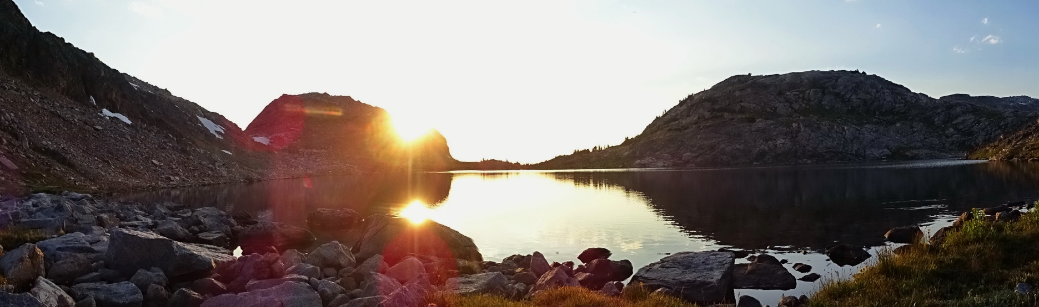

Section 3. Climate-Change Related Health Impacts  
**—** Rob Byron, Bruce Maxwell, Nicholas Silverman, Phil Higuera, and Madison Boone

As described in the previous section, rising global temperatures are driving complex changes in atmospheric and ocean circulation. The results of those changes—e.g., increases in spring flooding, late-summer drought, extreme weather events, and forest fires, more frequent and intense heat waves, and spread of infectious diseases—are recognized for their potential to impact human health. Indeed, climate change is *already* adversely impacting the health of Americans and those negative impacts are expected to increase over coming decades (Ebi et al. 2018a). Montanans are included among those being affected, with climate change impacts expected to increase into the future based on temperature projections for Montana (Whitlock et al. 2017).

Exposure Pathways and Health Outcomes

Figure 3-1 depicts how climate pressures, following multiple exposure pathways, lead to specific health outcomes for people. Those outcomes, discussed throughout this section, include heat-related illness, vector-borne diseases, mental health impacts, physical trauma, injuries, and death, respiratory, cardiovascular, and gastrointestinal conditions, and adverse effects on pregnancies and birth outcomes.

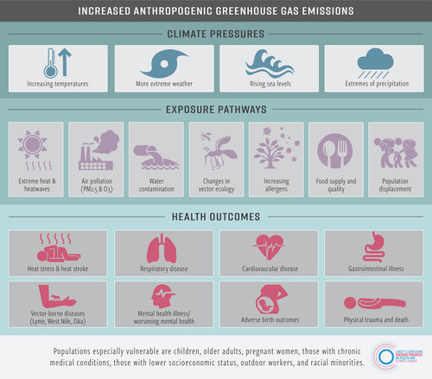

Figure 3-1. Ways climate change is harming human health. (Lancet Countdown 2018, Salas, et al)Specific human response data connecting heat and smoke to human health is limited for Montana. A comprehensive assessment of the impacts of climate change on human health *for the US* concluded that climate change exacerbates existing climate-sensitive health threats and creates new challenges, exposing more people in more places to hazardous weather and climate conditions (Ebi et al. 2018a). Most people in Montana identify the increase in smoky days in summer as evidence of changing climate conditions causing more wildfire activity and associated health impacts. Less obvious, but potentially just as dangerous, is the increase in hot summer days and nights leading to a range of health issues.

Outside of Montana, human response data is more readily available, for example:

* An increase in climate-related extreme events has led to an increase in the number of emergency room visits and hospital admissions in the US (Ebi et al. 2018a).
* Warmer and drier conditions during summer have contributed to longer fire seasons in the western US (Westerling 2016; Dalton et al. 2017). Smoke events during 2004–2009 were associated with a 7.2% increase in respiratory hospital admissions among adults over 65 in the western United States (Liu et al. 2017).
* In Boise, Idaho, seven of the last 10 years have included smoke levels considered “unhealthy for sensitive groups” (including children) for at least a week during the fire season (IDDEQ 2013), causing some cancellation of school-related sports activities (USGCRP 2018).
* From 1990-2010, heat-related hospital admissions were 2% higher and deaths 10% higher than the average for extreme heat events in King County, Washington (Isaksen et al. 2015; Isaksen et al. 2016). As a result, demand for emergency medical services for children, the elderly, and outdoor laborers increased (Calkins et al. 2016).
* The state of Oregon has also recorded spikes in heat-related emergency room visits (Oregon Health Authority 2019).

Climate-driven hardships can also affect mental health, resulting in outcomes ranging from stress to suicide (Clayton et al. 2017). Although not specifically linked to climate change, Montana, Oregon, Washington, and Idaho all rank among the top ten states in terms of prevalence of mental illness and lowest access to mental health care (Hellebuyck et al. 2018). Income loss associated with climate impacts will likely increase the risk of people experiencing food insecurity (Oregon Health Authority 2014). American Indian tribes and Indigenous peoples face multiple physical and mental health challenges related to climate change, with impacts to subsistence and cultural resources (Ebi et al. 2018b). Tracking climate stressors and training related to climate anxiety and post-disaster trauma is *not* widespread among the Montana health workforce (Doppelt 2016).

|  |  |
| --- | --- |
|  | Sidebar: Climate Change and Mental Well-being— Perspectives from Montana Farmers and Ranchers |
| Meredith Howard, Selena Ahmed, Paul Lachapelle, and Mark B. Schure |
| While the physical and economic implications of climate change are studied widely, including effects on agricultural systems, the consequent mental health implications have largely been overlooked. As farmers and ranchers support local, national, and global food security, they represent an especially vulnerable and critical population to support. Montana State University researchers* surveyed farmers and ranchers (n=125) in Montana using a mixed-method approach to investigate the relationship between climate change perceptions and mental well-being. Survey results revealed the following:   * The majority of respondents (72%) agreed that climate change is having an adverse effect on their farm/ ranch. * Nearly three quarters of respondents reported feeling moderate to high levels of anxiety when thinking about climate effects on their agricultural business. * The greater the reported perceived risk regarding climate change, the greater the level of reported anxiety. * The impact of climate change on farm/ranch profitability was perceived as a main cause of distress.   Qualitative results provided in-depth perspectives regarding climate change and mental well-being of Montana producers. One respondent commented, “(I am) worried about crop losses of current and future years, and about where funds will come for dealing with climate change on the farm. As with most, my worries generally stem from financial stress.”  Another respondent shared, “Climate change contributes to my distress because it makes planning for long-term crops more difficult and predicting weather patterns less predictable.”  Public health preparedness efforts are warranted to provide mental health support for the agricultural sector. Research and outreach efforts are further called for to promote the adoption of practices that mitigate climate risk and enhance personal and food system resilience. Linkages of climate-induced anxiety to demographic challenges of an increasingly aging and female farm and ranch population should also be studied. Policy discussions at various scales should be considered to address financial risk to agricultural enterprises in the face of increased climate variability.  -------  * From Howard M, Ahmed S, Lachapelle P, Schure MB. Farmer and rancher perceptions of climate change and their relationships with mental health. Journal of Rural Mental Health. Forthcoming. |

Climate change is expected to increase atmospheric particulate matter mainly due to more frequent and longer droughts that lengthen the wildfire season (Jenkins et al. 2014), increase ignitable fuels and result in larger wildfires (Norby et al. 2010; Jolly et al. 2015; Abatzoglou and Williams 2016) and thus, more smoke. Projections of precipitation changes in Montana, although with moderate uncertainty, indicate that wetter and earlier springs can increase wildfire fuel and if followed by mid-summer drought can increase fire frequency. Particulate matter is also expected to increase in eastern Montana as dust emissions in agricultural areas where more land gets tilled for crops (Gage et al. 2016) and tillage is a common summer fallow practice (Cook et al. 2014; Dawson et al. 2014).

Extreme Heat in Montana

Climate change is increasing the intensity and frequency of heat waves (Meehi and Tebaldi 2004; Reid et al. 2009). Globally, 157 million more people were exposed to extreme heat in 2017 than in 2000 (Watts et al. 2018). Assuming no changes in current emissions, the Union of Concerned Scientists projects that by mid century “the number of people [in the United States] experiencing 30 or more days with a heat index above 105°F in an average year will increase from just under 900,000 to more than 90 million—nearly one-third of the US population” (UCS 2019).

Multiple studies have demonstrated increased mortality associated with heat waves (Knowlton et al. 2009; Ostro et al. 2009; Isaksen et al. 2016), which is the major cause of weather-related deaths in the United States (NWS undated). Gubernot et al. (2015) found that people who work in agriculture or construction jobs have the highest risk for heat-related death; that risk may be even higher for small businesses that have no backup personnel. This finding should cause Montanans concern given that agriculture and construction make up important parts of our state’s economy.

Human impacts from excessive heat

Heat affects humans in a variety of ways, impinging on multiple body systems. As depicted in Figure 3-2, elevated temperatures can directly cause heat-related conditions ranging from muscle cramps to heat exhaustion to heat stroke, the latter of which is deadly if not treated promptly (Becker and Stewart 2011; Epstein and Yanovich 2019). In addition, elevated temperatures have been associated with increases in respiratory disease (Anderson et al. 2013; Ho et al. 2015); heart disease and strokes (Knowlton et al. 2009; Wang et al. 2016; Achebak et al. 2018); and fluid and electrolyte disorders, kidney disease, and kidney failure (Bobb et al. 2014; Ross et al. 2018; Sorensen and Garcia-Trabanino 2019). Elevated temperatures are also associated with increased risk of preterm labor (Auger et al. 2014; Ha et al. 2016; Avalos et al. 2017), as well as sudden infant death/sudden unexpected infant death syndromes (SIDS/SUID) (Jhun et al. 2017). Elevated temperatures can also cause worsening mental status, as described in a subsequent subsection.

The health effects of extreme heat are influenced by the severity and duration of high temperatures. Simultaneous effects of air pollution and population vulnerability (Basu 2009) can compound the effects. Typical temperatures to which the population is exposed, plus the extent that they are adapted to the conditions, may modify that vulnerability (Curriero et al. 2002; Baccini et al. 2008; Ho et al. 2015).

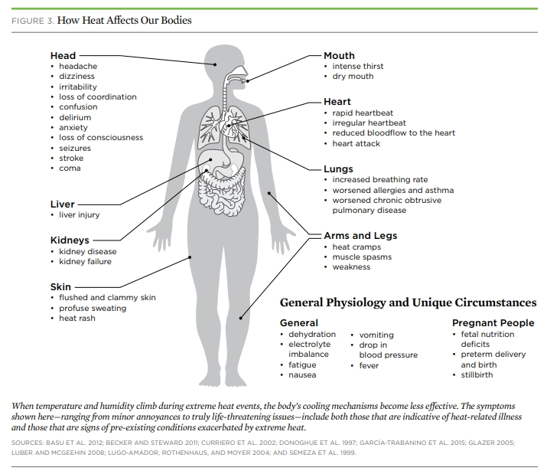

Figure 3-2. Killer heat in the United States: climate choices and the future of dangerously hot days. Figure used with permission from The Union of Concerned Scientists (UCS 2019).

Workers, especially those who work outdoors or in hot indoor environments, are at increased risk of heat stress and other heat-related disorders, occupational injuries, and reduced productivity at work (Levy and Roelofs 2019). Agricultural labor, more prevalent in heat vulnerability assessments in rural areas, can expose workers to increased risk of heat strain and dehydration[7] due to repeated exposures to high ambient temperatures, arduous physical exertion, and limited fluid intake. These risk factors may result in acute kidney injury (Moyce et al. 2017), as well as increased risk for heat-related traumatic injuries (Spector et al. 2016). Combining heat-related illness and injury prevention efforts should be considered for high-risk populations exposed to warm ambient conditions and high physical exertion (Spector et al. 2016).

Spector et al. (2016) suggest that increased ambient temperature may increase workers’ exposure to hazardous chemicals and the adverse effects of those chemicals on their health. Global warming will influence the distribution of weeds, pathogens, and insect pests and will introduce *new* pests (Whitlock et al. 2017), all of which could change the types and amounts of pesticides used, thereby affecting the health of agricultural workers and others. In addition, global warming is increasing a) ground-level ozone concentrations with adverse effects on outdoor workers, and b) extreme weather events that pose injury risks to rescue and recovery workers (Levy and Roelofs 2019).

Assessing heat impacts in Montana

Multiple studies—covering wide ranges of temperature, time, and geographic area—have sought to assess the health impacts of extreme heat (e.g., Morabito et al. 2014; Zhang et al. 2014). Some studies estimate how heat-related mortality differs between rural and urban landscapes (reviewed by Ho et al. 2015). Other studies develop indices to locate heat vulnerable populations (Vescovi etal. 2005; Reid et al. 2009; Reid et al. 2012; Chuang and Gober 2015).

In addition, several computer models and thermal comfort indices, described below, have been developed (cited and reviewed by Mills et al. 2016). Such models have become increasingly sophisticated, including incorporating the ability of populations to acclimate to extreme heat (Fiala et al. 2001; WMO 2004). However, applying this approach requires information that is not routinely available (e.g., long-wave radiation) and has focused on urban conditions that are not widely relevant to Montana.

Although thermal comfort indices may be based on complex models—especially when modeling environmental stress during extreme conditions—some rely on simple measures (Mills et al. 2016). The Universal Thermal Comfort Index, for example, is based physiological heat balance models with simple-to-obtain dry temperatures as model input (Zare et al. 2018). The Universal Thermal Comfort Index is designed to be applicable in all seasons and climates, and for all spatial and temporal scales (Bröde et al. 2012). The top five Universal Thermal Comfort Index categories[8] are often used with downscaling of regional climate data, mostly in urban settings.

We first mapped heat across Montana based on the historic highest average daily land surface temperatures recorded for each county over the recording period (~100 years), represented by the 95th percentile value (Figure 3-3).

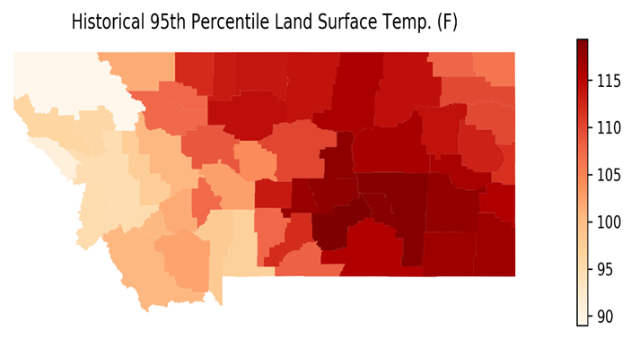

Figure 3-3. The 95th percentile historical land surface temperatures for each county in Montana, for the period of xxxx-yyyy. The scale to the right shows temperature in oF.

To localize assessment of extreme temperatures we examined daily temperature data from 38 NOAA weather stations across Montana[9]. We determined the maximum and minimum temperature trends in summer months (June, July and August) at each station. The trend in summer minimums relate to night temperatures, which place a particular burden on the human thermoregulatory system, particularly for those who are elderly and those who rely on natural ventilation to reduce body temperature (Mills et al. 2016). The number of continuous days and nights at high temperatures accumulates potential negative impact on people. Fifteen out of the 38 stations across Montana indicated an increasing trend in summer (June, July, August) maximum temperatures over the last 30 years (Figure 3-4). The eastern most stations showed no trend in maximum temperatures. No stations had a negative trend in maximum summer temperatures over the last 30 years (1990-2019). Summer nighttime minimum temperatures showed an increasing trend at 15 of the 38 stations and a decreasing trend at four stations from 1990 to 2019 (Figure 3-5). All of the decreasing trends in summer nighttime temperatures were in western Montana. Five of the 15 increasing summer maximum temperatures were also stations indicating increasing trends in summer nighttime temperatures and three of those five were in urban centers that are more likely to hold heat at night following hot days.*

|  |  |
| --- | --- |
| Related image | *The number of continuous days and nights at high temperatures accumulates potential negative impact on people. Fifteen out of the 38 stations across Montana indicated an increasing trend in summer (June, July, August) maximum temperatures over the last 30 years (Figure 3-4). The eastern most stations showed no trend in maximum temperatures. No stations had a negative trend in maximum summer temperatures over the last 30 years (1990-2019).* |

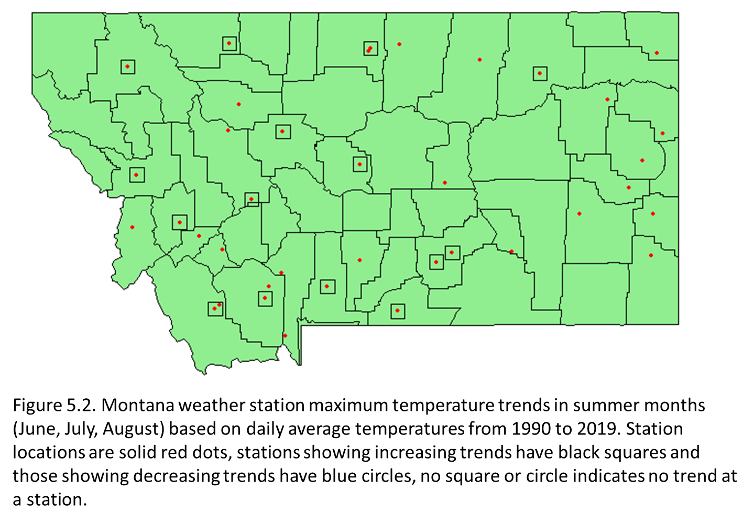

Figure 3-4. Montana weather station maximum temperature trends in summer months (June, July, August) based on daily average temperatures from 1990-2019. Station locations are solid red dots. Stations showing increasing trends have black squares and those showing decreasing trends have blue circles. No square or circle indicates no trend at a station.

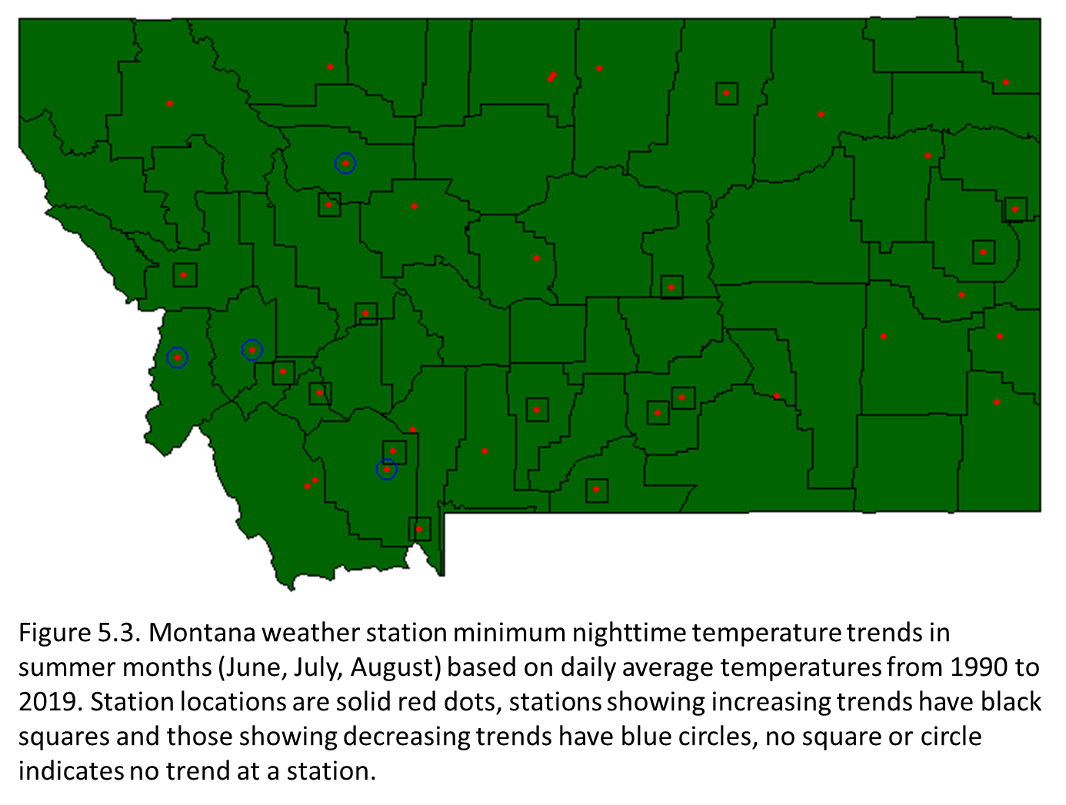

Figure 3-5. Montana weather station minimum nighttime temperature trends in summer months (June, July, August) based on daily average temperatures from 1990-2019. Station locations are solid red dots. Stations showing increasing trends have black squares and those showing decreasing trends have blue circles. No square or circle indicates no trend at a station.

Trends in winter (December, January, February) minimum temperatures at weather stations indicated an increasing trend at only two of 38 stations, both in southwestern Montana, and four stations showed decreasing trends in winter minimum temperatures from 1990-2019 (Figure 3-6). When the number of years of data was increased to 50 (1970-2019), 11 out of 35 stations showed an increasing trend in winter minimum temperatures spread across the state and there were no stations indicating a decreasing trend. Thus, the time span for analysis can influence the trend analysis, as can the months included in a season. For example, when winter was expanded to include December and March 13 out of 15 weather stations showed winter low temperatures with an increasing trend.

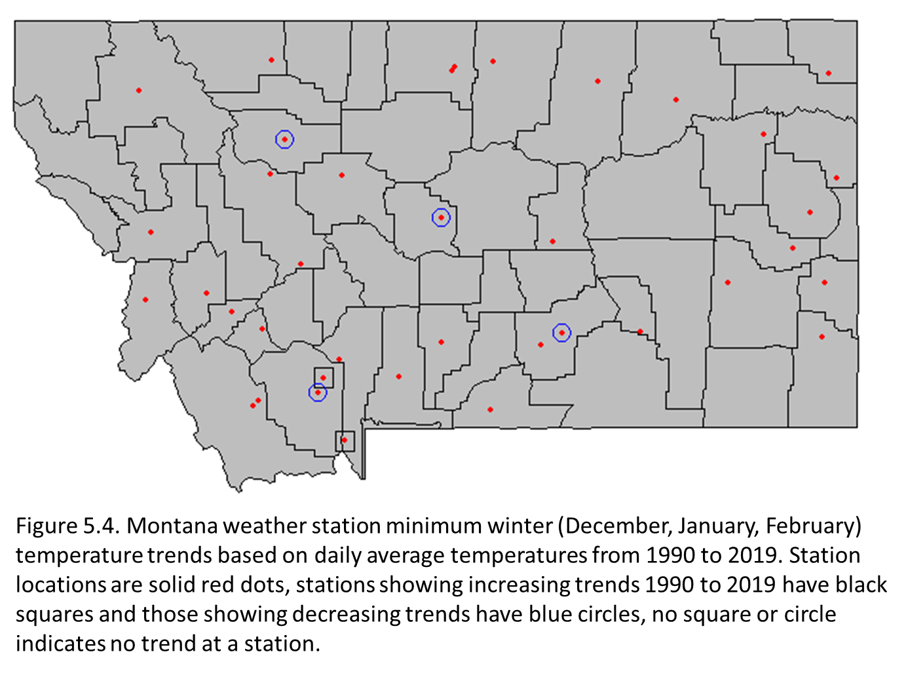

Figure 3-6. Montana weather station minimum winter (December, January, February) temperature trends based on daily average temperatures from 1990-2019.Station locations are solid red dots. Stations showing increasing trends 1990-2019 have black squares and those showing decreasing trends have blue circles. No square or circle indicates no trend at a station.

Increasing temperature trends over the last 30 yr at individual weather stations were not limited to the larger cities in Montana where heat islands[10] might be most common. Small rural towns are also vulnerable to increasing heat, and many include citizens highly vulnerable to extreme conditions. The number of summer days with maximum temperatures over 90oF is projected to increase by up to 35 days by mid-century (Whitlock et al. 2017).

Human population heat vulnerability has been quantified and mapped, but only a few studies have *combined* heat vulnerability information with data on heat exposure to evaluate the health risks associated with extreme heat (Tomlinson et al. 2011; Buscail et al. 2012; Ho et al. 2015; Morabito et al. 2015). Identification of heat risk hot spots (heat islands) can be used to guide heat mitigation interventions, such as establishment of green or reflective roofs, urban parks, and water features. Most heat health risk studies have aggregated data to match spatial units employed by the US Census Bureau, from which vulnerability information is typically derived (Ho et al.2015).

One of us (Silverman) used satellite imagery to map the dry land surface temperature, then overlaid a set of socioeconomic variables to better identify the counties most at risk to extreme temperatures. We used a modification of the high temperature vulnerability metrics described by Ho et al. (2015) based on data available and more appropriate for Montana. We used US Census Bureau surveys, recorded age, income level, and type of housing that would help determine susceptibility to heat impacts (Figure 3-7).

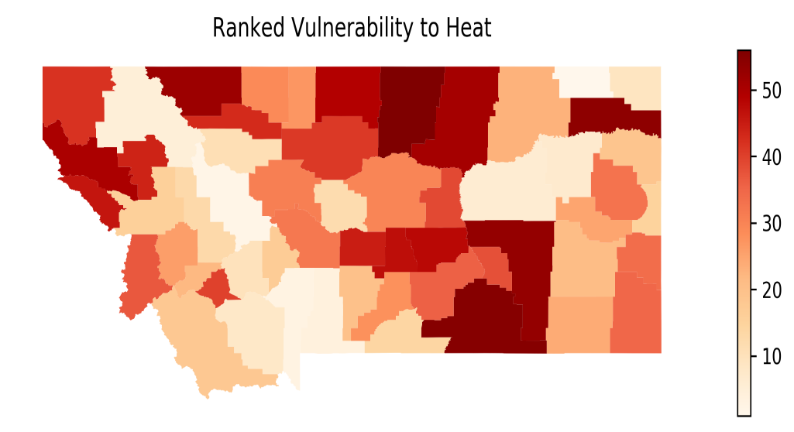

Figure 3-7. Montana counties ranked by heat vulnerability index for humans (the higher the index value or darker the shading the more vulnerable). Vulnerability was based on a combination of the top 5% land surface temperatures in each county, the average income for people in the county, the percent of county population under a poverty line, the percent of poverty households with children, the percent of population employed in construction and production (implying predominantly outdoor workers with greatest exposure to heat), and percent of population unemployed, all from the 2016 US Census (ref?). The temperatures were weighted higher than the socioeconomic factors used to create the vulnerability index.

|  |  |  |  |  |
| --- | --- | --- | --- | --- |
|  | |  |  |  | | --- | --- | --- | |  | Sidebar: Which is More Deadly—Extreme Heat or Extreme Cold? |  | |
| This seemingly simple question actually has no clear answer. One might think that warmer conditions in Montana’s future would result in fewer cold-temperature-related deaths, but is that true?  Temperature extremes in both directions kill hundreds of people in the US each year, but determining the actual death toll is subject to large errors. Two US agencies, using different methods and datasets, came to opposite conclusions about which is more deadly:   * NOAA’s monthly publication Storm Data (NOAAa). regularly reports many more deaths per year as heat-related than as cold-related (NOAAb) . For example, their annual summary for 2011 indicates 206 deaths from extreme heat versus 29 from extreme cold. * The Center for Disease Control’s National Center for Health Statistics analyzed death certificates in the US and came to the opposite conclusion—twice as many people die of “excessive cold” conditions than of “excessive heat” (Berko et al. 2014). About 1300 deaths per year from 2006-2010 were coded as resulting from extreme cold exposure, whereas 670 deaths per year were attributed to extreme heat.   The different findings result, at least in part, on whether the focus is on acute or short-term responses to extreme weather or, alternatively, seasonal differences in estimates of daily mortality. Abnormally cold conditions may have little effect on estimates of daily mortality; for example, deaths in winter increase as a result of non-weather-related diseases, like influenza. In addition, a recent study noted that a large majority of cold-related deaths occur under moderately cold conditions, so a reduction in extreme cold due to global warming is not expected to cause a large reduction in cold-related deaths (Gasparrini et al. 2015). It is also widely accepted that direct attribution (in medical records) of cause of death underestimates the number of people who die from temperature extremes (USGCRP 2016). For example, a person who dies from a heart attack that resulted from heat or cold exposure is listed only as having died from a heart attack, even though extreme temperature exposure may have hastened or triggered the heart attack.  Looking to the future, the Fourth National Climate Assessment found that under an upper-bound (RCP8.5) emissions scenario we should expect a large increase in US extreme temperature deaths. In 49 large US cities, representing one-third of the nation’s population, the report projected that changes in extreme hot and extreme cold temperatures would result in 9300 additional premature deaths per year by 2090, at a cost of $140 billion per year in 2015 dollars (Ebi et al. 2018a). Since the study only covered populations in large cities, Montana was not included. These mortality estimates may be reduced through adaptation efforts, like acclimatization programs (e.g., ensuring adequate heating and cooling systems, improved insulation). The report also considered the reduction in extreme cold deaths expected in a warmer climate; approximately 100 fewer cold deaths per year were expected in the US by 2050, with no further reduction in cold deaths between 2050 and 2090 (Ebi et al. 2018a)  The bottom line is that high and low temperature extremes affect vulnerable populations, such as the unwell, the poor, the young, and the elderly, among others. Understanding the extreme-temperature risk for the future requires additional in-depth study of the interaction between temperature-related deaths and socioeconomic factors. With additional information, can we avoid adverse policy outcomes and achieve effective adaptation strategies. |

## Air Quality and Climate Change

Human health concerns related to air quality are, in a large part, due to particulate matter and ground level ozone, as described below:

* *Particulate matter (PM)—*especially PM2.5, or particulates under 2.5 micrometers in size—has been associated with multiple health effects, including cardiovascular, respiratory, and immunological, the latter manifesting as increased risk for pneumonia (Rappold et al. 2011; Reid et al. 2016; Tinling et al. 2016). Additionally, particulate matter has been found to cross the placenta in pregnant women (Bové et al. 2019), and has been associated with preterm birth (DeFranco et al. 2016; Trasande et al. 2016) and low birth weight (Fleischer et al. 2014).
* *Ground level ozone*, formed primarily when sunlight acts on nitrous oxides and volatile organic compounds, has been associated with asthma exacerbations, increased hospitalizations, and premature mortality (Bell et al. 2004; Zanobetti and Schwartz 2008; Di et al. 2017), as well as with preterm birth (Olsson et al. 2013).

Both particulate matter and ground level ozone are expected to increase with climate change. In Montana, ozone levels are generally low, but particulate matter levels potentially elevated. Eight counties in Montana, for example, received grades of “F” for particulate matter in the American Lung Association report *State of the Air 2018* (American Lung Association 2018).[11] Wildfires can provide significant contributions to high levels of particulate matter. In addition, some local areas have elevated particulate matter levels during winter months due to inversion layers in combination withand high woodstove usage.

Wildfires and Wildfire Smoke

Between 1997-2006 an annual global count of 339,000 deaths has been attributed to wildfires (Johnston et al. 2012). Deaths and injuries can occur to people caught in fast-moving fires, as well as among emergency response personnel, firefighters, and others assisting with fire management. Wildfires can result in large-scale, temporary evacuations, or permanent displacement following the destruction of homes or even entire towns (Insurance Information Institute undated). The November 2018 Paradise Fire in California, for example, killed 85 people, displaced hundreds, and destroyed over 18,000 buildings (Vox 2019).

Wildfire smoke, which can extend far beyond the immediate fire area, contains many contaminants hazardous to human health. Those substances include particulate matter, polyaromatic hydrocarbons, carbon monoxide, nitrous oxide, aldehydes, benzene, and more (Naeher et al. 2010; Reisen et al. 2015; Ammann et al. 2001; Dennis et al. 2002; Lighty et al. 2000; Sapkota et al. 2005). Exposure to wildfire smoke can result in emergency departments for a variety of conditions, newly caused or agitated, including respiratory conditions like asthma and chronic obstructive pulmonary disease (Rappold et al. 2011; Reid et al. 2016; Tinling et al. 2016; Cascio, 2018); cardiovascular conditions, including stroke, heart attack, and heart failure (Wettstein et al. 2018); and cardiac arrest (Dennekamp et al. 2015; Haikerwal et al. 2015). Exposure to wildfire smoke also increases the risk of respiratory disease and mortality (Fann et al. 2018, Liu et al. 2015, Cascio 2018).

Exposure to particulate matter, an important constituent of wildfire smoke, can lead to chronic diseases or reduced life expectancy (Pope et al. 2009; Puett et al. 2009). Acute exposure to particulate matter is associated with various health outcomes, from exacerbations of respiratory symptoms to increased medication use (Gielen et al. 1997) to hospital admissions or death (e.g., Dominici et al. 2006; Schwartz et al. 1996). Similarly, Liu et al. (2015) found that in the US elevated total ambient particulate matter during or after wildfires were associated with acute health outcomes (Liu et al. 2015).

Wildfires were estimated to contribute about 18% of the total atmospheric particulate matter (PM) emissions in the US from 2004-2009 (Liu et al. 2015). However, on days exceeding regulatory PM2.5 standards wildfires contributed an average of 71.3 % of total PM2.5. Under future climate change, Liu et al. (2015) estimated that more than 82 million individuals will experience a 57 % and 31 % increase in the frequency and intensity, respectively, of “smoke waves” defined as two or more consecutive days with high, wildfire-specific PM2.5. Wildfires are projected to become the principal driver of summertime particulate matter concentrations in the western US (Ebi et al. 2018a).

Wildfires and prescribed fires contribute to ozone formation (Jaffe et al. 2008; Jaffe and Widger 2012) which can contribute to other human-health-related impacts. Wildfire smoke can worsen air quality locally (Navarro et al. 2016), with substantial public health impacts in regions with large populations near heavily forested areas (Henderson et al. 2011; Johnston et al. 2012; Liu et al. 2015; Reid et al. 2016; Fann et al. 2018). Smoke can decrease visibility causing hazardous conditions (Yue et al. 2013), and can be transported hundreds of miles downwind (Sapkota et al. 2005; Witham and Manning 2007; Cottle et al 2014; Val Martin et al. 2015; Dreessen et al. 2016; Kollanus et al. 2016; Koplitz et al. 2016).

Over the past several decades, climate change has made summer conditions much more conducive to burning: warmer springs, warming and dryer summers, and drier fuels have led to longer fire seasons (Jolly et al. 2015; Westerling et al. 2006; USGCRP 2017; Wehner et al. 2017; USEPA 2016) and an increased frequency of large wildfires (Barbero et al. 2014; Dennison et al. 2014). These changes have come with commensurate increases in acres burned, damages, and intensity, trends which are expected to worsen (Running 2006; Liu et al. 2016; Westerling 2016; Schoennagel et al. 2017; Wehner et al. 2017). Climate change is estimated to have doubled the area of forest burned in the western United States from 1984-2015 (Abatzoglou and Williams 2016), increasing the number of smoky days in the region.

For Montana (and the West) projected climatic changes consistently point to an increase in fire danger: the summer climate conditions (i.e., increased temperatures, decreased precipitation) that lead to dry fuel (Chegwidden et al. 2018). And indeed, years with extensive wildfire activity in Montana are consistently associated with unusually warm, dry summer conditions (e.g., drought, sometimes starting in spring). Such conditions create unusually dry, dead vegetation that serves as fuel for fires. When fires ignite under these conditions, whether caused by humans or lightning, they spread faster, are harder to suppress, and end up burning much larger areas than in years with average summer climate conditions. As shown in Figure 3-8, projections done for this assessment show Montana’s projected climate is expected to drive large increases in fire potential across Montana by mid-century.

|  |
| --- |
| Figure 3-8. Projected mean percent change in the number of days per summer with “very high” fire danger, conditions associated with widespread burning, for the period 2040-2069, under the upper-bound (RCP 8.5) emissions scenario. Percent change is relative to the period 1971-2000, using multi-model mean derived from 17 downscaled CMIP5[12] models. |

Projections indicate that the number of days of extreme fire danger increased by around 5 days (or 50% increase), relative to the 10 days/yr average 1970-2000. By mid-century, the number of days with extreme fire danger increases by 10 days, doubling (100% change) from the 1970-2000 benchmark (Figure 3-9)[13]. The degree of uncertainty associated with climate driven fire projections has been challenged by forest management changes influencing fire potential and extent over periods that the models are calibrated (Higuera et al. 2015). Humans affect fire activity in many ways, including fire suppression, increasing ignitions and conducting controlled burns (Wiedinmyer and Hurteau 2010; Balch et al. 2017).

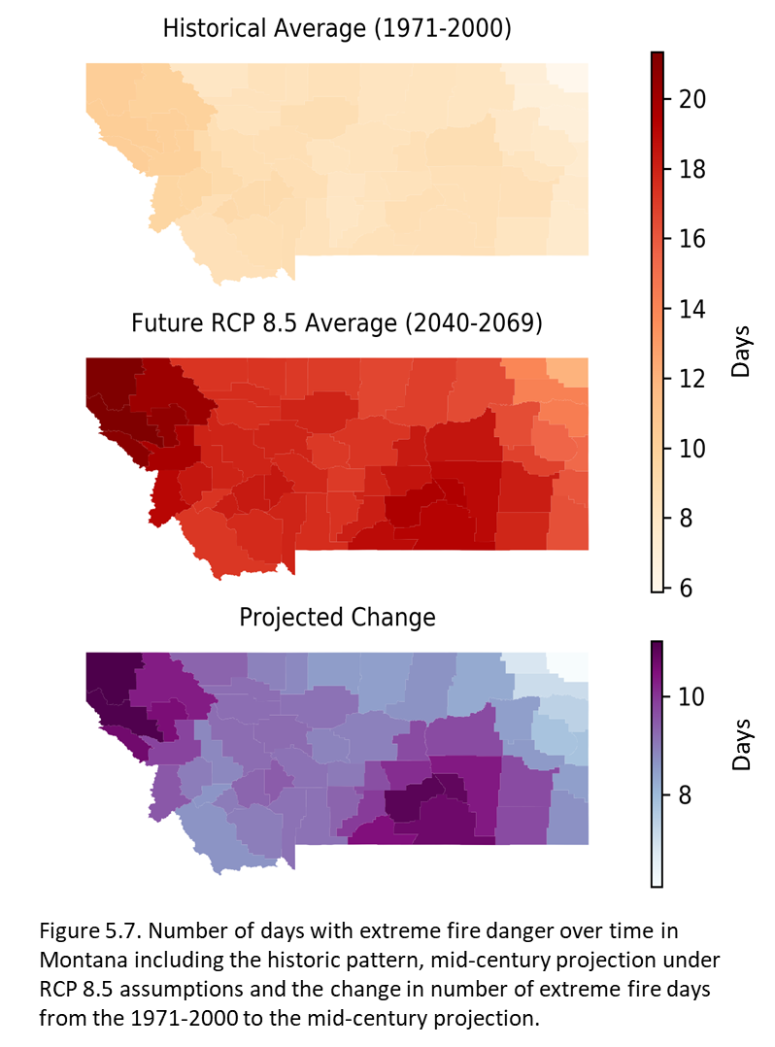

Figure 3-9. Number of days with extreme fire danger over time in Montana. From top to bottom we show the historic pattern, the mid-century projection under RCP8.5 (upper-bound emission scenario), and the change in number of extreme fire days from the 1971-2000 to the mid-century projection.

Together, longer fire seasons and an increase in the number of large fires will increase smoke across many Montana communities, which in turn will result in impaired human health (Liu et al. 2016) and reduced visibility (Yue et al. 2013; Val Martin et al. 2015). Wildfires are projected to become the principal driver of summertime particulate matter concentrations in the Northwest US, offsetting even large reductions in emissions of particulate matter precursors to greenhouse gases (Spracklen et al. 2009; Val Martin et al. 2015). Over the short term, the degree to which increased fire danger results in increased burning and smoke emissions is dependent on a large set of variables; therefore the certainty of the projections is reduced and difficult to quantify.

Wildfire smoke can be severe in communities in western Montana (IDDEQ 2013). In Montana, Department of Environmental Quality reports showed that air quality in communities or counties rated “unhealthy for sensitive groups,” “unhealthy,” “very unhealthy,” or “hazardous” increased significantly from 2010-2017, followed by declining smoke in the relatively cool wet summers of 2018 and 2019 (Figure 3-10). The number of smoke events in each health category showed similar trends, with the valleys of western Montana receiving the most “unhealthy” smoke days followed by the southeastern region of Montana. Seeley Lake, Lolo, Superior, and Frenchtown all had ten or more days where the air quality was rated “unhealthy,” “very unhealthy,” or “hazardous” in 2017, the year thought to be most like future years with dry hot summers (Whitlock et al. 2017).

|  |
| --- |
| Figure 3-10. The number of communities, counties, and regions in Montana where wildfire smoke led to varying air quality ratings (MDEQ data 2019). |

If one assumes that increased fire potential will be correlated with increased unhealthy to hazardous air quality, Montana may expect more communities exposed and a doubling of days exceeding moderate air quality where western Montana will be most affected. In the future, years with widespread regional fire activity, like 2017, will be interspersed with years with average or below-average fire activity, like 2018 and 2019. Overall, climate change projections indicate that we will experience more years with widespread fire activity in the upcoming decades. More frequent wildfires and poor air quality are expected to increase respiratory illnesses in the decades to come (Ebi et al. 2018a). Airborne particulate levels from wildfires are projected to increase 160% by mid-century under the RCP4.5 scenario, creating a greater risk of smoke exposure through increasing frequency, length, and intensity of smoke events (Liu et al. 2016).

Individual actions suggested for minimizing the health impacts of wildfire smoke exposure include staying indoors, using masks (N95) when outside, avoiding strenuous outside activities, turning air conditioning to recirculation mode to avoid drawing in outside air, and using portable or in-line high-efficiency particulate air (HEPA) filters indoors. Further study regarding the efficacy of each of these recommendations is needed. More details on individual actions can be found in Section 5.

Water-related Illnesses

Floods, which may increase related to the extreme precipitation events and earlier snowmelt expected under climate change in Montana (Whitlock et al. 2017), can affect people’s health in a variety of ways. Immediate impacts include injury, hypothermia, death from drowning, exposure to toxic substances released by flood waters, and exacerbation of underlying conditions such as cardiovascular or pulmonary disease (due the flood itself or cleaning up afterwards). Later complications include respiratory and skin infections, vector-borne illnesses, and mental health conditions (Du et al. 2010; Ryan et al. 2015; Paterson et al. 2018). Even in the absence of flooding, elevated rates of gastrointestinal disease have been associated with precipitation events (Carlton et al. 2016; Levy et al. 2016), and with dry conditions (Alexander et al. 2013; Friedrich 2013), though the latter association is weaker.

Harmful algal blooms in the US have increased from under 100 in 2013 to over 500 in 2019[14] (EWG undated). Many factors influence harmful algal blooms including increased nutrients from agricultural runoff or sewage, changes in water circulation, and increased water temperatures (Paerl and Huisman 2009; Moore et al. 2011; Davidson et al. 2014). Harmful algal blooms can impair municipal water supplies, hamper recreational activity, and cause significant economic hardships if tourism is reduced in affected areas. Further, such blooms can impact human health. Depending on the causative organism and type of exposure, maladies caused by harmful algal blooms can include gastrointestinal symptoms, muscle cramps, skin rashes, liver damage, and even death.

Food Safety and Nutrition Concerns

Though often more subtle, climate change impacts on food supply, food safety, and nutritional content may be more profound than other health impacts on a global basis. Climate change can have a dramatic impact on our food supply, and hence on human health via, for example:

* Elevated CO2 levels reduce the protein and micronutrient content of grains, putting larger swaths of the global population at risk for malnutrition and anemia (Medek et al. 2017; Smith and Myers 2018; Uddling et al. 2018).
* Heat and water stress, both expected to increase with climate change, can induce production of aflatoxins, fungal-produced toxins that are known carcinogens (Medina et al. 2014).
* Increased temperatures, both modest and extreme, lower crop yields (Zhao et al. 2017; Vogel et al. 2019), even more so with drought (Lesk et al. 2016).
* Extreme weather events can impact crop makeup and yields (Nelson et al. 2014).
* Increased prices, in turn, are a natural result of lower crop yields.

Given current levels of undernutrition and malnutrition, these stresses on the food supply wrought by a warming planet could outweigh all other human health impacts brought on by climate change (Springmann et al. 2016).[15]

|  |  |
| --- | --- |
|  | Sidebar: Climate Impacts on Agricultural Production and Nutrition |
|  |
| **The problem: climate change threatens human health through its effect on agriculture and nutrition**. Children require adequate and healthy food to meet their potential; inadequate nutrition can permanently affect their brain development and growth potential. Even with an adequate food supply, 11% of Montanans are currently food insecure (Coleman-Jensen et al. 2018).  **Climate change affects the quality of food.** Even as plants grow larger and store more carbohydrates (sugars) with increasing carbon dioxide levels, they contain less protein, zinc, iron, and other nutrients (Myers 2014). Most studied are the grains which provide almost half of the calories eaten by humans, worldwide—especially wheat, corn, and rice—and legumes. These changes can lead to a number of health problems. The human immune system depends on these nutrients; these changes in undernourished people can affect their ability to fight infections. One of every five US children suffer from low iron levels for part of their childhood (Irwin and Jeffrey 2001); one in four older adults have inadequate intake of zinc (NCHS undated). Low iron results in tiredness and low blood counts. Prolonged low iron levels also lower IQ, associated with lower earning capacity and shortened life span. Low zinc levels can cause diarrhea, weight loss, skin lesions, and decreased immunity.  **Climate change can also lower the overall quantity of food produced by multiple causes.** Conditions that decrease food production lead to increased food prices, affecting adequate nutrition in lower income people. Even if one region or country produces adequate food in a season, shortages elsewhere still impact food prices. The salt content of underground water sources (aquifers) and coastal lands is increasing, making these regions less productive or non-productive. Soil salination already affects 20% of cultivated lands, and is being worsened by heat stress, aquifer salination, and sea level rise. Every day of extreme heat lowers the yield of grain crops. Pests and weeds thrive better with higher carbon dioxide, which lower productivity of food crops. Changes in climate with the increasing extreme weather (flood and precipitation events), late summer drought, and increasing fire severity also impact production of food.  **Livestock, not just plants, have issues with climate change.** Dairy cattle’s milk production decreases with increased heat. Deaths in all animals, including livestock, increase with a rise in heat and black animals are more sensitive. Heat waves make livestock less fertile. Extreme weather events also lead to increased animal mortality.  **The future?** We can hope for improvement in drought-resistant/heat-tolerant strains and other adaptive measures to improve some of these conditions, but feeding the world in a changing climate remains a significant challenge. |

Vector-borne Disease

Vectors are organisms—such as ticks, mosquitoes, and fleas—that transmit diseases from one host to another. Globally, vector-borne diseases include Zika, plague, dengue, malaria, yellow fever, Chagas disease, and Chikungunya, among others. In the United States, Rocky Mountain spotted fever, Lyme disease, and anaplasmosis, all carried by ticks, and West Nile virus, transmitted by mosquitoes, are most prominent. Zika, dengue, Chikungunya, and Eastern Equine Encephalitis are also of concern.

Overall, climate change is expected to increase the range of vectors, primarily ticks and mosquitoes in the United States, thereby increasing the number of people exposed to the diseases they transmit (Beard et al. 2016; Sonenshine 2018). Recent work by Rosenberg et al. (2018) shows that the number of vector-borne diseases tripled in the US between 2004 and 2016, with over 100,000 cases reported in 2016.

The interactions between climate, vectors, and pathogens is complex. For example, for certain mosquitoes increased temperatures boost the rate of reproduction and feeding, lengthen the breeding season, and shorten the maturation for pathogens they carry (Patz et al. 1996; Epstein et al. 1998; Epstein 2005). However, those complex relationships vary by locale and species. Temperatures that benefit mosquitoes may be detrimental to ticks; flooding may wash away larval stages of mosquitoes; drought may contribute to a decline in tick numbers, whereas mosquitoes, which can breed in very small pools of water, may be less affected. Rodent vectors, such as deer mice that carry Hantavirus, demonstrate equally variable relationships (Gubler et al. 2001).

Lyme disease

According to the CDC, Lyme disease is the most common vector-borne illness in the US, with approximately 300,000 total cases diagnosed annually (CDCa DDD undated). Lyme disease is most prevalent in the Northeast, but has been spreading westward and northward. The main vector, the deer or blacklegged tick, is not found in arid parts of the West, requiring more moisture to thrive. Though the most common tick-borne disease in Montana with an average of 10 cases per year, through 2018 all were imported from other states (MTDPHHSa undated).

West Nile virus

West Nile virus, first reported in the United States in 1999, is found in nearly every country and is the most common mosquito-borne illness in the United States, with 2647 cases and 167 deaths reported in 2018 (CDCb undated). West Nile virus is considered the most important cause of viral encephalitis globally (Chancey et al. 2015; Paz 2015) with increased spread projected with climate change (Paz 2015).

In the last several years, the northwest region of the US has seen an increase in some infectious diseases. The Washington Department of Health’s vector surveillance program has observed an earlier onset of West Nile virus-carrying mosquitoes, likely associated with higher temperatures, and an increasing number of human infections, with some resulting in fatalities (WSDOH 2018). Montana had no cases of West Nile virus until 2002 and in 2018 there were 51 cases reporting human infection in 18 counties and nine counties where mosquito pools[16] tested positive out of 30 counties tested (Figure 3-11 A and B). Three people have died from West Nile virus in Montana since it was first detected (MTDPHHSb undated). Climatic conditions associated with West Nile virus would be relatively high precipitation creating increased standing water along with high temperatures.

(A) 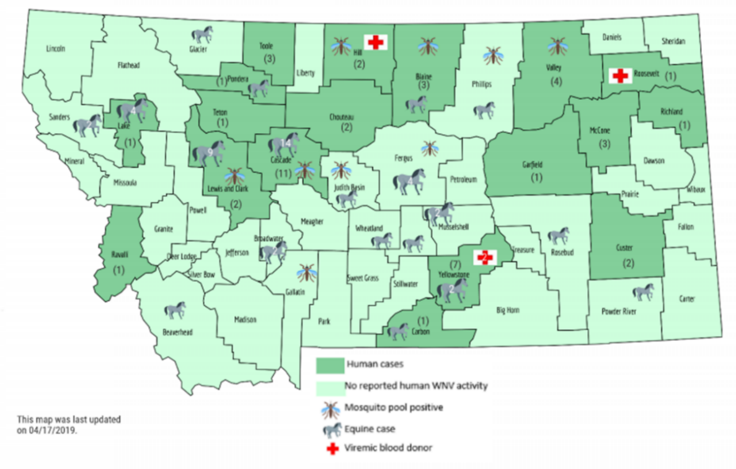

(B) 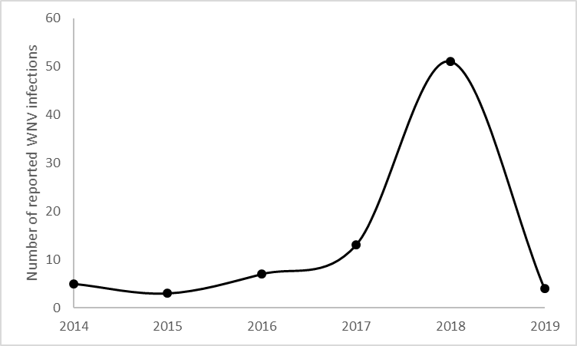

Figure 3-11. Occurrence of West Nile virus in Montana (MTDPHHSc undated). (A) Map showing 2019 (last update 10/3/19) detections in both humans and horses, by county. (B) Plot of human cases for the entire state from 2014-2019.

Special concerns for young people

Beginning at the fetal development stage, environmental exposures to air or water pollution can increase the risk of impaired brain development (Clifford et al. 2016), stillbirth (Siddika 2016), and preterm births (Peterson et al. 2015; Sun et al. 2015). Infants and children can be disproportionately affected by toxic exposures because they eat, drink, and breathe more in proportion to their body size (Heindel et al. 2016). Natural disasters, as well as gradual changes (like changing landscapes and livelihoods) caused by climate stressors, increase the risk of anxiety, depression, and post-traumatic stress disorder (Clayton et al. 2014). Evidence shows that exposure to both pollution and trauma early in life is detrimental to near-term health, and an increasing body of evidence suggests that early-childhood health status influences health and socioeconomic status later in life (Anda and Brown 2010; Currie et al. 2014).

Similarly, Perera (2017) states that children and youth will likely experience cumulative physical and mental health effects of climate change over their lifetimes due to increased exposure to extreme weather events (e.g., trauma from injury, heat stress, displacement), and increased toxic exposures. Examples of the latter include increased ground-level ozone pollution in urban areas or increased risk of drinking water contamination in rural areas.

Other concerns of note

The Oregon Health Authority recorded spikes in cases of *Salmonella* sp. and *Escherichia coli*(oftenreferred to as *E. coli*)during months with extreme heat in 2015 (Bancroft and Byster 2017).  No reports currently correlate climate-related changes with these disease occurrences in Montana.

Mental Health Concerns

The mental health impacts of climate change are profound and varied. Elevated temperatures have been related to worsening mental health status (Obradovich et al. 2018), diminished cognitive function (Laurent et al. 2018), increased violence (Clayton et al. 2017), and suicide (Page et al. 2007). Heat has been associated with increased interpersonal aggression in the form of domestic violence, abuse, and rape, as well as intergroup conflicts (Hsiang et al. 2013).

People with preexisting mental illness are at increased risk following weather-related events (Trombley et al. 2017), as are youth (Paulson et al. 2015; Orengo-Aguayo et al. 2019). Even small increases in temperature can lead to significant increases in mental illness (Obradovich et al. 2018).

Extreme weather events such as flooding (Lamond et al. 2015), wildfires, or storms have been shown to impact mental health. That impact can lead to increases in post-traumatic stress disorder, anxiety, depression, substance abuse, and suicidal thoughts. A sense of community loss and, in many cases, displacement can also result and may occur over time due to slower, more sustained climate change impacts (e.g., drought or sea level change) (Hayes et al. 2018; Palinkas and Wong 2019).

According to the Center for Disease Control and Prevention, Montana has the highest per capita suicide rate in the country (CDCc undated). This unfortunate reality, coupled with the limited access to mental health professionals in most rural areas of our state, greatly heightens the importance of preparedness planning in Montana to address the anxiety, stress, and other mental issues exacerbated by climate change.

|  |  |
| --- | --- |
| Related image | *According to the Center for Disease Control and Prevention, Montana has the highest per capita suicide rate in the country (CDCc undated). This unfortunate reality, coupled with the limited access to mental health professionals in most rural areas of our state, greatly heightens the importance of preparedness planning in Montana to address the anxiety, stress, and other mental issues exacerbated by climate change.* |

Literature Cited

Abatzoglou JT and Williams AP. 2016. Impact of anthropogenic climate change on wildfire across western US forests. Proceedings of the National Academy of Sciences of the United States of America 113(42):11770-5. Available online http://dx.doi.org/10.1073/pnas.1607171113. Accessed 3 Mar 2020.

Achebak H, Devolder D, Ballester J. 2018. Heat-related mortality trends under recent climate warming in Spain: a 36-year observational study. PLOS Medicine 15(7):e1002617. doi:10.1371/journal.pmed.1002617.

Alexander KA, Carzolio M, Goodin D, Vance E. 2013. Climate change is likely to worsen the public health threat of diarrheal disease in Botswana. International Journal of Environmental Research and Public Health 10(4):1202–30. doi:10.3390/ijerph10041202.

American Lung Association. 2018. ……….. https://www.lung.org/assets/documents/healthy-air/state-of-the-air/sota-2018-full.pdf p 116

Anda RF, Brown DW. 2010. Adverse childhood experiences and population health in Washington: the Face of a chronic public health disaster. Results from the 2009 Behavioral Risk Factor Surveillance System (BRFSS) [report]. Washington State Family Policy Council. 131 p. Available online http://www.wvlegislature.gov/senate1/majority/poverty/ACEsinWashington2009BRFSSFinalReport%20-%20Crittenton.pdf. Accessed 3 Mar 2020.

Anderson BG, Dominici F, Wang Y, McCormack MC, Bell ML, Peng RD. 2013. Heat-related emergency hospitalizations for respiratory diseases in the Medicare Population. American Journal of Respiratory and Critical Care Medicine 187(10):1098–103. doi:10.1164/rccm.201211-1969oc.

Auger N, Naimi AI, Smargiassi A, Lo E, Kosatsky T. 2014. Extreme heat and risk of early delivery among preterm and term pregnancies. Epidemiology 25(3):344–50. doi:10.1097/EDE.0000000000000074.

Avalos LA, Chen H, Li D-K, Basu R. 2017. The impact of high apparent temperature on spontaneous preterm delivery: a case-crossover study. Environmental Health 16(1):5. doi:10.1186/s12940-017-0209-5.

Baccini M, Biggeri A, Accetta G, Kosatsky T, Katsouyanni K, Analitis A, Anderson HR, Bisanti L, D’Ippoliti D, Danova J. 2008. Heat effects on mortality in 15 European cities. Epidemiology 19:711-9.

Balch JK, Bradley BA, Abatzoglou JT, Nagy RC, Fusco EJ, Mahood AL. 2017. Human-started wildfires expand the fire niche across the United States. Proceedings of the National Academy of Sciences 114(11): 2946-51. Available online https://dx.doi.org/10.1073/pnas.1617394114. Accessed 3 Mar 2020.

Bancroft J, Byster L. 2017. Selected reportable communicable disease summary [report]. Portland OR: Oregon Health Authority. 132 p. Available online https://sharedsystems.dhsoha.state.or.us/DHSForms/Served/le8645_2017.pdf. Accessed 3 Mar 2020

Barbero R, Abatzoglou JT, Steel EA, Larkin NK. 2014. Modeling very large-fire occurrences over the continental United States from weather and climate forcing. Environmental Research Letters 9(12):124009. http://dx.doi.org/10.1088/1748-9326/9/12/124009.

Basu R. 2009. High ambient temperature and mortality: a review of epidemiologic studies from 2001 to 2008. Environmental Health 8:40. doi:10.1186/1476-069X-8-40.

Beard CB, Eisen RJ, Barker CM, Garofalo JF, Hahn M, Hayden M, Monaghan AJ, Ogden NH, Schramm PJ. 2016. Ch. 5: Vector-borne diseases [chapter]. In: The impacts of climate change on human health in the United States: a scientific assessment. Washington DC: US Global Change Research Program. p 129-156. Available online https://s3.amazonaws.com/climatehealth2016/low/ClimateHealth2016_05_Vector_small.pdf. Accessed 3 Mar 2020.

Becker JA, Stewart LK. 2011. Heat-related illness. American Family Physician 83(11):1325–30.

Bell ML, MacDermott A, Zeger SL, Samet JM, Dominici F. 2004. Ozone and short-term mortality in 95 US urban communities, 1987-2000. Journal of the American Medical Association 292(19):2372–8. doi:10.1001/jama.292.19.2372.

Berko J, Ingram DD, Saha S, Parker JD. 2014. Deaths attributed to heat, cold, and other weather events in the United States, 2006-2010. National Health Statistics Report July 30(76):1-15.

Bobb JF, Obermeyer Z, Wang Y, Dominici F. 2014. Cause-specific risk of hospital admission related to extreme heat in older adults. Journal of the American Medical Association 312(24):2659–67. doi:10.1001/jama.2014.15715.

Bové H, Bongaerts E, Slenders E, Bijnens EM, Saenen ND, Gyselaers W, Eyken P, Plusquin M, Roeffaers MB, Ameloot M, et al. 2019. Ambient black carbon particles reach the fetal side of human placenta. Nature Communications 10(1):3866. doi:10.1038/s41467-019-11654-3.

Bröde P, Fiala D, Błażejczyk K, Holmér I, Jendritzky G, Kampmann B, Tinz B, Havenith G. 2012. Deriving the operational procedure for the Universal Thermal Climate Index (UTCI). International Journal of Biometeorology 56(3):481-94.

Buscail CE, Upegui E, Viel J-F. 2012. Mapping heatwave health risk at the community level for public health action. International Journal of Health Geographics, 11(38). https://doi.org/10.1186/1476-072X-11-38.

Calkins MM, Isaksen TB, Stubbs BA, Yost MG, Fenske RA. 2016. Impacts of extreme heat on emergency medical service calls in King County, Washington, 2007-2012: relative risk and time series analyses of basic and advanced life support. Environmental Health 15(1):13. doi:10.1186/s12940-016-0109-0.

Carlton EJ, Woster AP, DeWitt P, Goldstein RS, Levy K. 2016. A systematic review and meta-analysis of ambient temperature and diarrhoeal diseases. International Journal of Epidemiology 45(1):117–30. doi:10.1093/ije/dyv296.

Cascio WE. 2018. Wildland fire smoke and human health. Science of the Total Environment 624:586-95. http://dx.doi.org/10.1016/j.scitoenv.2017.12.086.

[CDCa] Centers for Disease Control and Prevention. [undated]. How many people get Lyme disease? [website]. Available <https://www.cdc.gov/lyme/stats/humancases.html>. Accessed 3 Mar 2020.

[CDCb] Centers for Disease Control and Prevention. [undated]. West Nile virus disease cases and presumptive viremic blood donors by state--United States, 2018 [report]. 2 p. Available online https://www.cdc.gov/westnile/resources/pdfs/data/WNV-Disease-Cases-PVDs-by-State-2018-P.pdf. Accessed 3 Mar 2020.

Chancey C, Grinev A, Volkova E, Rios M. 2015. The global ecology and epidemiology of West Nile virus. Biomedical Research International 2015:376230. doi:10.1155/2015/376230.

Chegwidden O, Hegewisch K, Abatzoglou JT, Hartmann H, Nijssen B. (2018, December). The northwest climate toolbox: supporting stakeholder engagement with climate and hydrology information. In AGU Fall Meeting Abstracts.

Chuang WC, Gober P. 2015. Predicting hospitalization for heat-related illness at the census tract level: accuracy of a generic heat vulnerability index in Phoenix, Arizona (USA). Environmental Health Perspectives 123(6): 606–12. doi:[10.1289/ehp.1307868](https://dx.doi.org/10.1289%2Fehp.1307868)

Clayton S, Manning C, Krygsman K, Speiser M. 2017. [Mental health and our changing climate: impacts, implications, and guidance](https://www.apa.org/news/press/releases/2017/03/mental-health-climate.pdf) [report]. Washington, D.C.: American Psychological Association, and ecoAmerica. 70 p. Available online https://www.apa.org/images/mental-health-climate_tcm7-215704.pdf. Accessed 29 Feb 2020.

Clayton S, Manning CM, Hodge C. 2014. Beyond storms and droughts: the psychological impacts of climate change [report]. Washington DC: American Psychological Association and ecoAmerica. 51 p. http://ecoamerica.org/wp-content/uploads/2014/06/eA_Beyond_Storms_and_Droughts_Psych_Impacts_of_Climate_Change.pdf. Accessed 3 Mar 2020.

Clifford A, Lang L, Chen R, Anstey KJ, Seaton A. 2016. Exposure to air pollution and cognitive functioning across the life course—a systematic literature review. Environmental Research 147:383-98. <http://dx.doi.org/10.1016/j.envres.2016.01.018>.

Coleman-Jensen A, Rabbitt MP, Gregory CA, Singh A. 2018. Household food security in the United States in 2017 [report]. Report# ERR-256. US Department of Agriculture, Economic Research Service. 44 p. Available online https://www.ers.usda.gov/webdocs/publications/90023/err-256.pdf?v=0. Accessed 3 Mar 2020.

Cook BI, Smerdon JE, Seager R, Coats S. 2014. Global warming and 21st century drying. Climate Dynamics 43(9):2607-27. http://dx.doi.org/10.1007/s00382-014-2075-7

Cottle P, Strawbridge K, McKendry I. 2014. Long-range transport of Siberian wildfire smoke to British Columbia: Lidar observations and air quality impacts. Atmospheric Environment 90:71-7. http://dx.doi.org/10.1016/j.atmosenv.2014.03.005.

Currie J, Zivin JG, Mullins J, Neidell M. 2014. What do we know about short- and long-term effects of early-life exposure to pollution? Annual Review of Resource Economics 6 (1):217-47. http://dx.doi.org/10.1146/annurev-resource-100913-012610.

Curriero FC, Heiner KS, Samet JM, Zeger SL, Strug L, Patz JA. 2002. Temperature and mortality in 11 cities of the eastern United States. American Journal of Epidemiology 155:80-7.

Dalton MM, Dello KD, Hawkins L, Mote PW, Rupp DE. 2017. Third Oregon climate assessment report. Corvallis OR: Oregon State University, Oregon Climate Change Research Institute. 106 p. Available online <http://www.occri.net/media/1055/ocar3_final_all_01-30-2017_compressed.pdf>. Accessed 3 Mar 2020.

Davidson K, Gowen RJ, Harrison PJ, Fleming LE, Hoagland P, Moschonas G. 2014. Anthropogenic nutrients and harmful algae in coastal waters. Journal of Environmental Management 146:206–16. doi:10.1016/j.jenvman.2014.07.002.

Dawson JP, Bloomer BJ, Winner DA, Weaver CP. 2014. Understanding the meteorological drivers of US particulate matter concentrations in a changing climate. Bulletin of the American Meteorological Society 95(4):521-32. http://dx.doi.org/10.1175/BAMS-D-12-00181.1

DeFranco E, Moravec W, Xu F, Hall E, Hossain M, Haynes EN, Muglia L, Chen A. 2016. Exposure to airborne particulate matter during pregnancy is associated with preterm birth: a population-based cohort study. Environmental Health-UK 15(1):6. doi:10.1186/s12940-016-0094-3.

Dennekamp M, Straney LD, Erbas B, Abramson MJ, Keywood M, Smith K, Sim MR, Glass DC, Monaco A, Haikerwal A, et al. 2015. Forest fire smoke exposures and out-of-hospital cardiac arrests in Melbourne, Australia: a case-crossover study. Environmental Health Perspectives 123(10):959–64. doi:10.1289/ehp.1408436.

Dennison PE, Brewer SC, Arnold JD, Moritz MA. 2014. Large wildfire trends in the western United States, 1984-2011. Geophysical Research Letters 41(8):2928-33. http://dx.doi.org/10.1002/2014GL059576.

Di Q, Wang Yan, Zanobetti A, Wang Yun, Koutrakis P, Choirat C, Dominici F, Schwartz JD. 2017. Air pollution and mortality in the Medicare population. New England Journal of Medicine 376(26):2513–22. doi:10.1056/nejmoa1702747.

Doppelt B. 2016. Transformational Resilience: How Building Human Resilience to Climate Disruption Can Safeguard Society and Increase Wellbeing. Greenleaf Publishing (Routledge/Taylor & Francis), New York. 368 p.

Dreessen J, Sullivan J, Delgado R. 2016. Observations and impacts of transported Canadian wildfire smoke on ozone and aerosol air quality in the Maryland region on June 9-12, 2015. Journal of the Air & Waste Management Association 66(9):842-62. http://dx.doi.org/10.1080/10962247.2016.1161674.

Du W, FitzGerald G, Clark M, Hou X-Y. 2010. Health impacts of floods. Prehospital Disaster Medicine 25(3):265–72. doi:10.1017/s1049023x00008141.

Ebi KL, Balbus JM, Luber G, Bole A, Crimmins A, Glass G, Saha S, Shimamoto MM, Trtanj J, White-Newsome JL. 2018a. Human health [chapter 14]. In Reidmiller DR, Avery CW, Easterling DR, Kunkel KE, Lewis KLM, Maycock TK, Stewart BC (eds). Impacts, Risks, and Adaptation in the United States: Fourth National Climate Assessment, Volume II. Washington DC: U.S. Global Change Research Program. p 539–71. Available online https://nca2018.globalchange.gov/chapter/health. Accessed 3 Mar 2020.

Ebi KL, Balbus JM, Luber G, Bole A, Crimmins A, Glass G, Saha S, Shimamoto MM, Trtanj J, White-Newsome JL. 2018b. Tribes and indigenous people [chapter 15]. Human Health. In Reidmiller DR, Avery CW, Easterling DR, Kunkel KE, Lewis KLM, Maycock TK, Stewart BC (eds). Impacts, Risks, and Adaptation in the United States: Fourth National Climate Assessment, Volume II. Washington DC: U.S. Global Change Research Program. p 572–603. Available online <https://nca2018.globalchange.gov/downloads/NCA4_Ch15_Tribes-and-Indigenous-Peoples_Full.pdf>. Accessed 3 Mar 2020

Epstein PR, Diaz HF, Elias S, Grabherr G, Graham NE, Martens WJ, Mosley-Thompson E, Susskind J. 1998. Biological and physical signs of climate change: focus on mosquito-borne diseases. Bulletin of the American Meteorological Society 79(3):409–17.

Epstein PR. 2005. Perspective: climate change and human health. New England Journal of Medicine 353(14):1433–1436. doi:10.1056/nejmp058079.

Epstein Y, Yanovich R. 2019. Heatstroke. New England Journal of Medicine 380(25):2449–59. doi:10.1056/nejmra1810762.

[EWG] Environmental Working Group. [undated]. News reports on algal blooms, 2010 to present [website]. Available online <https://www.ewg.org/interactive-maps/2019_algal_blooms/map/>. Accessed 3 Mar 2020.

Fann N, Alman B, Broome RA, Morgan GG, Johnston FH, Pouliot G, Rappold AG. 2018. The health impacts and economic value of wildland fire episodes in the US: 2008-2012. Science of the Total Environment 610-611:802-9. <http://dx.doi.org/10.1016/j.scitoenv.2017.08.024>.

Fiala D, Lomas KJ, Stohrer M. 2001. Computer prediction of human thermoregulatory and temperature responses to a wide range of environmental conditions. International Journal of . J. Biometeorology 45:143-59.

Fleischer NL, Merialdi M, van Donkelaar A, Vadillo-Ortega F, Martin RV, Betran A, Souza J, O’Neill MS. 2014. Outdoor air pollution, preterm birth, and low birth weight: analysis of the World Health Organization Global Survey on Maternal and Perinatal Health. Environmental Health Perspectives 122(4):425–30. doi:10.1289/ehp.1306837.

Friedrich M. 2013. Climate change linked with increase in diarrheal disease. Journal of the American Medical Association 309(19):1985. doi:10.1001/jama.2013.5879.

Gage AM, Olimb SK, Nelson J. 2016. Plowprint: tracking cumulative cropland expansion to target grassland conservation. Great Plains Research 26:107-16.

Gasparrini A, Guo Y, Hashizume M, Lavigne E, Zanobetti A, Schwartz J, Tobias A, Tong S, Rocklöv J, Forsberg B, Leone M, De Sario M, Bell ML, Leon Guo YL, Wu C-F, Kan H, Yi S-M, de Sousa Zanotti Stagliorio Coelho M, Hilario Nascimento Saldiva P, Honda Y, Kim H, Armstrong B. 2015. Mortality risk attributable to high and low ambient temperature: a multicountry observational study. Lancet 386:369-75. doi:10.1016/S0140-6736(14)62114-0.

Gubernot DM, Anderson BG, Hunting KL. 2015. Characterizing occupational heat‐related mortality in the United States, 2000–2010: an analysis using the census of fatal occupational injuries database. Am J Ind Med. 58(2):203–11. doi:10.1002/ajim.22381.

Gubler D, Reiter P, Ebi K, Yap W, Nasci R, Patz J. 2001. Climate variability and change in the United States: potential impacts on vector- and rodent-borne diseases. Environmental Health Perspectives. 109(suppl 2):223–33. doi:10.1289/ehp.109-1240669.

Ha S, Liu D, Zhu Y, Kim S, Sherman S, Mendola P. 2016. Ambient temperature and early delivery of singleton pregnancies. Environmental Health Perspectives. 125(3):453–9. doi:10.1289/ehp97.

Haikerwal A, Akram M, Monaco A, Smith K, Sim MR, Meyer M, Tonkin AM, Abramson MJ, Dennekamp M. 2015. Impact of fine particulate matter (PM2.5) exposure during wildfires on cardiovascular health outcomes. Journal of the American Heart Association 4(7):e001653. doi:10.1161/jaha.114.001653.

Hayes K, Blashki G, Wiseman J, Burke S, Reifels L. 2018. Climate change and mental health: risks, impacts and priority actions. International Journal of Mental Health Systems 12(1):28. doi:10.1186/s13033-018-0210-6.

Heindel JJ, Balbus J, Birnbaum L, Brune-Drisse MN, Grandjean P, Gray K, Landrigan PJ, Sly PD, Suk W, Slechta DC, Thompson C, Hanson M. 2016. Developmental origins of health and disease: integrating environmental influences. Endocrinology 2016 (1):17-22. http://dx.doi.org/10.1210/en.2015-1394.

Hellebuyck M, Halpern M, Nguyen T, Fritze D. 2018. The state of mental health in America: ranking the States [web page]. Mental Health America, Alexandria, VA. http://www.mentalhealthamerica.net/issues/ranking-states

Henderson SB, Brauer M, Macnab C, Kennedy SM. 2011. Three measures of forest fire smoke exposure and their association with respiratory and cardiovascular health outcomes in a population-based cohort. Environmental Health Perspectives 119(9):1266-71. doi:10.1289/ehp.1002288.

Higuera PE, Abatzoglou JT, Littell JS, Morgan P. 2015. The changing strength and nature of fire-climate relationships in the northern Rocky Mountains, USA, 1902-2008. PLOS ONE 10(6):e0127563. doi:10.1371/journal.pone.0127563.

Ho HC, Knudby A, Huang W. 2015. A spatial framework to map heat health risks at multiple scales. International Journal of Environmental Research and Public Health 12:16110–23. doi:10.3390/ijerph121215046

Hsiang SM, Burke M, Miguel E. 2013. Quantifying the influence of climate on human conflict. Science 341(6151):1235367. doi:10.1126/science.1235367.

[IDDEQ] Idaho Department of Environmental Quality. 2013. Request for EPA concurrence as exceptional events for 2012 wildfire impacts on PM2.5 monitor values at Salmon and Pinehurst Idaho [report]. 275 p. http://www.deq.idaho.gov/media/1187/exceptional-events-request-pinehurst-salmon-final.pdf.

Insurance Information Institute [undated]. …………. <https://www.iii.org/fact-statistic/facts-statistics-wildfires>.

[IPCC] Intergovernmental Panel on Climate Change. 2019. Summary for policymakers. In: [H.- O. Pörtner, D.C. Roberts, V. Masson-Delmotte, P. Zhai, M. Tignor, E. Poloczanska, K. Mintenbeck, M. Nicolai, A. Okem, J. Petzold, B. Rama, N. Weyer (eds.). IPCC special report on the ocean and cryosphere in a changing climate. Available online https://www.ipcc.ch/srocc/chapter/summary-for-policymakers/. Accessed 3 Mar 2020.

Irwin J, Jeffrey K. 2001. Anemia in children. American Family Physician 64(8):1379-87.

Isaksen T, Fenske RA, Hom EK, Ren Y, Lyons H, Yost MG. 2016. Increased mortality associated with extreme-heat exposure in King County, Washington, 1980–2010. International Journal of Biometeorology. 60(1):85–98. doi:10.1007/s00484-015-1007-9.

Isaksen, T.B., G. Yost Michael, K. Hom Elizabeth, Y. Ren, H. Lyons, and A. Fenske Richard. 2015. Increased hospital admissions associated with extreme-heat exposure in King County, Washington, 1990-2010. Reviews on Environmental Health 30(1):51-64. http://dx.doi.org/10.1515/reveh-2014-0050

Jackson, J.E., M.G. Yost, C. Karr, C. Fitzpatrick, B.K. Lamb, S.H. Chung, J. Chen, J. Avise, R.A. Rosenblatt, and R.A. Fenske, 2010: Public health impacts of climate change in Washington State: Projected mortality risks due to heat events and air pollution. Climatic Change, 102 (1-2), 159-186. http://dx.doi.org/10.1007/s10584-010-9852-3

Jaffe, D., D. Chand, W. Haffner, A. Westerling, and D. Spracklen, 2008: Influences of fire on O3 concentrations in the western US. Environmental Science & Technology, 42 (16), 5885-5891. http://dx.doi.org/10.1021/es800084k.

Jaffe, D., W. Hafner, D. Chand, A. Westerling, and D. Spracklen, 2008: Interannual variations in PM2.5 due to wildfires in the western United States. Environmental Science & Technology, 42 (8), 2812-2818. http://dx.doi.org/10.1021/es702755v

Jaffe, D.A. and L. Zhang, 2017: Meteorological anomalies lead to elevated O3 in the western U.S. in June 2015. Geophysical Research Letters, 44 (4), 1990-1997. http://dx.doi.org/10.1002/2016GL072010

Jaffe DA and Widger NL. 2012. Ozone production from wildfires: a critical review. Atmospheric Environment 51:1-10. http://dx.doi.org/10.1016/j.atmosenv.2011.11.063.

Jenkins MJ, Runyon JB, Fettig CJ, Page WG, Bentz BJ. 2014. Interactions among the mountain pine beetle, fires, and fuels. Forest Science 60(3):489-501. http://dx.doi.org/10.5849/forsci.13-017

Jhun I, Mata DA, Nordio F, Lee M, Schwartz J, Zanobetti A. 2017. Ambient temperature and sudden infant death syndrome in the United States. Epidemiology 28(5):728. doi:10.1097/ede.0000000000000703.

Johnston FH, Henderson SB, Chen Y, Randerson JT, Marlier M, DeFries RS, Kinney P, Bowman D, Brauer M. 2012. Estimated global mortality attributable to smoke from landscape fires. Environmental Health Perspectives 120(5):695–701. doi:10.1289/ehp.1104422.

Jolly WM, Cochrane MA, Freeborn PH, Holden ZA, Brown TJ, Williamson GJ, Bowman DM. 2015. Climate-induced variations in global wildfire danger from 1979 to 2013. Nature Communications 6:7537.

Knowlton K, Rotkin-Ellman M, King G, Margolis HG, Smith D, Solomon G, Trent R, English P. 2009. The 2006 California heat wave: impacts on hospitalizations and Emergency Department visits. Environmental Health Perspectives 117(1):61–7. doi:10.1289/ehp.11594.

Kollanus V, Tittanen P, Niemi JV, Lanki T. 2016. Effects of long-range transported air pollution from vegetation fires on daily mortality and hospital admissions in the Helsinki metropolitan area, Finland. Environmental Research 151:351-8. doi:10.1016/j.envres.2016.08.003

Koplitz SN, Mickley LJ, Marlier ME, Buonocore JJ, Kim PS, Liu T, Sulprizio MP, DeFries RS, Jacob DJ, Schwartz J, Pongsiri M, Meyers SS. 2016. Public health impacts of the severe haze in equatorial Asia in September-October 2015: Demonstration of a new framework for informing fire management of strategies to reduce downwind smoke exposure. Environmental Research Letters 11(9):094023. doi:10.1088/1748-9326/11/9/094023.

Lamond J, Joseph RD, Proverbs DG. 2015. An exploration of factors affecting the long-term psychological impact and deterioration of mental health in flooded households. Environmental Research 140:325–34. doi:10.1016/j.envres.2015.04.008.

Laurent J, Williams A, Oulhote Y, Zanobetti A, Allen JG, Spengler JD. 2018. Reduced cognitive function during a heat wave among residents of non-air-conditioned buildings: an observational study of young adults in the summer of 2016. Plos Medicine 15(7):e1002605. doi:10.1371/journal.pmed.1002605.

Lancet Countdown, 2018: 2018 Lancet Countdown on Health and Climate Change Brief for the United State of America. Salas RN, Knappenberger P, Hess JJ. Lancet Countdown U.S. Brief, London, United Kingdom, 32 pp.

Lesk C, Rowhani P, Ramankutty N. 2016. Influence of extreme weather disasters on global crop production. Nature 529(7584):84–8. doi:10.1038/nature16467.

Levy K, Woster AP, Goldstein RS, Carlton EJ. 2016. Untangling the impacts of climate change on waterborne diseases: a systematic review of relationships between diarrheal diseases and temperature, rainfall, flooding, and drought. Environmental Science and Technology. 50(10):4905–22. doi:10.1021/acs.est.5b06186.

Levy BS, Roelofs C. 2019. Impacts of climate change on workers’ health and safety. In Oxford Research Encyclopedia of Global Public Health.

Liu JC, Pereira G, Uhl SA, Bravo MA, Bell ML. 2015. A systematic review of the physical health impacts from non-occupational exposure to wildfire smoke. Environmental Research 136:120-32. http://dx.doi.org/10.1016/j.envres.2014.10.015.

Liu J, Mickley LJ, Sulprizio MP, Dominici F, Yue X, Ebisu K, Anderson G, Khan RF, Bravo MA, Bell ML. 2016. Particulate air pollution from wildfires in the western US under climate change. Climatic Change 138(3):655–66. doi:10.1007/s10584-016-1762-6.

Liu JC, Mickley LJ, Sulprizio MP, Yue X, Peng RD, Dominici F, Bell ML. 2016. Future respiratory hospital admissions from wildfire smoke under climate change in the western US. Environmental Research Letters 11(12):124018. doi:10.1088/1748-9326/11/12/124018.

Liu JC, Wilson A, Mickley LJ, Ebisu K, Sulprizio MP, Wang Y, Peng RD, Yue X, Dominici F, Bell ML. 2017. Who among the elderly is most vulnerable to exposure to and health risks of fine particulate matter from wildfire smoke? American Journal of Epidemiology 186(6):730-5. http://dx.doi.org/10.1093/aje/kwx141

Medek DE, Schwartz J, Myers SS. 2017. Estimated effects of future atmospheric CO2 concentrations on protein intake and the risk of protein deficiency by country and region. Environmental Health Perspesctives 125(8). doi:10.1289/ehp41.

Medina A, Rodriguez A, Magan N. 2014. Effect of climate change on *Aspergillus flavus* and aflatoxin B1 production. Frontiers in Microbiology 5:348. doi:10.3389/fmicb.2014.00348.

Meehi GA, Tebaldi C. 2004. More intense, more frequent, and longer lasting heat waves in the 21st century. Science 305:994-7.

Moore SK, Mantua NJ, Salathé EP. 2011. Past trends and future scenarios for environmental conditions favoring the accumulation of paralytic shellfish toxins in Puget Sound shellfish. Harmful Algae 10(5):521–9. doi:10.1016/j.hal.2011.04.004.

Morabito MA, Crisci A, Messeri A, Capecchi V, Modesti PA, Gensini GF, Orlandini S. 2014. Environmental temperature and thermal indices: what is the most effective predictor of heat-related mortality in different geographical contexts? Scientific World Journal. doi:10.1155/2014/961750.

Morabito M, Crisci A, Gioli B, Gualtieri G, Toscano P, di Stefano V, Orlandini S,Gensini GF. 2015. Urban-hazard risk analysis: mapping of heat-related risks in the elderly in major Italian cities. PLoS ONE 10. <https://doi.org/10.1371/journal.pone.0127277>.

Moyce S, Mitchell D, Armitage T, Tancredi D, Joseph J, Schenker M. 2017. Heat strain, volume depletion, and kidney function in California agricultural workers. Occupational and Environmental Medicine 74(6):402-9.

[MTDPHHSa] Montana Department of Public Health and Human Services. [undated]. Tick-borne illnesses [website]. Available online https://dphhs.mt.gov/publichealth/cdepi/diseases/ticks. Accessed 3 Mar 2020.

[MTDPHHSb] Montana Department of Public Health and Human Services. [undated]. Ref missing!!

[MTDPHHSc] Montana Department of Public Health and Human Services. [undated]. West Nile virus [website]. Available online https://dphhs.mt.gov/publichealth/cdepi/diseases/westnilevirus. Accessed 3 Mar 2020.

Myers SS, Zanobetti A, Kloog I, Huybers P, Leakey ADB, Bloom AJ, Carlisle E, Dietterich LH, Fitzgerald G, Hasegawa T, Holbrook NM, Nelson RL, Ottman MJ, Raboy V, Sakai H, Sartor KA, Schwartz J, Seneweera S, Tausz M, Usui Y. 2014. Increasing CO2 threatens human nutrition. Nature 510:139–42.

Naeher LP, Brauer M, Lipsett M, Zelikoff JT, Simpson CD, Koenig JQ, Smith KR. 2010. Woodsmoke health effects: a review. Inhalation Toxicology 19(1):67–106. doi:10.1080/08958370600985875.

Navarro KM, Cisneros R, O’Neill SM, Schweizer D, Larkin NK, Balmes JR. 2016. Air-quality impacts and intake fraction of PM2.5 during the 2013 Rim Megafire. Environmental Science and Technology 50 (21):11965-73. http://dx.doi.org/10.1021/acs.est.6b02252.

[NCHS] National Center for Health Statistics. [undated]. National health and nutrition survey [website]. Available online https://www.cdc.gov/nchs/nhanes/index.htm. Accessed 2019 December 20.

Nelson GC, Valin H, Sands RD, Havlík P, Ahammad H, Deryng D, Elliott J, Fujimori S, Hasegawa T, Heyhoe E, plus 14 more. 2014. Climate change effects on agriculture: economic responses to biophysical shocks. Proceedings of the National Academy of Sciences 111(9):3274–9. doi:10.1073/pnas.1222465110.

[NOAAa] National Oceanic and Atmospheric Agency. [undated]. National Climate Data Center Storm Data publication. Available online https://www.ncdc.noaa.gov/IPS/sd/sd.html.

[NOAAb] National Oceanic and Atmospheric Agency. [undated]. National Climate Data Center Storm Data publication, 2011 Annual Summary: http://www1.ncdc.noaa.gov/pub/orders/IPS/IPS-05A3B56D-AB9E-4D79-8FE8-A01A2CE41E42.pdf.

Norby RJ, Warren JM, Iversen CM, Medlyn BE, McMurtrie RE. 2010. CO2 enhancement of forest productivity constrained by limited nitrogen availability. Proceedings of the National Academy of Sciences of the United States of America 107(45):19368-73. http://dx.doi.org/10.1073/pnas.1006463107

[NWS] National Weather Service [undated]. Weather-related fatality and injury statistics [website]. Available online <https://www.weather.gov/hazstat/>. Accessed 19 Feb 2020.

Obradovich N, Migliorini R, Paulus MP, Rahwan I. 2018. Empirical evidence of mental health risks posed by climate change. Proceedings of the National Academy of Sciences 115(43):201801528. doi:10.1073/pnas.1801528115.

Olsson D, Mogren I, Forsberg B. 2013. Air pollution exposure in early pregnancy and adverse pregnancy outcomes: a register-based cohort study. Bmj Open. 3(2):e001955. doi:10.1136/bmjopen-2012-001955.

Oregon Health Authority. 2014. Oregon climate and health profile report [report]. 88 p. Available http://www.oregon.gov/oha/PH/HEALTHYENVIRONMENTS/CLIMATECHANGE/Documents/oregon-climate-and-health-profile-report.pdf. Accessed 3 Mar 202.

Oregon Health Authority. 2019. Summer 2019 Oregon ESSENCE Hazard Report. 4 p. Available online http://www.oregon.gov/oha/PH/DISEASESCONDITIONS/COMMUNICABLEDISEASE/PREPAREDNESSSURVEILLANCEEPIDEMIOLOGY/ESSENCE/Documents/HazardReports/ESSENCE_Hazards.pdf. Accessed 3 Mar 2020.

Orengo-Aguayo R, Stewart RW, de Arellano MA, Suárez-Kindy J, Young J. 2019. Disaster exposure and mental health among Puerto Rican youths after Hurricane Maria. Journal of the American Medical Association Jama Network Open 2(4):e192619. doi:10.1001/jamanetworkopen.2019.2619.

Ostro BD, Roth LA, Green RS, Basu R. 2009. Estimating the mortality effect of the July 2006 California heat wave. Environmental Research 109(5):614–9. doi:10.1016/j.envres.2009.03.010.

Paerl HW, Huisman J. 2009. Climate change: a catalyst for global expansion of harmful cyanobacterial blooms. Environmental Microbiology Reports 1(1):27-37. doi:10.1111/j.1758-2229.2008.00004.x.

Page LA, Hajat S, Kovats SR. 2007. Relationship between daily suicide counts and temperature in England and Wales. British Journal of Psychiatry 191(2):106–12. doi:10.1192/bjp.bp.106.031948.

Palinkas LA, Wong M. 2019. Global climate change and mental health. Current Opinion in Psychology 32:12–6. doi:10.1016/j.copsyc.2019.06.023.

Paterson DL, Wright H, Harris PN. 2018. Health risks of flood disasters. Clinical Infectious Diseases 67(9):1450–4. doi:10.1093/cid/ciy227.

Patz JA, Epstein PR, Burke TA, Balbus JM. 1996. Global climate change and emerging infectious diseases. Journal of the American Medical Association 275(3):217–23. doi:10.1001/jama.1996.03530270057032.

[Paulson JA](https://www.ncbi.nlm.nih.gov/pubmed/?term=Paulson%20JA), [Ahdoot S](https://www.ncbi.nlm.nih.gov/pubmed/?term=Ahdoot%20S), [Baum CR](https://www.ncbi.nlm.nih.gov/pubmed/?term=Baum%20CR), [Bole A](https://www.ncbi.nlm.nih.gov/pubmed/?term=Bole%20A), [Brumberg HL](https://www.ncbi.nlm.nih.gov/pubmed/?term=Brumberg%20HL), [Campbell CC](https://www.ncbi.nlm.nih.gov/pubmed/?term=Campbell%20CC), [Lanphear BP](https://www.ncbi.nlm.nih.gov/pubmed/?term=Lanphear%20BP), [Lowry JA](https://www.ncbi.nlm.nih.gov/pubmed/?term=Lowry%20JA), [Pacheco SE](https://www.ncbi.nlm.nih.gov/pubmed/?term=Pacheco%20SE), [Spanier AJ](https://www.ncbi.nlm.nih.gov/pubmed/?term=Spanier%20AJ), [Trasande L](https://www.ncbi.nlm.nih.gov/pubmed/?term=Trasande%20L). 2015. Global climate change and children’s health. Pediatrics 136(5):992–7. doi:10.1542/peds.2015-3232.

Paz S. 2015. Climate change impacts on West Nile virus transmission in a global context. Philosophical Transactions Royal Society B Biological Sciences 370(1665):20130561. doi:10.1098/rstb.2013.0561.

Perera FP. 2017. Multiple threats to child health from fossil fuel combustion: impacts of air pollution and climate change. Environmental Health Perspectives 125:141-8. Available online <http://dx.doi.org/10.1289/EHP299>. Accessed 3 Mar 2020.

Peterson W, Bond N, Robert M. 2015. The warm blob—conditions in the northeastern Pacific Ocean [article]. PICES Press 23(1):36-8. Available online https://www.pices.int/publications/pices_press/volume23/PPJanuary2015.pdf. Accessed 3 Mar 2020.

Rappold AG, Stone SL, Cascio WE, Neas LM, Kilaru VJ, Carraway M, Szykman JJ, Ising A, Cleve WE, Meredith JT, et al. 2011. Peat bog wildfire smoke exposure in rural North Carolina is associated with cardiopulmonary Emergency Department visits assessed through syndromic surveillance. Environmental Health Perspectives. 119(10):1415–1420. doi:10.1289/ehp.1003206.

Reid CE, O’Neill MS, Gronlund CJ, Brines SJ, Brown DG, Diez-Roux AV, Schwartz J. 2009. Mapping community determinants of heat vulnerability. Environmental Health Perspectives 117:1730-6.

Reid CE, Mann J, Alfasso R, English PB, King GC, Lincoln RA, Margolis HG, Rubado DJ, Sabato JE, West NL. 2012. Evaluation of a heat vulnerability index on abnormally hot days: an environmental public health tracking study. Environmental Health Perspectives 120:715-20.

Reid C, Jerrett M, Tager I, Petersen M, Mann J, Balmes J. 2016. Differential respiratory health effects from the 2008 northern California wildfires: a spatiotemporal approach. Environmental Research 150:227-35. https://dx.doi.org/10.1016/j.envres.2016.06.012

Reid CE, Brauer M, Johnston FH, Jerrett M, Balmes JR, Elliott CT. 2016. Critical review of health impacts of wildfire smoke exposure. Environmental Health Perspectives 124:1334-43. <http://dx.doi.org/10.1289/ehp.1409277>

Reisen F, Duran SM, Flannigan M, Elliott C, Rideout K. 2015. Wildfire smoke and public health risk. International Journal of Wildland Fire 24(8):1029–44. doi:10.1071/WF15034.

Rosenberg R, Lindsey NP, Fischer M, Gregory CJ, Hinckley AF, Mead PS, Paz-Bailey G, Waterman SH, Drexler NA, Kersh GJ, Hooks H, Partridge SK, Visser SN, Beard CB, Petersen LR. 2018. Vital signs: trends in reported vectorborne disease cases—United States and territories, 2004–2016. Morbidity Mortal Weekly Report 67(17):496–501. doi:10.15585/mmwr.mm6717e1.

Ross ME, Vicedo-Cabrera AM, Kopp RE, Song L, Goldfarb DS, Pulido J, Warner S, Furth SL, Tasian GE. 2018. Assessment of the combination of temperature and relative humidity on kidney stone presentations. Environmental Research 162:97–105. doi:10.1016/j.envres.2017.12.020.

Running SW. 2006. Is global warming causing more, larger wildfires? Science 313(5789):927–8. doi:10.1126/science.1130370.

Ryan B, Franklin RC, Burkle FM, Aitken P, Smith E, Watt K, Leggat P. 2015. Identifying and describing the impact of cyclone-, storm-, and flood-related disasters on treatment management, care, and exacerbations of non-communicable diseases and the implications for public health. PLOS Current Disasters edition 1. doi:10.1371/currents.dis.62e9286d152de04799644dcca47d9288.

Sapkota A, Symons JM, Kleissl J, Wang L, Parlange MB, Ondov J, Breysse PN, Diette GB, Eggelston PA, Buckley TJ. 2005. Impact of the 2002 Canadian forest fires on particulate matter air quality in Baltimore City. Environmental Science and Technology 39(1):24-32. http://dx.doi.org/10.1021/es035311z.

Schoennagel T, Balch JK, Brenkert-Smith H, Dennison PE, Harvey BJ, Krawchuk MA, Mietkiewicz N, Morgan P, Moritz MA, Rasker R, et al. 2017. Adapt to more wildfire in western North American forests as climate changes. Proceedings of the National Academy of Sciences 114(18):4582–90. doi:10.1073/pnas.1617464114.

Siddika N, Balogun HA, Amegah AK, Jaakkola JJK. 2016. Prenatal ambient air pollution exposure and the risk of stillbirth: systematic review and meta-analysis of the empirical evidence. Occupational and Environmental Medicine 73(9):573-81. doi:10.1136/oemed-2015-103086.

Smith MR, Myers SS. 2018. Impact of anthropogenic CO2 emissions on global human nutrition. Nature Climate Change 8:834–9. doi:10.1038/s41558-018-0253-3.

Sonenshine DE. 2018. Range expansion of tick disease vectors in North America: implications for spread of tick-borne disease. International Journal of Environ Research and Public Health 15(3):478. doi:10.3390/ijerph15030478.

Sorensen C, Garcia-Trabanino R. 2019. A new era of climate medicine—addressing heat-triggered renal disease. New England Journal of Medicine. 381(8):693–6. doi:10.1056/nejmp1907859.

Spector JT, Bonauto DK, Sheppard L, Busch-Isaksen T, Calkins M, Adams D, Lieblich M, Fenske RA. 2016. A case-crossover study of heat exposure and injury risk in outdoor agricultural workers. PLOS ONE 11(10):e0164498. http://dx.doi.org/10.1371/journal.pone.0164498

Spracklen DV, Mickley LJ, Logan JA, Hudman RC, Yevich R, Flannigan MD, Westerling AL. 2009. Impacts of climate change from 2000 to 2050 on wildfire activity and carbonaceous aerosol concentrations in the western United States. Journal of Geophysical Research 114:D20301. Available online https://agupubs.onlinelibrary.wiley.com/doi/epdf/10.1029/2008JD010966. Accessed 3 Mar 2020.

Springmann M, Mason-D’Croz D, Robinson S, Garnett T, Godfray CH, Gollin D, Rayner M, Ballon P, Scarborough P. 2016. Global and regional health effects of future food production under climate change: a modelling study. Lancet 387(10031):1937–46. doi:10.1016/s0140-6736(15)01156-3.

Sun X, Luo X, Zhao C, Chung Ng RW, Lim CED, Zhang B, Liu T. 2015. The association between fine particulate matter exposure during pregnancy and preterm birth: a meta-analysis. BMC Pregnancy and Childbirth 15:300. http://dx.doi.org/10.1186/s12884-015-0738-2.

Tinling MA, West JJ, Cascio WE, Kilaru V, Rappold AG. 2016. Repeating cardiopulmonary health effects in rural North Carolina population during a second large peat wildfire. Environmental Health 15(1):12. doi:10.1186/s12940-016-0093-4.

Tomlinson CJ, Chapman L, Thornes JE, Baker C. 2011. Including the urban heat island in spatial heat health risk assessment strategies. International Journal of Health Geographics 10(42). https://doi.org/10.1186/1476-072X-10-42.

Trasande L, Malecha P, Attina TM. 2016. Particulate matter exposure and preterm birth: estimates of US attributable burden and economic costs. Environmental Health Perspectives 124(12):1913–8. doi:10.1289/ehp.1510810.

Trombley J, Chalupka S, Anderko L. 2017. Climate change and mental health. American Journal of Nursing 117(4):44–52. doi:10.1097/01.naj.0000515232.51795.fa.

[UCS] Union of Concerned Scientists. 2019. Killer heat in the United States; climate choices and the future of dangerously hot days [report]. Dahl K, Spanger-Siegfried E, Licker R, Caldas A, Abatzoglou J, Mailloux N, Cleetus R, Udvardy S, Declet-Barreto J, Worth P, authors. Available online <https://www.ucsusa.org/sites/default/files/attach/2019/07/killer-heat-analysis-full-report.pdf>. Accessed 15 September 2019.

Uddling J, Broberg MC, Feng Z, Pleijel H. 2018. Crop quality under rising atmospheric CO2. Current Opinion in Plant Biology 45(B):262–7. doi:10.1016/j.pbi.2018.06.001.

[USEPA] US Environmental Protection Agency. 2016. Climate change indicators: wildfires. US Environmental Protection Agency (EPA), Washington, DC. https://www.epa.gov/climate-indicators/climate-change-indicators/wildfires

[USEPA] US Environmental Protection Agency. 2016. Emissions Inventory for Air Quality Modeling Technical Support Document: Heavy-Duty Vehicle Greenhouse Gas Phase 2 Final Rule. EPA 420-R-16-008. U.S. Environmental Protection Agency (EPA), Washington, DC. 199 p. https://nepis.epa.gov/Exe/ZyPURL.cgi?Dockey=P100PKEE.txt

[USGCRP] US Global Change Research Program. 2016. The impacts of climate change on human health in the United States: a scientific assessment. Crimmins A, Balbus J, Gamble JL, Beard CB, Bell JE, Dodgen D, Eisen RJ, Fann N, Hawkins MD, Herring SC, Jantarasami L, Mills DM, Saha S, Sarofim MC, Trtanj J, Ziska L, eds. Washington DC: U.S. Global Change Research Program. 312 p. Available online https://health2016.globalchange.gov. Accessed 1 Mar 2020. <http://dx.doi.org/10.7930/J0R49NQX>.

[USGCRP] US Global Change Research Program. 2017. Climate science special report: fourth National Climate Assessment, volume I. Wuebbles DJ, Fahey DW, Hibbard KA, Dokken DJ, Stewart BC, Maycock TK (eds). Washington DC: US Global Change Research Program. 477 p. doi:10.7930/J0J964J6.

[USGCRP]. US Global Change Research Program. 2018. Chapter 13: Air quality. In: Reidmiller DR, Avery CW, Easterling DR, Kunkel KE, Lewis KLM, Maycock TK, Stewart BC (eds). Impacts, risks, and adaptation in the United States: fourth National Climate Assessment, volume II. Washington DC: US Global Change Research Program. p 513-38. Available online at <https://nca2018.globalchange.gov/downloads/NCA4_Ch13_Air-Quality_Full.pdf>. Accessed 3 Mar 2020.

Val Martin M, Heald CL, Lamarque JF, Tilmes S, Emmons LK, Schichtel BA. 2015. How emissions, climate, and land use change will impact mid-century air quality over the United States: a focus on effects at national parks. Atmospheric Chemistry and Physics 15:2805-23. doi:10.5194/acp-15-2805-2015.

Vescovi L, Rebetez M, Rong F. 2005. Assessing public health risk due to extremely high temperature events: climate and social parameters. Climate Resilience 30:71-8.

Vogel E, Donat MG, Alexander LV, Meinshausen M, Ray DK, Karoly D, Meinshausen N, Frieler K. 2019. The effects of climate extremes on global agricultural yields. Environmental Research Letters 14(5):054010. doi:10.1088/1748-9326/ab154b.

Vox. 2019. The survivors: A year after the Camp Fire nearly leveled Paradise, California, the money is drying up and a lawsuit rages. Can recovery efforts ever return a community to its old self? [article] Available online https://www.vox.com/the-highlight/2019/10/16/20908291/camp-fire-wildfire-california-paradise-survivors. Accessed 3 Mar 2020.

Wang Yan, Bobb JF, Papi B, Wang Yun, Kosheleva A, Di Q, Schwartz JD, Dominici F. 2016. Heat stroke admissions during heat waves in 1916 US counties for the period from 1999 to 2010 and their effect modifiers. Environmental Health-UK 15(1):83. doi:10.1186/s12940-016-0167-3.

Watts N, Amann M, Arnell N, Ayeb-Karlsson S, Belesova K, Berry H, Bouley T, Boykoff M, Byass P, Cai W, et al. 2018. The 2018 report of the Lancet Countdown on health and climate change: shaping the health of nations for centuries to come. Lancet. 392(Lancet 386 2015):2479–514. doi:10.1016/s0140-6736(18)32594-7.

Wehner MF, Arnold JR, Knutson T, Kunkel KE, LeGrande AN. 2017. Chapter 8: Droughts, floods, and wildfires. In: Wuebbles DJ, Fahey DW, Hibbard KA, Dokken DJ, Stewart BC, Maycock TK (eds.). Climate science special report: fourth National Climate Assessment, Volume I. Washington DC: US Global Change Research Program. p. 231-56. Available online https://science2017.globalchange.gov/chapter/8/. Accessed 3 Mar 2020.

Westerling A, Hidalgo H, Cayan D, Swetnam T. 2006. Warming and earlier spring increase western US forest wildfire activity. Science 313(5789):940–3. doi:10.1126/science.1128834.

Westerling A. 2016. Increasing western US forest wildfire activity: sensitivity to changes in the timing of spring. Philosophical Transactions of the Royal Society B: Biological Sciences 371(1696):20150178. doi:10.1098/rstb.2015.0178.

Wettstein ZS, Hoshiko S, Fahimi J, Harrison RJ, Cascio WE, Rappold AG. 2018. Cardiovascular and cerebrovascular Emergency Department visits associated with wildfire smoke exposure in California in 2015. Journal of the American Heart Association 7(8). doi:10.1161/jaha.117.007492.

Whitlock C, Cross W, Maxwell B, Silverman N, Wade AA. 2017. 2017 Montana Climate Assessment. Bozeman and Missoula MT: Montana State University and University of Montana, Montana Institute on Ecosystems. 318 p. DOI:10.15788/m2ww82. Available online <http://montanaclimate.org>. Accessed September 2019.

Witham C and Manning AM. 2007. Impacts of Russian biomass burning on UK air quality. Atmospheric Environment 41(37):8075-90. http://dx.doi.org/10.1016/j.atmosenv.2007.06.058.

[WMO] _______. 2004. Proceedings of the Meeting of Experts to Develop Guidelines on Heat/Health Warning Systems. WCASP- No. 63, WMO-TD No. 1212.

[WSDOH] Washington State Department of Health. 2018. Washington tracking network: a source for environmental public health data [web tool]. Available online https://fortress.wa.gov/doh/wtn/WTNIBL/. Accessed 3 Mar 2020.

Yue X, Mickley LJ, Logan JA, Kaplan JO. 2013. Ensemble projections of wildfire activity and carbonaceous aerosol concentrations over the western United States in the mid-21st century. Atmospheric Environment 77:767-80. doi:10.1016/j.atmosenv.2013.06.003.

Zanobetti A, Schwartz J. 2008. Is there adaptation in the ozone mortality relationship: a multi-city case-crossover analysis. Environmental Health-UK 7(1):22. doi:10.1186/1476-069x-7-22.

Zare S, Hasheminejad N, Shirvan HE, Hemmatjo R, Sarebanzadeh K, Ahmadi S. 2018. Comparing Universal Thermal Climate Index (UTCI) with selected thermal indices/environmental parameters during 12 months of the year. Weather and Climate Extremes 19:49-57. [doi.org/10.1016/j.wace.2018.01.004](https://doi.org/10.1016/j.wace.2018.01.004).

Zhang K, Li Y, Schwartz J, O’Neill M. 2014. What weather variables are important in predicting heat-related mortality? A new application of statistical learning methods. Environmental Research 132:350-9.

Zhao C, Liu B, Piao S, Wang X, Lobell DB, Huang Y, Huang M, Yao Y, Bassu S, Ciais P, plus 19 others. 2017. Temperature increase reduces global yields of major crops in four independent estimates. Proceedings of the National Academy of Science 114(35):9326–31. doi:10.1073/pnas.1701762114.

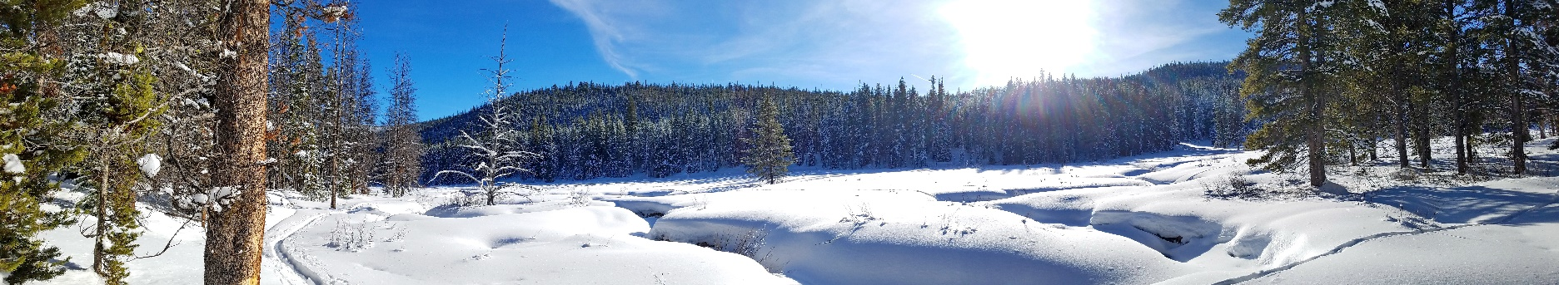

Section 4. Who is Most Vulnerable to Climate Change Impacts?  
— Alex Adams, Sue Higgins

In the previous section, we looked at how climate change can adversely impact human health. Some people are more vulnerable than others to such impacts. When considering all Americans, Gamble et al. (2016) identified those at higher risk to include children, older adults, pregnant females, tribal communities, communities of color, people with lower incomes, and people living in rural or remote regions. In addition, people with disabilities or mental health conditions, as well as people who are displaced, suffer from social isolation, or live without insurance, are also more likely to suffer adverse consequences from climate change (Forman et al. 2014).

Montanans fit into a number of these sectors and we describe nine such groups below. First, however, it is important to recognize that some people in Montana are *already*—meaning before climate change impacts—health challenged with issues like poor diet and nutrition, limited access to care, and/or chronic disease. Such challenges are depicted annually for nearly every US county in the *County Health Rankings and Roadmaps* report (Givens et al. 2019). Figure 4-1 shows how Montana’s 56 counties rank with respect to a set of “health factors” that drive how long and how well we live. Such factors—including socioeconomic, personal behavior, and the physical environment—can strongly influence new health challenges resulting from climate change.

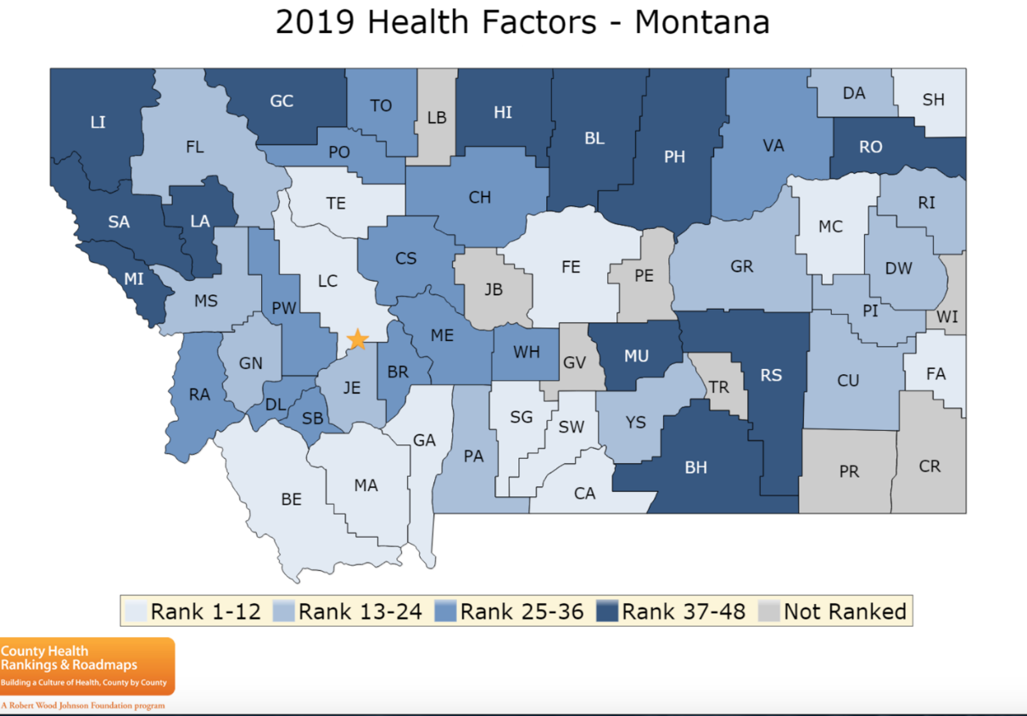

Figure 4-1. Montana’s 56 counties ranked with respect to the presence of health factors (factors that drive how long and how well we live including, for example, personal behaviors, socioeconomic factors, and the physical environment). The higher the rank, the greater the health challenge (Givens et al. 2019).

We find ten sectors of Montana’s population are at special risk of having their health impacted by Montana’s warming climate. We base that assessment on review and understanding of Montana’s health profile (Section 2), our state’s warming climate (Section 2; Whitlock et al. 2017), and known climate change impacts on human health (Section 3).

The subsections that follow describe the nine Montana sectors of concern, which are also graphically depicted in Figure 4-2.

People threatened by increased heat

*Why it matters.—*National data indicate impacts of increasing heat on mental health and risk of heat stroke (see Section 3). People without access to shade, air conditioning, and cooling places are at much greater risk. In addition, heat exposure during pregnancy carries with it the risk of premature births and birth defects (Section 3) (Ravanelli et al. 2019).

*What we know in Montana.—*Increased heat poses the greatest risk for migrant agricultural workers and others working outdoors, those living in inadequate housing (without, for example, insulation or air conditioning), and incarcerated people.

* *Those working in the outdoors.—*During the summer, migrant and seasonal farmworkers who come to Montana to harvest fruit are at increased risk due to inadequate or substandard housing facilities, poverty, cultural and linguistic isolation, and lack of health insurance. As depicted in Figure 4-2, fatalities from heat-related illness are highest in the agriculture, forestry, and fishing, and hunting sectors, attesting to the vulnerability these sectors have to high heat days (Moyce and Nealy 2019).

|  |
| --- |
| A screenshot of a social media post  Description automatically generated  Figure 4-2. Heat-related illness rate by industry (used with permission from Moyce and Nealy 2019). |

* *Housing and air conditioning.—*One form of housing that may be particularly susceptible to higher heat days are mobile homes.[17] Mobile homes are often less energy efficient than other housing and, despite the use of air conditioning, lack of insulation can make mobile homes unbearably hot. In 2017, there were 45,496 mobile homes in Montana, or 10.8% of the total housing units, which is nearly double the national average of 5.7% (Headwaters Economics 2019). In addition, mobile homes are more likely to be damaged in extreme weather, which poses a risk for both the structure and its occupants.

Data on air conditioning in Montana is sparse. Based on a small-sample survey, NEEA (2012) estimated that 19% of rural Montana households and 35% of urban households have some form of air conditioning units (NEEA 2014). The most common setup in urban areas are central air conditioning systems, while rural areas favor window. Regionally, the proportion of homes with air conditioning has been increasing. In 2009, 61% of homes in the Northern Mountain Census Division (CO, UT, WY, MT, and ID) had air conditioning, while in 2015 the percentage had increased to 71% (USEIA undated).

* *Detention centers.*—Montana has 36 county detention centers, six 72-hour hold facilities, and 26 treatment facilities. Surveys of Montana’s detention centers show inadequate plumbing, poor circulation, and mold. Such inadequacies can result in even more significant health stresses with the addition of fire, flood, or other environmental events (ACLUMT 2015).

People living in proximity to wildfire and smoke

*Why it matters.—*Particulates from wildfire smoke greatly impact incidence of lung disease and asthma (see Seeley Lake fires sidebar). Smoke and losses from fire can also cause or accentuate depression and anxiety. Montanans living in or near areas prone to wildfire are most vulnerable, though smoke can travel great distances. (Section 3 provides more information on health effects of wildfire and smoke.)

*What we know in Montana.—*The wildland urban interface includes both intermix areas, where houses and wildlands are intermingled, and interface areas, where houses are located near wildlands. In 2010, 64.1% of Montana houses were located in the wildland-urban interface (Martinuzzi et al. 2010), the second highest percentage of all Western states behind Wyoming. Over 18% of Montana houses were located in intermix areas, which is also the second highest percentage among all Western states, behind New Mexico (Headwaters Economics 2019). Houses and structures in the intermix area are at highest risk of burning, followed by those in the interface area, followed by those away from the wildland-urban interface.

|  |  |
| --- | --- |
|  | Sidebar: Seeley Lake fires |
|  |
| May want to use info from here. Have not contacted UM authors to ask them to write or for permission to use parts of report |

People facing food and water insecurity

*Why it matters.—*Montanans face the stark reality of losing nutritious—and for some, indigenous—foods due to wildfires, drought, and flood events resulting from climate change. Drought can diminish local crop yields and floods can carry and distribute crop diseases. Drinking water supplies, likewise, can be threatened—first due to diminished water availability during drought, and second due to public water and wastewater disruption and potential for water-borne pathogen spread during flooding. Home wells that are inundated can become contaminated, thereby posing a health risk.

*What we know in Montana.—*In 2017, 42,745 (10.2% of total) households received Food Stamps from the Supplemental Nutrition Assistance Program[18]; 19,564 (4.7% of total) received Supplemental Security Income[19]; and 8696 (2.1% of total) received cash public assistance income (Headwaters Economics 2019).

Nearly 10 percent of Montanans struggle with hunger and 37,000 children live in food-insecure homes. Thirty of Montana’s 56 counties have areas considered *food deserts*, i.e., low-income areas where at least 500 people and/or 33% of the residents must travel more than 10 miles to the nearest supermarket (or 1 mile in urban areas). This equates to nearly 72,000 Montanans without with fresh, affordable food on a daily basis (MFBN undated).

|  |  |
| --- | --- |
| Related image | *Nearly 10 percent of Montanans struggle with hunger and 37,000 children live in food insecure homes. Thirty of Montana’s 56 counties have areas considered to be food deserts, i.e., low-income areas where at least 500 people and/or 33% of the residents must travel more than 10 miles to the nearest supermarket (or 1 mile in urban areas). This equates to nearly 72,000 Montanans without with fresh, affordable food on a daily basis (MFBN undated).* |

Many Montanans (86%) get their drinking water from public water supplies. Most public water supply systems (94%) meet the Environmental Protection Agency’s Safe Drinking Water Standards. Still, the 2017 MCA (Whitlock et al. 2017) describes multiple threats to Montana’s domestic water supply, including drought, flooding, and extreme storm events. The MCA also states that Montana will experience reduced snowpack and diminished late season flows with changing climate. Both are critical to public and private water supplies, as well as agriculture production and, hence, food security.

Tribal members in Montana are observing impacts from climate change on traditional foods. For example, for the Crow Tribe, warming streams are affecting the distribution and health of fish species. The availability of multiple berry shrub species and other traditionally harvested plants are also impacted (Doyle et al. 2013; Martin et al. 2020). Devastating spring floods inundated the Reservation in 2007 and 2011, with the 2011 flood setting a gauging station record and damaging more than 200 homes (Olp 2011; Thackeray 2011). Many families lacked the financial resources to remediate flood damage; people have had to move back into their damaged and now mold-infested homes, in spite of the health risks (Martin et al. 2020).

Interviews with both Native and non-Native low-income residents of the Flathead Indian Reservation in northwest Montana found that half reported being food insecure. About 28% of those interviewed hunt, fish, and/or gather foods such as wild berries, and on average were more food secure than those who did not. Wild foods were valued for their taste, freshness, nutritional value, and traditional significance, as well as for increasing self-sufficiency. These residents perceived that their local wild foods are being adversely impacted by climate change, particularly by wildfires and increased variability in precipitation and seasonality (Smith et al. 2019).

People who are very young or very old

*Why it matters.—*As their bodies develop, young people are more sensitive to health problems and environmental stresses (County of Los Angeles 2013). They spend more time outside and have a faster breathing rate than adults, thus are more at risk for respiratory problems from airborne particulates, wildfire smoke, and allergens. Children are also more sensitive to infectious diseases brought on by natural disasters that might compromise water sanitation (Balbus and Malina 2009; Cooley et al. 2012).

Advanced age is the greatest risk factor related to illness or death from extreme heat (MTDPHHS 2020), due to hormonal changes that make thermoregulation and hydration more difficult (Brennan et al. 2019). In addition, the likelihood of chronic disease increases with age (CDC 2011). The elderly are more likely to have preexisting medical conditions such as diabetes, pulmonary disease, and congestive heart failure, all of which might be exacerbated by the higher temperatures expected with climate change. The elderly often have compromised mobility that reduces, as one example, their ability to respond to natural disasters. Given chronic obstructive pulmonary disease (and more), the elderly are highly susceptible to air pollution such as ground level ozone, particulate matter, or dust associated with drought, wildfires, and high wind events (Bell et al. 2014).

*What we know in Montana.—*In 2018, the percent of children younger than 5 yr was 5.9%, similar to the US average. However, 18.7% of Montana residents were 65 and older, compared to 16.0% nationwide. The proportion 65 and older is even higher in more rural counties, putting them at risk due to limited access to healthcare (see below). In the six most populous counties, 16.8% are 65 and older, while in the more rural counties 21.7% are 65 and older (US Census Bureau 2019).

People with limited access to health services

*Why it matters.—*Extreme weather events and natural disasters limit access to medical care. It is all too common for Montanans to be snowed into their rural homes, with days passing before plows can get through. In February 2018, for example, snow drifts of 20 ft were reported on the Blackfeet Reservation, and a state of emergency declared by the Tribal Council and Montana Governor Bullock (Great Falls Tribune 2/21/18; Spokesman-Review 2/27/18). Likewise, rapid spring runoff flooding, sometimes combined with major precipitation, can cut communication lines, block access to roads, and limit availability of medical services to those in remote areas. Roundup experienced such flooding in the spring of 2011, resulting in disruptions to potable water supply and closed roads (City of Roundup undated).

The inability to access medical providers resulting from such storm events is particularly consequential for those who already have compromised health (MTDPHHS 2019). Without either close-by community health services in rural Montana, or the transportation infrastructure needed to find medical attention, assistance can be greatly delayed.

*What we know in Montana.—*As of April 2019, Montana had 48 critical access hospitals, 60 rural health clinics, and 51 federally qualified health centers located outside of urban areas (HRSAa undated). Montana has the fourth largest land area of any state in the nation; thus even with these facilities, annual survey studies of Montana community members by the Montana Office of Rural Health point to health access as a major concern (Healthinfo 2017). The Federal Health Resources and Services Administration designates 23 of Montana’s 56 counties as Health Provider Shortage Areas, meaning residents have limited access to primary care providers (HRSA JJ undated). Such a designation is based on provider-to-patient ratio, percentage of the population living in poverty, and travel time to the nearest health facility.

Residents of rural counties had a mortality rate 1.5 times higher due to unintentional injury compared to residents of more urban counties. Rural county residents also had higher death rates due to chronic liver disease and cirrhosis, heart disease, diabetes, and suicide compared to residents of more urban counties, in part due to lack of immediate access to health providers (MTDPHHS 2019).

People living in poverty

*Why it matters.—*To save money, families with low incomes often must make lifestyle choices that may subject them to impacts of climate change. These tough choices can result in poor diet, inadequate shelter, delayed medical care, unhealthy housing with leaks and mold, and no funds for working fans or air conditioners. People in poverty sometimes live in mobile homes and are more vulnerable to heat-related illnesses and extreme weather events (Headwaters Economics 2019).

*What we know in Montana.—*The poverty rate in Montana is similar to the US average: in 2017, 14.4% of Montana residents lived below the federally defined poverty level compared to 14.6% nationally. However, a mean of 17.6% of young Montana residents under 18 years of age live in poverty, with highest percentages in more rural and reservation regions. The rate for residents under 5 was 20.1%. In contrast, the poverty rate for Montana residents 65 and older was 8.3% (Givens et al. 2019; US Census 2018).

American Indians

*Why it matters.—*Widespread recognition exists that American Indians are among the more vulnerable groups to climate change (Ford 2012; Bennett et al. 2014; Gamble et al. 2016). As the third National Climate Assessment’s section on Indigenous Peoples explains (Bennett et al. 2014):

Native cultures are directly tied to Native places and homelands, and many indigenous peoples regard all people, plants, and animals that share our world as relatives rather than resources. Language, ceremonies, cultures, practices, and food sources evolved in concert with the inhabitants, human and non-human, of specific homelands.

Hence, in addition to coping with long-standing economic, social, and political problems, tribes are stressed by climate changes that threaten ways of life they have been maintaining for thousands of years. Native communities’ cultural and spiritual reliance on subsistence foods, water sources, and local ecosystems contributes to an increasing vulnerability during climate events (Cozetto et al. 2013; Gamble et al. 2016). The US Global Change Research Program 2016 report summarizes climate impacts to the health of Native peoples under the themes of loss of cultural identity, water insecurity, decreased food safety and security, and degraded infrastructure (Gamble et al. 2016).

*What we know in Montana.—*Interviews with Crow Tribal Elders reveal that climate change impacts to wild foods, water quality, and traditional spiritual practices are already underway (Doyle et al. 2013; Doyle and Eggers 2017). Crow Elders express a widespread sense of environmental-cultural-health loss, along with despair at their inability to address root causes of these local impacts of climate change (Martin et al. 2019). On the Flathead Indian Reservation, more than a quarter of low-income residents surveyed (both Native and non-Native) increase their food security by harvesting wild foods; they perceive these wild food systems as already adversely impacted by climate changes such as increased wildfires and weather variability (Smith et al. 2019).

While communities nationwide share impacts to water security from droughts, floods, and other extreme climate events, the threats to culturally and nutritionally vital aquatic species are particularly serious for tribes (Cozetto et al. 2013; Donatuto et al. 2011; Doyle et al. 2013). Deteriorating water quality in Montana, in part due to climate change (Whitlock et al. 2017)*,* impacts all of us. For many Crow families, increased microbial contamination means that rivers have been lost as a source of trusted water for ceremonial drinking and bathing (Doyle et al. 2013). Addressing degraded water and wastewater infrastructure is always challenging (Ferguson et al. 2011; Ojima et al. 2013; Redsteer et al. 2011), but for tribes the maze of jurisdictional and legal complexities makes this even more difficult, as well described by the Apsaalooke Water and Wastewater Authority, Crow Reservation, Montana (Doyle et al. 2018). In response, several Montana tribes are proactively assessing current and projected climate change impacts, developing resiliency plans, and implementing adaptation strategies (see sidebar).

|  |  |  |
| --- | --- | --- |
|  | Sidebar: Changes Rippling Through Our Waters and Lives  C. Martin, J. Doyle, J. LaFrance, M.J. Lefthand, S.L. Young, E. Three Irons, and M. Eggers  The Crow Reservation is located in south central Montana, in the heart of our traditional homelands. As we live in a wide-open landscape and are tied to a different time than the fast pace of western life, our understanding of nature and observations of the seasons comes from the eye instead of a calendar or watch.  Climate change is already impacting our lands, our waters, our health and well-being. To better understand these impacts, we interviewed 26 Crow Elders about their perceptions of changes in local weather patterns and ecosystems throughout their lifetime, and how they are being affected. We conducted a thematic analysis of the interviews.  Interviewees’ observations paralleled and elaborated on western climate data: we are experiencing far less snowfall and milder winters, increased spring flooding, hotter summers, and more severe wildfire seasons. Additionally, many Elders commented on extreme, unusual, and unpredictable weather events, compared to earlier times when the seasons were consistent year after year.   |  | | --- | | Bill Lincoln picking chokecherries  on the Crow Reservation.  Photo courtesy of John Doyle. |   Interviews notably identified impacts to wild foods, which have not been recorded by western science; wild game, fish, berries, and medicinal plants are being detrimentally affected in diverse ways. Our homes and infrastructure have been hit time after time by high floods; we have few resources to repair the damage, so this is taking a toll on families, including on our health and well-being.  In addition to ecosystem resource losses and changes, we are devastated by the loss of coal jobs and coal tax revenue. More than 1200 coal mining and tax-funded jobs have been lost in the past couple years, in a community of about 8000 people. Without that income and lacking any other tax structure, we cannot adequately fund our government nor maintain our infrastructure.  Through the research we have been conducting on western climate data and with our Tribal Elders, we are able to better understand what has been happening and anticipate what is to come.  Although we are enduring unprecedented environmental change and extreme economic conditions, we are looking for solutions we can implement ourselves.  ---  For more detail, see Martin et al. (2020). |

People without adequate health insurance

*Why it matters.—*Access to health insurance is directly related to a person’s ability to respond to health emergencies. People with chronic health conditions but no health insurance are less likely to be able to manage their illnesses, putting them at greater risk should an emergency arise (Sommers et al. 2017). Those without health insurance, for example, suffer more consequences from air pollution compared to those with health insurance (Cooley et al. 2012). Likewise other climate-related concerns, such as vector- or water-borne disease, will be more difficult to treat for those without health insurance.

*What we know in Montana.—*In 2017, 91.5% of Montana residents had either private or public health insurance, close to the national average of 93.1% (Table 4-1). However, the proportion of Montana residents with health insurance varies both by age and between rural and urban places. Almost all residents old enough to qualify for Medicare have health insurance. The percent of residents with health insurance is higher in the urban counties than in rural counties.

|  |  |  |  |  |
| --- | --- | --- | --- | --- |
| Table 4-1. Percentage of Montana residents with health insurance in 2017 (US Census Bureau undated) | | | |  |
| **Residency** | **Age group** | | | |
| **17 and under** | **18-64** | **65 and older** |  |
| **All counties** | 92.4% | 83.5% | 99.7% | 91.5% |
| **Six most populous counties** | 94.7% | 86.2% | 99.7% | 92.9% |
| **All other counties** | 89.0% | 79.1% | 99.6% | 89.5% |

People with existing chronic conditions

*Why it matters.—*Data indicate that people living with existing chronic conditions (e.g., asthma, obesity, heart disease, pulmonary disease) are more vulnerable to the risks of climate impact (ref?).

*What we know in Montana.—*Rural risk factors for health disparities in Montana include geographic isolation, fewer health care providers, more health risk behaviors (such as binge drinking and unhealthy diets), lower socioeconomic status, and limited employment opportunities. Rural Montanans, regardless of race or ethnicity, have higher mortality rates for six of the ten leading causes of death, including heart disease, diabetes, and chronic liver disease, compared to residents of more urban counties (US Census Bureau 2010). The story becomes even more stark when focusing on Montana’s Native communities alone. The median age of death in Montana, for example, is 15 years younger for American Indian men compared to White men, and 17 years younger for American Indian women compared to White women.

People with mental health issues

*Why it matters.—*People living with and learning about the consequences of climate change can experience stress, anxiety, and deep feelings of loss (Clayton et al. 2017). A 2018 Yale survey found that nearly 70% of Americans are “worried” about climate change, 29% are “very worried,” and 51% said they felt “helpless” (Climate Communications Yale 2018). Chronic conditions like depression and anxiety can be worsened by climate change with consequences ranging from minimal stress to clinical disorders such as post-traumatic stress disorder and suicidal thoughts (USGCRP 2016). Feelings of hopelessness, helplessness, apathy, denial, and fatalism associated with environmental change have become so prevalent as to have earned their own diagnostic terms, including *climate grief*, *eco-anxiety*, and *solastalgia* (Albrecht et al. 2007; Scher 2018; Clayton et al. 2019; Time 11/21/2019).

*What we know in Montana.—_______* Need some text _______.

Along with the mental health issues shared by many across Montana, tribal members may suffer a unique type of personal anguish, one tied to tribal history, which changes brought by climate change can exacerbate. In a study conducted primarily by Crow Tribal members, 26 Tribal Elders were interviewed about the impacts of climate change on local ecosystems and community health. Nearly all participants described a sense of loss in relation to the impacts from changing climate and environmental conditions on their land. They write (Martin et al. 2020):

For us, and perhaps for many other indigenous people, the changes aren’t simply unfamiliar alterations in our home environment causing discomfort—they are direct threats to our ability to carry on the traditional practices which define us as a people. It is history repeating itself in an even more insidious way. We lost the majority of our lands through treaties and Congressional acts. We lost generations of raising and educating our own children through federal boarding schools starting in the 1880s. We have since lost the upper Bighorn River to Yellowtail Dam, agricultural and recreational lands to non-Tribal members, much of our traditional diet—the list goes on. Now, even though we live in our traditional territory, the changes in climate are changing our homelands all around us, and this time there is no single enemy to fight.

What conclusions can we draw?

The 2017 Montana Climate Assessment (Whitlock et al. 2017) finds that Montana will experience more 90-degree+ heat days, increased wildfires, more spring flooding, and less water available with more drought during the late growing season. Given this knowledge, communities need to take action now to protect the health of Montana’s residents most vulnerable to impacts of climate change: children, the poor, the elderly, people with chronic illnesses, people who make their living outdoors, rural Montanans with poor access to health care, and Native communities with significant traditional and subsistence ties to the land. The next section helps set systems in place for how community members, medical clinic, public health programs, and city, state, and tribal planners can respond now to address these inequities.

**Literature Cited**

[ACLUMT] American Civil Liberties Union of Montana. 2015. Locked in the past—Montana's jails in crisis. [internal report] 74 p. Available online <https://www.aclumontana.org/sites/default/files/field_documents/2015-aclu-jail-report.pdf>. Accessed 28 Feb 2020.

[Albrecht G](https://www.ncbi.nlm.nih.gov/pubmed/?term=Albrecht%20G%5BAuthor%5D&cauthor=true&cauthor_uid=18027145)1, [Sartore GM](https://www.ncbi.nlm.nih.gov/pubmed/?term=Sartore%20GM%5BAuthor%5D&cauthor=true&cauthor_uid=18027145), [Connor L](https://www.ncbi.nlm.nih.gov/pubmed/?term=Connor%20L%5BAuthor%5D&cauthor=true&cauthor_uid=18027145), [Higginbotham N](https://www.ncbi.nlm.nih.gov/pubmed/?term=Higginbotham%20N%5BAuthor%5D&cauthor=true&cauthor_uid=18027145), [Freeman S](https://www.ncbi.nlm.nih.gov/pubmed/?term=Freeman%20S%5BAuthor%5D&cauthor=true&cauthor_uid=18027145), [Kelly B](https://www.ncbi.nlm.nih.gov/pubmed/?term=Kelly%20B%5BAuthor%5D&cauthor=true&cauthor_uid=18027145), [Stain H](https://www.ncbi.nlm.nih.gov/pubmed/?term=Stain%20H%5BAuthor%5D&cauthor=true&cauthor_uid=18027145), [Tonna A](https://www.ncbi.nlm.nih.gov/pubmed/?term=Tonna%20A%5BAuthor%5D&cauthor=true&cauthor_uid=18027145), [Pollard G](https://www.ncbi.nlm.nih.gov/pubmed/?term=Pollard%20G%5BAuthor%5D&cauthor=true&cauthor_uid=18027145). 2007. Solastalgia: the distress caused by environmental change. [Australas Psychiatry](https://www.ncbi.nlm.nih.gov/pubmed/18027145) 15(Suppl 1):S95-8. doi:[10.1080/10398560701701288](https://doi.org/10.1080/10398560701701288)

Balbus JM, Malina C. 2009. Identifying vulnerable subpopulations for climate change health effects in the United States. Journal of Occupational and Environmental Medicine 51(1):33-7. doi: 10.1097/JOM.0b013e318193e12e.

Bell ML, Zanobetti A, Dominici F. 2014. Who is more affected by ozone pollution? A systematic review and meta-analysis. American Journal of Epidemiology 180(1):15–28.

Bennett TMB, Maynard NG, Cochran P, Gough R, Lynn K, Maldonado J, Voggesser G, Wotkyns S, Cozzetto K. 2014. Indigenous Peoples, Lands, and Resources [chapter]. In: Melillo JM, Richmond TC, Yohe GW, eds. 2014: climate change impacts in the United States: the third national climate assessment. Washington DC:US Global Change Research Program. Available online https://nca2014.globalchange.gov/highlights/report-findings/indigenous-peoples. Accessed 29 Feb 2020.

Brennan M, O’Keeffe ST, Mulkerrin EC. 2019. Dehydration and renal failure in older persons during heatwaves-predictable, hard to identify but preventable? Age and Ageing 48(5)615–8.

[CDC] Centers for Disease Control and Prevention. 2011. [internal report] Morbidity and Mortality Weekly Report vol. 60. CDC health disparities and inequalities report—United States, 2011. 116 p. Available online http://www.cdc.gov/mmwr/pdf/other/su6001.pdf. Accessed 29 Feb 2020.

City of Roundup. [undated]. Floods of 2011. Available online <http://www.roundupmontana.net/flood-2011.html>. Accessed 28 Feb 2020.

Clayton S, Manning C, Krygsman K, Speiser M. 2017. [Mental health and our changing climate: impacts, implications, and guidance](https://www.apa.org/news/press/releases/2017/03/mental-health-climate.pdf) [report]. Washington, D.C.: American Psychological Association, and ecoAmerica. 70 p. Available online https://www.apa.org/images/mental-health-climate_tcm7-215704.pdf. Accessed 29 Feb 2020.

Climate Communication Yale. 2019. Climate change in the American mind: December 2018 [website]. New Haven CT:Yale University, Yale Program on Climate Communication. Available online <https://climatecommunication.yale.edu/publications/climate-change-in-the-american-mind-december-2018/4/>. Accesed 29 Feb 2020.

Cooley H, Moore E, Heberger M, Allen L. 2012. Social vulnerability to climate change in California (California Energy Commission Pub. # CEC-500-2012-013, 2012).

County of Los Angeles. 2013. County of Los Angeles Public Health, Health Atlas for the City of Los Angeles (Los Angeles, CA, June 2013). http://healthyplan.la/wordpress/wp-content/uploads/2013/10/Health-Atlas-for-the-City-of-Los-Angeles-July-2013- FINAL-SMALL.pdf

Cozetto K, Chief K, Dittmer K, Brubaker M, Fough R, Souza K, Ettawageshik F, Wotkyns S, Opitz-Stapleton S, Duren S, Chavan P. 2013. Climate change impacts on the water resources of American Indians and Alaska Natives in the US. Climatic Change 120:569–84. doi:10.1007/s10584-013-0852-y.

Donatuto JL, Satterfield TA, Gregory R. 2011. Poisoning the body to nourish the soul: prioritising health risks and impacts in a Native American community. Health, Risk, and Society 13(2):103-27. doi:10.1080/13698575.2011.556186.

Doyle JT, Redsteer MH, Eggers MJ. 2013. Exploring effects of climate change on Northern Plains American Indian health. Climatic Change 120(3):643–55. doi:10.1007/s10584-013-0799-z.

Doyle JT, Eggers MJ. 2017. Tribal community knowledge of climate changes, Crow Reservation, Montana. In Montana Climate Assessment. Montana Climate Office, University of Montana, Missoula, MT.

Doyle JT, Kindness L, Realbird J, Eggers MJ, Camper AK. 2018. Challenges and opportunities for tribal waters: addressing disparities in safe public drinking water on the Crow Reservation in Montana, USA. International Journal of Environmental Research in Public Health 15(4):E567. doi:10.3390/ijerph15040567.

Ferguson DB, Alvord C, Crimmins M, Redsteer HM, Hayes M, McNutt C, Pulwarty R,Svoboda M. 2011. Drought preparedness for tribes in the Four Corners region. Report from April 2010 Workshop. Tucson, AZ: Climate Assessment for the Southwest. 42 pp., The Climate Assessment for the Southwest (CLIMAS), The Institute of the Environment, The University of Arizona.

Ford JD. 2012. Indigenous health and climate change. American Journal of Public Health 102(7):1260-6.

Gamble J,  Balbus J, Berger M, Bouye K, Campbell V, Chief K, Conlon K, Crimmins A, Flanagan B, Gonzalez-Maddux C,  Hallisey E, Hutchins S, Jantarasami L, Khoury S, Kiefer M, Kolling J, Lynn K, Manangan A, McDonald M, Morello-Frosch R, Hiza M, Sheffield P, Thigpen Tart K,  Watson J, Whyte KP, Wolkin AF. 2016. Chapter 9: populations of concern. In: XYA, XYC, DER, eds. The impacts of climate change on human health in the United States: A Scientific Assessment. Washington DC:US Global Change Research Program. p 247-86. Available online https://doi.org/10.7930/J0Q81B0T. Accessed 28 Feb 2020.

Givens M, Jovaag A, Roubal A. 2019. Montana: 2019 county health rankings report. Madison WI: University of Wisconsin Population Health Institute. 16 p. Available online https://www.countyhealthrankings.org/sites/default/files/media/document/state/downloads/CHR2019_MT.pdf. Accessed 28 Feb 2020.

Great Falls Tribune. 21 Feb 2018. Critical human needs rise as Blackfeet endure unrelenting winter storms. Available online <https://www.greatfallstribune.com/story/news/2018/02/21/critical-human-needs-rise-blackfeet-endure-unrelenting-winter-storms/359300002/>. Accessed 28 Feb 2020.

Headwaters Economics. 2019. Populations at risk [website]. Available online <https://headwaterseconomics.org/tools/populations-at-risk/>. Accessed 28 Feb 2020.

Healthinfo. 2017. Addressing health needs in rural Montana: an aggregate summary of community health needs assessments and implementation plans of Montana critical access and rural hospitals 2015-2017. [internal report?] Available online <http://healthinfo.montana.edu/morh/Addressing%20Health%20Needs%20in%20Rural%20Montana.pdf>. Accessed ____.

[HRSAa] Health Resources and Services Administration. [undated]. Explore data and maps on HRSA’s health care programs. [website] Available at data.HRSA.gov. Accessed 29 Feb 2020.

[HRSAb] Health Resources and Services Administration. [undated]. Health workforce: shortage designation scoring criteria [webpage]. Available online https://bhw.hrsa.gov/shortage-designation/hpsa-criteria. Accessed 29 Feb 2020.

Martin C, Doyle J, LaFrance J, Lefthand MJ, Young SL, Three Irons E, Eggers M.J. 2019. Change rippling through our waters and culture. Journal of Contemporary Water Research and Education. Accepted contingent on minor revisions.

Martin C, Doyle J, LaFrance J, Lefthand MJ, Young SL, Three Irons E, Eggers M. 2020. Change rippling through our waters and culture. Journal of Contemporary Water Research and Education. In final review.

Martinuzzi S, Steward SI, Helmers DP, Mockrin MH, Hammer RB, Radeloff VC. 2010. The 2010 wildland-urban interface of the conterminous United States. Research Map NRS-8. Us Forest Service, Northern Research Station.

[MDR] Montana Department of Revenue. [undated]. Montana and manufactured homes. [website] Available online https://mtrevenue.gov/property/property-types/mobile-manufactured-homes/. Accessed 28 Feb 2020.

[MFBN] Montana Food Bank Network. [undated]. Hunger in Montana. [website] Available online https://mfbn.org/hunger-in-montana/. Accessed 28 Feb 2020.

Moyce S, Nealy E. 2019. Montana’s hot jobs: heat-related illness in the occupational setting. Presented at Montana Environmental Health Association/Montana Public Health Association Annual Conference and Meeting. September, Bozeman, MT.

[MTDPHHS] Montana Department of Public Health and Human Services. 2019. Montana state health improvement plan, 2019-2023. [internal report] 35 p. Available online https://dphhs.mt.gov/Portals/85/ahealthiermontana/2019SHIPFinal.pdf. Accessed 28 Feb 2020.

[NEAA] Northwest Energy Efficiency Alliance. 2012. 2011 Residential building stock assessment: single-family characteristics and energy use. A report to NEAA from Ecotope Inc, Seattle WA. 231 p. Available online https://neea.org/img/documents/residential-building-stock-assessment-single-family-characteristics-and-energy-use.pdf. Accessed 28 Feb 2020.

[NEAA] Northwest Energy Efficiency Alliance. 2014. Montana single-family homes—state summary statistics. [internal report] Portland OR: NEAA. 21 p. Available online https://neea.org/img/documents/montana-state-report-final.pdf. Accessed 28 Feb 2020.

Ojima D, Steiner J, McNeeley S, Cozetto K, Childress A. 2013. Great Plains Regional Climate Assessment Technical Report, National Climate Assessment 2013. 301 p.

Olp S. 2011. Crow flooding: more than 200 Crow Reservation homes damaged, destroyed from flooding. Billings Gazette. June 15, 2011. Billings, MT

Ravanelli N, Casasola W, English T, Edwards K M, Jay O. 2019. Heat stress and fetal risk. Environmental limits for exercise and passive heat stress during pregnancy: a systematic review with best evidence synthesis. British Journal of Sports Medicine 53(13):799-805.

Redsteer MH, Kelley KB, Francis H, Block D. 2011. Disaster risk assessment case study: recent drought on the Navajo Nation, southwestern United States. Contributing Paper for the Global Assessment Report on Disaster Risk Reduction. 19 p. United Nations Office for Disaster Risk Reduction and U.S. Geological Survey, Reston, VA.

Scher A. 24 Dec 2018. Climate grief: the growing emotional toll of climate change. NBC News. Retrieved from: [www.nbcnews.com/health/mental-health/climate-grief-growing-emotional-toll-climate-change-n946751](http://www.nbcnews.com/health/mental-health/climate-grief-growing-emotional-toll-climate-change-n946751).

Sommers BD, Gawande AA, Baicker K. 2017. Health insurance coverage and health--what the recent evidence tells us. New England Journal of Medicine 377(6):586-93. doi:10.1056/NEJMsb1706645.

Smith E, Ahmed S, Dupuis V, Running Crane M, Eggers M, Pierre M, Flagg K, Byker Shanks C. 2019. Contribution of wild foods to diet, food security, and cultural values amidst climate change. Journal of Agriculture, Food Systems, and Community Development 9(B):191-214. Available online https://doi.org/10.5304/jafscd.2019.09B.011. Accessed 28 Feb 2020.

Spokesman-Review. 27 Feb 2018. Relentless winter brings state of emergency to Montana reservations. Available online <https://www.spokesman.com/stories/2018/feb/27/relentless-winter-brings-state-of-emergency-to-mon/>). Accessed 28 Feb 2020.

Thackeray L. 2012. 2012 Montana wildfires burn most acreage since 1910. Billings Gazette. 11/1/2012. Billings, MT

Time. 21 Nov 2019. [Terrified of climate change? You might have eco-anxiety](https://time.com/5735388/climate-change-eco-anxiety/).

US Census Bureau. 2010. Urban and rural classification and urban area criterion. Available online https://www.census.gov/programs-surveys/geography/guidance/geo-areas/urban-rural/2010-urban-rural.html. Accessed 29 Feb 2020.

US Census Bureau. 2018. US Census American community survey 2013-2017 5-year data release. [website] Available online https://www.census.gov/newsroom/press-kits/2018/acs-5year.html. Accessed 29 Feb 2020.

US Census Bureau. 2019. State population by characteristics: 2010-2019 [webpage]. Available online https://www.census.gov/data/tables/time-series/demo/popest/2010s-state-detail.html#par_textimage_785300169 gov. 2010. Accessed 29 Feb 2020.

[USEIA] US Energy Information Administration. [undated]. Residential energy consumption survey [webpage]. Available online <https://www.eia.gov/consumption/residential/>. Accessed 28 Feb 2020.

[USGCRP] US Global Change Research Program. 2016. The impacts of climate change on human health in the United States: a scientific assessment. Crimmins A, Balbus J, Gamble JL, Beard CB, Bell JE, Dodgen D, Eisen RJ, Fann N, Hawkins MD, Herring SC, Jantarasami L, Mills DM, Saha S, Sarofim MC, Trtanj J, Ziska L, eds. Washington DC: U.S. Global Change Research Program. 312 p. Available online <https://health2016.globalchange.gov>. Accessed 1 Mar 2020. <http://dx.doi.org/10.7930/J0R49NQX>.

Whitlock C, Cross W, Maxwell B, Silverman N, Wade AA. 2017. 2017 Montana Climate Assessment. Bozeman and Missoula MT: Montana State University and University of Montana, Montana Institute on Ecosystems. 318 p. DOI:10.15788/m2ww82. Available online <http://montanaclimate.org>. Accessed September 2019.

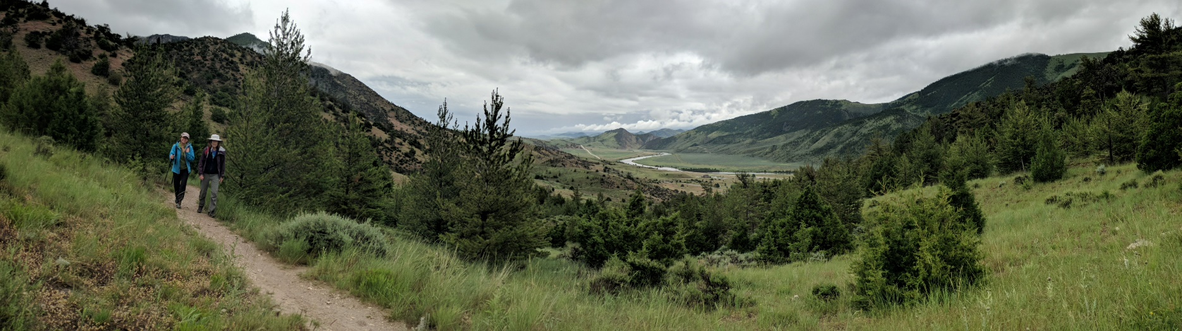

Section 5. Climate Health Actions for Individuals, Communities, and Healthcare Practitioners and Clinics  
**— Alex Adams, Sue Higgins, Mari Eggers**

Opportunities abound for Montana individuals, communities, and health practitioners—be they single providers or clinics—to address climate-change-induced health concerns. In this section, we catalog ways each of these groups can prepare for, respond, or adapt to our state’s warming climate. We describe actions and resources for dealing with the key health issues described in Sections 3 and 4, with a goal of providing information that helps Montanans maintain optimal health in the face of climate change. The recommendations are not exhaustive, and some of these actions are not available to everyone. It may seem like the challenge is too great, but any small effort to improve your health, wellbeing, and personal resilience makes a difference.

Tackling problems of climate-induced environmental health issues—e.g., dried up rivers, increased forest disease, or wilting crops—often involves discussions of mitigation and adaptation. Mitigation is the work to reduce or stabilize the changes already taking place. Adaptation involves efforts to adjust to life in a changing climate. Mitigation and adaption efforts also apply to tackling climate-induced human health issues. Such efforts can be simple, yet collectively make a big difference. For example, growing a nutritious and shared community garden, creating more green space by planting a tree, taking walks with a friend, buying an electric car, eating more local foods, installing solar panels, driving less, recycling, biking, and more: all play a part in strengthening individual and community health (Khumalo and Stoneciper 2018).

|  |  |
| --- | --- |
| Related image | *While the risks and outcomes of climate change may seem beyond anyone’s direct control, there are many actions possible for protecting your health, your family’s health, and your community’s health.* |

While the risks and outcomes of climate change may seem beyond anyone’s direct control, there are many actions possible for protecting your health, your family’s health, and your community’s health. The remainder of this section details those actions, as well as key information sources, in three subsections: for individuals, for communities, and for health practitioners. Now is the right time to explore these healthcare options; create goals and actions plans; and build relationships to understand who around you are most vulnerable to climate health impacts, and who are best situated to provide support.

Personal Actions: Preparing Yourself for Health Risks

Below we recommend actions individuals can take to prepare for or minimize health risks associated with climate change. The recommendations are broken into climate concerns similar to those addressed in Section 3 (global and national health concerns in a changing climate) and Section 4 (Montana sectors vulnerable to climate change).

Protecting your health in a changing climate takes work. While we provide actions and information for climate-induced health concerns, there are two simple steps every individual can take now. First, have regular checkups with a health care professional; and second, stay informed regarding expected and ongoing climate impacts.

Extreme events and disaster planning

Montana is expected to experience weather extremes, from more thunderstorms to more intense heat waves (Section 2) (Whitlock et al. 2017). During the winter, many Montanans will experience severe storms with frigid temperatures, high winds, and heavy snows.

Here’s what you can do:

* Plan ahead so that you can comfortably stay in your home during these events, including having several days of medications, water, and food safely stored in the home. Make sure you have adequate blankets or sleeping bags to stay warm during low temperatures and/or power outages.
* Install a functional carbon monoxide detector in your home during cold temperatures. If you use a furnace system, change and check the furnace filter regularly.
* Extreme weather events—e.g., floods, drought, wildfires, and severe winter storms—pose serious risks to mental health, particularly if these events are accompanied by displacement, or loss of property or life. They can bring increased risk of anxiety, depression, post-traumatic stress disorder, suicidal thoughts, and suicide (USGCRP 2016; Kuipers 2019). If you experience a traumatic extreme weather or climate event, seek support from a healthcare professional.
* If your home could flood from a natural disaster, check with your insurance provider as you might need to purchase separate coverage from the National Flood Insurance Program (FEMAa undated).

Heat

Whitlock et al. (2017) document that with climate change the number of days when temperature exceeds 90oF in Montana is increasing.

Here’s what you can do:

* During the summer, ensure that you have curtains or shades on windows, as well as adequate ventilation or air conditioning, to help keep your living space cool during high temperatures.
* Explore retrofit options to help keep your home cooler, including white roofing and added insulation and ventilation.
* Get acquainted with cooling centers or other options in your community where you can seek shelter in extreme heat events.
* Learn the signs of heat exhaustion and heat stroke (Figure 5-1). Get out of the sun as soon as possible; drink water and take breaks in the shade if you experience heat exhaustion. If you believe you have heat stroke, seek immediate medical attention.

|  |
| --- |
| A screenshot of a cell phone  Description automatically generated  Figure 5-1. Recognize the difference between heat exhaustion and heat stroke, and respond quickly. Note that heat stroke requires immediate medical attention (image courtesy NWS undated). |

Air quality

Climate change is expected to affect respiratory health through increased air pollution including wildfire smoke, and a longer dust and pollen season (Section 3). People with pollen sensitivities may experience more severe reactions, and those with respiratory conditions such as asthma may be especially at risk (Sarfaty et al. 2017).

Here’s what you can do:

General

* When outdoor air quality is poor, reduce sources of indoor air pollution. Avoid burning candles, smoking tobacco, using aerosol sprays, or burning your wood stove or fireplace.
* Protect air quality inside your home by using air filters and keeping doors and windows closed when outdoor air quality is poor. Consider installing HEPA filters and/or activated carbon filters in your home or business to remove dust, pollen, and smoke particles. Filter efficiency is rated by the Minimum Efficiency Reporting Value (MERV) system on a scale of 1-20; the higher the number the better the filter (USEPAa undated). The best filters, MERV rating of 17-20, are called High Efficiency Particulate Air (HEPA) filters. Check with the manufacturer or their local representative to find out what filters will work with your furnace. You may wish to upgrade to a HEPA filter only during poor air quality events. If you use a portable air cleaner instead, know that the less expensive ones (under $200) may not filter out wildfire smoke. Mechanical cleaners are reliable while some electronic cleaners produce hazardous ozone and/or other hazardous chemicals (USEPAa undated).
* Monitor pollen conditions, develop a treatment plan with you allergist, and have the necessary medications on hand. Periods of drought may also increase irritants such as dust, so limit your time outside during times of high pollen and/or dust.
* You can check current air quality anywhere in the country, including Montana, at http://airnow.gov [20]. The website color coding system, from green to dark red, makes it easy to tell what level of health risk currently exists for your location. There is also an Airnow app for iOS and Android mobile devices.
* Support transitioning to clean, renewable sources of energy. As the American Lung Association states in their Lung Health Brief, “Switching to clean, renewable energy will allow the US to generate electricity without adding pollution that harms Americans’ health… Decades of research shows that these pollutants trigger asthma attacks and heart attacks, cause cancer, and shorten lives, among many other health impacts.” (American Lung Association, Lung Health Policy Brief “Clean Energy and Health” – I’m tracking down a citation.)

Wildfire smoke

* To protect your home from fire, remove trees, dead brush, or other flammable materials near the home exterior. Check with your local fire department for more detailed advice applicable to your local conditions.
* When smoke is present, keep your windows closed and carefully monitor the status of wildfires in your region. If you live in a high-fire-risk area, have an evacuation plan and be prepared to leave your home on a moment’s notice, if necessary.
* Wildfire smoke creates a fine particulate matter that cannot be filtered by dust masks or bandanas (Secton 3). These fine particles can increase the risk of heart attack or stroke, especially in individuals age 65 and older (American Heart Association 2018; Wettstein et al. 2018). Those with respiratory conditions and the young are especially vulnerable to wildfire smoke. When smoke is present, avoid extended periods outside and keep inside air clean by closing windows and doors. If it is too warm to comfortably stay inside, seek shelter away from the smoke such as in a designated evacuation center (CDC 2019).
* Do not hold or participate in outdoor activities, especially rigorous outdoor activities like running and other sports, when wildfire smoke or haze is visible. Check with your local health department to see if they have issued air quality advisories to schools for outdoor sports. Ask your children’s schools if they receive air quality advisories and if so, if they abide by them. (Note: health departments can provide advice only; they cannot cancel school sports events.)

Flood and drought

In some areas of Montana, climate change has the potential to negatively impact drinking water quality and quantity as the climate warms (Whitlock et al. 2017). For example, flooding can contaminate groundwater sources and harmful algal blooms are expected to become more frequent in a warming climate. The trends of early-season runoff and late-season drought described by Whitlock et al. (2017) can also impact food security and the incidence of vector-borne disease.

Here’s what you can do:

* Protect your home from the risk of mold by checking for piping leaks or water accumulation under sinks, in crawl spaces, or in basements. Install drainage systems to prevent rainwater or saturated grounds from damaging your home, including providing a foothold for mold and rot.
* If you find mold in your home, act quickly. Not only are there health effects from mold exposure, but also the longer mold grows the more damage it will cause to your home. You must both eliminate the water source and remove the mold. EPA’s *A Brief Guide to Mold, Moisture, and Your Home* provides a useful guide, including the tradeoffs between cleaning your home yourself versus employing a professional (USEPA 2012).
* For homes with wells, monitor water supply and make your home as water-efficient as possible. These are good practices anytime, and potentially critical during times of drought. Store spare water in case of an emergency that interrupts water supplies.
* Ensure your wellhead has a watertight “sanitary” cap, rather than an old-style cap with no gasket. The casing for your well must extend at least 18” above the natural ground surface; casing extensions can be added if needed (USEPAb undated). These features protect your home well water from contamination year-round, and especially in the event of a flood.
* In case of flood contamination of your home well or municipal supply, be prepared to boil, filter, or chemically purify your own water before drinking Such treatments can eliminate most organic contaminants and microbes (USEPAc undated). Organic compounds can be the biggest concern during a flood due to sewage (human, livestock) runoff. However, those with wells should know—in advance via testing—if their water contains such inorganic contaminants as uranium, arsenic, manganese, or other metals. That knowledge is important enough under normal conditions. In the case of flood, such contaminants might make boiling your water a poor idea as boiling will likely concentrate the inorganic contaminants, resulting in increased health danger. Uranium, arsenic, and some other hazardous contaminants have no taste, smell or color—so you won’t know they are present until you have your water tested.
* Never swim in, nor drink from, water where blue-green algae (cyanobacteria) are visible or where hazardous algal blooms have been reported (MTDPHHS undated). Similarly, keep pets and livestock away from water where hazardous algal blooms are present. Cyanobacteria occur throughout Montana in lakes, reservoirs, and any other standing body of water exposed to the sun, and all species have the potential to produce toxins. If you are camping, understand that boiling, filtering, or adding tablets to water will not remove these toxins. Public drinking water supplies in Montana are not required to monitor or test for cyanobacterial toxins (MTDPHHS undated). For further information, see the *Harmful Algal Bloom Guidance Document for Montana* (MTDPHHS 2019).

Food security

The late season drought projected in the MCA (Whitlock et al. 2017) can lead to crop losses, lower yields, higher food prices, and higher risk of food-borne disease.

Here’s what you can do:

* Buy from local food sources whenever possible. Plant and grow your own vegetables using organic fertilizer and an efficient irrigation system.
* Learn how to prepare and store more foods for later use.
* For the small farmer, consider new strategies such as growing pulse crops like lentils, which consume less water and adapt to hot summer temperatures; or early detection and aggressive management of weeds (MSU Extension 2017).
* Learn from—and possibly help create your own—community project that focuses on [local food and agriculture](https://www.missoulaclimate.org/local-food-and-agriculture.html). Such a project is underway in Missoula, where participants envision “…a vibrant, affordable, and resilient local food and agriculture economy in the Missoula community with an educated consumer base that creates sufficient demand for local food” (Climate Smart Missoula undated). Such programs can help people become engaged in local healthy foods policies that assure nutritious foods in schools, learn to grow their own fruit and vegetable gardens, and capture and reuse water.

Vector-borne disease

Changing temperatures and water regimes are expected to expand the range of illnesses spread by vectors such as mosquitos, ticks, and fleas (Section 3).

Here’s what you can do:

* Mount (or repair) screens on windows and doors to prevent mosquitos from entering your home.
* Monitor outbreaks of vector-borne illnesses—e.g., West Nile Virus, Rocky Mountain Spotted Fever and Zika—spread by mosquitos, ticks, and fleas through the Montana Department of Health and Human Services web updates available at https://dphhs.mt.gov/publichealth/cdepi/surveillance, or through your local health department. An example of the data that can be found there is provided in Figure 5-2.

|  |
| --- |
| Figure 5-2. Summary of tickborne diseases as reported by Montana residents between 2003-2018. The figure is an example of vector-borne disease tracking that citizens can access from the Montana Department of Public Health and Human Services website—start at https://dphhs.mt.gov/publichealth/cdepi/surveillance . |

* Although not indicated at present, also watch for potential emergence of zoonotic disease (sickness from human contact with infected animals) by monitoring this DPHHS source: https://dphhs.mt.gov/publichealth/cdepi/diseases/zoonotic.
* To prevent bug bites use bug spray; wear light-colored long sleeve shirts and loose-fitting clothing; avoid outdoor time during peak mosquito times, especially at dawn and dusk; and tuck your pants into your socks when walking through grasses or areas where ticks are common. Check yourself for ticks when you return home.

Mental health: getting involved and finding support

The impacts of heat and fire, flood and drought have major influence on our mental health. Recognizing that you need help and taking the first steps to process hard times is often the most difficult. General approaches to protecting mental health include crisis counseling, primary care intervention, individual and group therapy, and practices that increase emotional coping ability (Hayes et al. 2018).

Here’s what you can do:

* Learn more about coping skills. If you can, seek advice from a mental health counselor, therapist, or another trusted support person.
* Get involved with art, literature, and spirituality; spend time with friends; and experience and preserve nature to increase emotional resiliency (Koger et al. 2011; Holt-Lunstad, Smith, Baker, Harris, Stephenson 2015; Hayes et al. 2018).
* Involvement in civic action such as polling, voting, or advocacy is another way to build community and be proactive. Involvement in climate change adaptation or mitigation has been shown to have mental health benefits (Reser et al. 2012), so find a group or organization that is active on climate change issues and get involved.
* Foster optimism by maintaining connectedness to family, place, culture, and community (Clayton et al. 2017). Talk with others about climate-related distress (e.g., the “[Good Grief Network](https://www.goodgriefnetwork.org/)”) (Scher 2018; Stern 2019).
* Seek solace in nature as a way help overcome feelings of anxiety, hopelessness, and powerlessness over the future (Koger et al. 2011).

Community Actions: Teaming Up for Success

Montana communities vary widely in the financial and human resources they have available to develope climate change plans and solutions. Yet, no matter the level of community resources and support available, it is always possible to make progress and implement strategies that best “fit” the community.

The impacts of climate change on health will also not be equal among community members (Islam and Winkel 2017; National Geographic 2019. It is important to develop climate action plans that are equitable and tailored in each community to the demographics (e.g., age and income distributions), exposures (climate components like increasing temperatures), and risks (the likelihood that the exposure events, like major forest fire nearby or flooding, will occur). Likewise, it is critical in planning to consider the needs of each community’s unique vulnerable populations, as described in Section 4.

Planning Ahead

Climate change impacts are starting to threaten state and local government credit ratings. Adaptation planning can reduce this threat. Governments are assessed by rating agencies for their ability to repay these loans, yet climate changes can threaten that capacity in multiple ways. Climate surprises such as drought, flooding, or other disasters can trigger an exodus of residents, resulting in declining tax revenue. Long-term climate changes such as hotter, drier summers and frequent wildfires can also reduce population and decrease demand for housing, leading to declines in property value and taxes paid. These occurrences add to the risks that rating agencies asses. As a result, they might lower a government’s credit rating which may ultimately increase its cost of borrowing money via bonds (New York Times 2019).

To better assess climate change risks, the rating agency Moody’s recently bought a controlling share of a company that specializes in climate change risk assessment. According to the New York Times several major rating agencies, including S and P Global and Moody’s, have issued reports “…warning state and local governments that their exposure to climate risk could affect their credit rating. Moody’s has said that cities and counties with plans for reducing their exposure to climate risks, by updating their infrastructure for example, could see their ratings improve as a result, or at least not deteriorate” (New York Times 2019).

Therefore, it is vital to the economic future of Montana communities that our state and local governments implement climate-change adaptation and mitigation planning. A wealth of online guides, toolkits, and outreach materials are available to help us build our resilience to climate-change impacts. Those resources have been developed by various federal agencies and professional and non-profit organizations, with myriad examples from successful communities.

One source of such materials is the Center for Disease Control’s Climate and Health Program, which provides comprehensive guides and funding sources for health departments and public health professionals. That program’s Building Resilience Against Climate Effects (BRACE)[21] plan offers a five-step program to assist health officials in developing strategies that will help their communities prepare for the health effects resulting from, or exacerbated by, climate change (Figure 5-3).

|  |
| --- |
| A close up of a sign  Description automatically generated  Figure 5-3. The CDC’s Climate-Ready States and Cities Initiative[22] competitively funds states and large cities to implement the five-step BRACE framework18 shown here. |

Initiating the BRACE or other planning framework requires broad community engagement. Carefully consider the support of your citizens and leaders. It is possible, and perhaps likely, that a community’s first step will be to implement a well-thought-out engagement and education campaign. As the National League of Cities advises in its multi-faceted (over 100 concepts presented) guide to local actions to address climate change (NLCI undated), “Start with people, stay with people: build an inclusive, broad public engagement program with local partners to grow public support and political will for climate action.”

|  |  |
| --- | --- |
| Related image | *As the National League of Cities advises, “Start with people, stay with people: build an inclusive, broad public engagement program with local partners to grow public support and political will for climate action.* |

The first step in creating a climate action plan is to do an assessment of sensitivity, exposure, and risk for your community. That assessment will form the basis for creating your community’s plan describing how it will prepare for and react to human health issues that result from climate change. When you come together, include local leaders, health professionals, citizens and a diverse stakeholder group broadly representing your community, and people experienced in creating climate-change plans. Be sure to explore the following questions:

* What is your community’s capacity to develop a health and climate assessment or action plan, and is the BRACE framework, or some other process, best suited for your community?
* Are funding sources available for this process including outside facilitation to help guide your climate and health assessment and eventual development of an action plan for your town?
* Are any stakeholder groups under-represented on your team and, if so, how can you engage them? What kind of community outreach will your team need to accomplish before, during, and after development of your climate action plan?
* What are the major climate- and health-related risks your community will likely experience in the coming decades? Who and what (e.g., limited medical services) are most vulnerable to health impacts from climate change in your town or region?
* Could first-step targeted activities be initiated in your community *before* conducting a full climate and health assessment plan? If so, what steps? Getting started is one way to build support for further action, plus can help develop climate and health literacy.

With patience, capable facilitation and access to health- and climate-science expertise, your community can assess its health vulnerabilities to climate change, identify the most suitable and highest priority interventions, and then create and continuously improve your community, climate-action plan. That plan will describe mitigation or adaptation actions that fit your local conditions. For example, the adjacent sidebar shows how the communities of the Blackfeet Tribe and the Confederated Salish and Kootenai Tribes responded to climate-related changes faced by their people and landscapes.

The remainder of this subsection highlights some strategies your community will want to consider.

|  |  |  |  |  |  |  |  |  |  |  |  |  |  |  |  |  |
| --- | --- | --- | --- | --- | --- | --- | --- | --- | --- | --- | --- | --- | --- | --- | --- | --- |
|  | Sidebar: Stories of Climate Change, Health, and Indigenous Ways  **Blackfeet Nation**  Gerald Wagner and Termaine Edmo, Blackfeet Environmental Office  In 2018, Blackfeet Nation released a climate adaptation plan that works to protect our diverse ecosystems from the impacts of a rapidly changing climate. Underlying this plan is the Blackfeet understanding that people and nature are one, and that people can only be healthy if we ensure the health of the environment we depend on. Blackfeet Nation borders Glacier National Park to the east and Canada to the north. The Blackfeet Nation is not only our home, it's our place of origin. From the soil we walk on, to the water and land we protect, the Amskapii pikunii people have worked hard to preserve our language, customs, traditions and practices throughout the 10,000 years we have called this region home. We understand deeply that what happens to the Earth happens to us, and that we protect ourselves by honoring our traditional principles and values of stewardship.  Climate change threatens all we hold sacred, and the impacts of a changing climate are visible everywhere. For example, more extreme weather events are starting to disrupt power and water supplies, communication systems, and transportation, making it difficult to maintain critical services. During winter storm emergencies people have become stranded in their homes with insufficient food or medicine, jeopardizing their health and well-being. More intense flooding can spread and other services.  In 2019 alone we experienced several winter storm emergencies and a flood disaster. During these events, our communities demonstrate exceptional resilience, compassion, and creativity. Neighbors help each other free vehicles from mud or snow, we drive miles out of our way to check on elders, and we continue to work on ways to be better prepared for the next emergency.  Our climate adaptation plan (blackfeetclimatechange.com) works to protect the health and well-being of our people. We want our people to understand the connection between climate change and health, so our adaptation plan is the foundation from which we iikakimaat (try hard) to care for the environment and thereby our people, and our ways of life.   |  |  |  | | --- | --- | --- | |  |  |  | | Photos, courtesy of Jacob LeVitus, from September 29 and 30, 2019. | | |   **Confederated Salish and Kootenai Tribes of the Flathead Indian Reservation**  Mike Durglo, Jr., Environmental Director, CSKT Natural Resources  The Flathead Indian Reservation is home to approximately 28,000 people, of which about 9000 identify as Native American. CSKT has approximately 6800 enrolled tribal members, 4000 of whom live on the reservation. On the Flathead Indian Reservation climate change threatens our treasured landscapes, our people, and the traditional customs and practices that sustain our way of life. Climate change is the result of the worldwide establishment of a way of life that is fundamentally at odds with the traditional ways of tribal people here. This establishment, and its disregard for the environment, poses serious risks to the S’elish, Qlispe, and Ktunaxa peoples that call the reservation home.  Climate change is already impacting the health and wellbeing of our people. Wildfires have caused hazardous air quality conditions, and extreme weather events create dangerous conditions and limit access to healthcare and other critical services. The climate crisis and the ecological changes that it brings threaten traditional customs including our access to first foods through hunting, fishing, and gathering, and our ability to conduct ceremonies and spiritual practices. Many foods and medicinal plants grow on the reservation and aboriginal lands. As a result, climate change threatens our cultural survival, which directly affects both our physical and mental health. To address these risks, CSKT released our first Climate Change Strategic Plan in 2013 (http://csktclimate.org/) and has taken deliberate actions to address climate impacts wherever possible. Our tribal values affirm that everything is connected and that human beings have a responsibility to care for the things that were placed here, before the human beings.  As with all things, the CSKT follow the circle pathway worldview. Our elders teach that all things are connected and that any impact or action on one resource will impact all. The diagram illustrates a tribal way of thinking as also expressed during our recent climate planning session. Climate disturbances including flood, drought, wind events, wildfires, all impact our tribal resources, and will therefore impact our culture, traditions, and our foods and spirituality—without which our lifeways cannot survive. Impacts are also expected to be place-based. Impacts in the high-elevation region will be different from impacts to resources in the dry-grass and sage-steppe ecoregions of the reservation. The climate crisis requires immediate and sustained action to protect human health and wellbeing. For the people of CSKT this requires protecting the ways of life that define us as a people.   |  |  |  | | --- | --- | --- | | **CSKT Lifeways Diagram** | | | | Spirit  Mind  Body |  | ***Places***  Timberline/Alpine Forest  Mixed Conifer (stand replacement/mixed fire regime)  Pine/grass (non-lethal fire regime)  Sage Steppe | | **Individual <<>> Family <<>> Community <<>> Tribe <<>> Nation <<>> World <<<< *Temporal* >>>>** | | | |

Heat

Two strategies communities can use to address heat-related impacts to health are to find ways for 1) staying cool and not overheating in extreme heat, and 2) cooling the air, indoors and outdoors.

Here are some examples centered on these strategies:

* Inform those working, playing, or otherwise spending extended time in the outdoors about the importance of resting, hydrating, and seeking shade.
* Ensure vulnerable populations (see Section 4) understand heat-related health issues and have a plan for staying cool. For example, develop programs to ensure vulnerable people have access to cool community spaces and that residences have window fans or air conditioners where necessary.
* Create incentives and programs to address the rising urban heat island effect (USEPAd undated). Example efforts include minimizing the use of black asphalt and tar on roads and driveways, and encouraging more environmentally friendly building practices, including cool roofs—constructed with light and heat reflecting materials—to reflect sunlight.
* Create incentives, programs, and/or campaigns to plant and care for trees and other vegetation to create shade (USEPAe undated).

Air quality

While it is possible to mitigate some of the effects of wildfire and smoke through forest management practices, these are generally not local community efforts. However, every Montana community can focus on adaptation strategies for dealing with wildfire by increasing the fire resistance of homes, and during wildfire season, improving air quality indoors and outside.

Actions your community can take include:

* Review fire risks of homes and increase the fire resistance in your community by pruning back shrubs and trees and removing dead plant matter. The Federal Emergency Management Administrations provides hand checklists for homeowners (FEMAb undated) and communities (FeEMAc undated)
* Develop or enhance emergency response plans for forest and grassland wildfires. Create a community database of people who would need physical assistance to evacuate if required.
* Inform homeowners about effective options to create safe indoor air using HEPA portable air cleaners, MERV 13 air filters or HVAC systems. These filters remove harmful particulate matter from the smoke that infiltrates your space. See the Personal / Air Quality / General subection above. Also, Climate Smart Missoula has developed a great resource to guide your choice (see <https://www.missoulaclimate.org/hepa-air-filtration.html>).
* Consider funding air filtration in public spaces such as schools, daycare centers, senior centers, municipal buildings, evacuation shelters, houses of worship, and gyms and recreational facilities. Such work is underway in Montana: the team at Climate Smart Missoula promoted safe, filtered, indoor air during fire season by donating portable HEPA air cleaners to those who were most vulnerable (see sidebar).
* Encourage employers to change workplace environment and policies to reduce smoke and heat exposure. For example, employers could provide access to shade and drinking water for outdoor workers and allow breaks to cool off during extremely hot weather.

|  |  |
| --- | --- |
|  | Sidebar: Community Climate Action Planning for Health Resilience—Tips from Missoula  Amy Cilimburg  More wildfire smoke combined with extreme heat is a real challenge to physical and mental health—what can we possibly do? That was a question our newly formed non-profit, Climate Smart Missoula, asked a few years back as we recognized Missoulians were not prepared to “weather the changing weather.” Via our Summer Smart program, we started working on a handful of initiatives, from planting shade trees to donating indoor HEPA air filters to home-bound seniors. Because we were already working with our City-County Health Department, in 2017, when hazardous smoke filled our valley, we were able to rapidly grow this program, providing HEPA filters—and thus clean indoor air—to those most at risk, from babies to those with asthma to the elderly.  This early effort helped us learn that although it can be difficult to address the intersection of health and climate change, it can be done. And there’s more to do!  Our Summer Smart efforts gave us the confidence and motivation to broaden this work. We’re now partnering with Missoula County and the City to craft and implement Missoula’s first-ever resiliency plan: Climate Ready Missoula*. We first partnered with scientists to understand climate projections and then, given these, worked with hundreds of county residents to identify who and what is most at risk and what adaptation goals and strategies would best address these risks. We highly recommend the “Climate Ready Communities” guide** or other similar (and free) planning resources available to help any Montana community get started.  By bringing people together to understand how we can best look ahead to the challenges coming our way and “bounce forward,” we can build social equity and strengthen a can-do attitude in the face of change. And community members will no doubt be healthier all around.  A few things we’ve learned along the way:   * Partner with community health professionals— they’re trusted community members * Initiate conversations about who is most at risk in your area * Consider starting with a focused initiative, then expand as capacity and buy-in grows * Connect with neighboring communities when and where you can * Take care of your own personal health and go forth armed with compassion and hope.   --- * https:[//www.climatereadymissoula.org/](https://www.climatereadymissoula.org/) ** https://climatereadycommunities.org/learn-more/about-guidebook/ |

Flooding and water-related illness

Flooding can impact the health of Montanans in a number of ways, including by increasing exposure to vector-borne diseases.

Actions to counteract or minimize exposure include:

* Protect wetlands and restrict new development in flood-prone areas in and adjacent to your community. Wetlands retain water and allow it to soak into the ground, recharging groundwater. Wetlands also filter and slowly release water to surface waters, so that water quality is improved. In rural Montana, 39% of the public water supply and 94% of the domestic water supply comes from groundwater (MTGIC undated). Hence, wetlands protection and open space planning not only conserve habitat and local amenities, they also help protect both surface and groundwater quality and quantity. For these reasons, identify and protect wetlands and other such groundwater recharge areas from development, such as the creation of impervious parking lots, when possible.
* Assess water and wastewater infrastructure needs and vulnerabilities and assure that an Emergency Response Plan is in place in the event of an emergency weather event. The Montana Department of Environmental Quality provides a useful two-page flier[23] that includes guidelines on training, development of local emergency planning committees, core elements of an Emergency Response Plan, and compliance with the National Incident Management System.
* Aside from emergency water management, your community will want to ensure all emergency service providers have training, supplies, plans, and systems ready, as needed, to help those in need with a) emergency communications and outreach; b) evacuation strategies, routes, and safety zones; and c) medical care. The Montana Primary Care Association[24], the Montana Department of Public Health and Human Services[25], and Ready and Safe Montana[26] are good resources to consult.

Food security

Drought and extreme weather events impact local food security, for example when hail damages crops. But while many Montanans source their food close to home, most of us rely heavily on food produced long distances away and trucked to our grocery stores. In addition, climate change in other parts of the world can impact *our* food security. Crop destruction or failure, and transportation interruption—potential outcomes from, for example, climate “surprises” (Section2)—may result in pricing increases or supply interruption to Montanan’s food supply.

A few examples of community actions to protect food security in the face of climate change are:

* Encourage community members to incorporate the complexities of food security as part of their climate action plans.
* Store non-perishable foods in a location expected to be safe and accessible during foreseeable climate-change-related events.
* Encourage urban gardens and small-scale agriculture to diversify local food supply, plus empower individuals with the knowledge that they can grow their own food.
* Tap resources offered by County Extension offices to understand irrigation efficiencies, pest control, and appropriate crops to plant for future climatic conditions.
* Enhance and incentivize more effective, multi-stakeholder approaches to drought response planning through local watershed groups and community public works departments
* Diversify food sources and crop types. Plant and eat from a variety of food sources.

Vector-borne disease

Paying attention to outbreaks of vector borne and infectious disease belongs high on community planning radar. Climate change is a key contributor to the emergence of these diseases (Section 3), and certainly mountain states are becoming more susceptible to vector-borne disease with warming temperatures that promote mosquito and other insect reproduction. Having good drainage near homes and mosquito control programs (e.g., municipalities that spray for mosquitos) are to ways to reduce vectors at the community level. But most of all, stay current on issues of disease transfer as provided by the Center for Disease Control[27], the US Department of Agriculture Animal and Plant Health Inspection Service[28], and Montana’s Department of Public Health and Human Services[29].

Mental health

Extreme weather events, prolonged heat and smoke, and environmental and societal change all affect mental health and a feeling of despair. Building capacity to plan ahead is critical to community wellbeing. Actions include:

* Plug in to your community’s local assets, including health departments, faith leaders, service organizations, chambers of commerce, watershed groups, and Extension agents. Plan for increased mental health response by working with local hospitals, clinics, and health departments to learn how to build mental health services that connect across jurisdictions and eliminate the stigma associated with mental health issues.
* Inform public and healthcare providers about the mental health impacts related to climate-change-induced extreme weather events, poor air quality, rising heat, flooding, drought, and more. Discuss and plan for the potential community disruption (e.g., to health care access and food availability) that can be caused by such events, and how that disruption can impact both the mental health of individuals and the community.
* Build in-school capacity to address mental health issues in youth.

Community tools and resources

Table 5-1 provides a list of resources for communities, including public and environmental health agencies and organizations, to develop climate change assessments and action plans.

| Table 5-1. Resources for state and local governments, communities, tribes, faith organizations, and teachers to help plan for, address, and educate about climate-change impacts. Note: websites associated with each numbered description can be found at the end of the table. | | | |
| --- | --- | --- | --- |
| **Source** | **Resource description** | | **Website** |
|  |  | |  |
| **NATIONAL: Comprehensive Planning for Climate Change Resilience and Adaptation** | | | |
| National Oceanic and Atmospheric Administration, US | 1) A comprehensive, nationwide, online climate toolkit to help communities a) explore hazards; b) assess vulnerability and risks; c) investigate options to reduce risks and protect assets; d) prioritize and plan; e) take actions to build resilience. At this site: find climate projections for every U.S. county, funding opportunities to plan for climate impacts and training options. | | |
| National League of Cities, Climate for Health & many other partner organizations | 2) Moving Forward: A Guide to Building Momentum on Climate Solutions in Your Community. A guide for civic leaders in smaller and mid-size communities who want to lead on climate and sustainability but may lack full-time sustainability staff. Provides resources and ideas to embed local climate solutions into planning and management activities, to achieve benefits with little or no additional costs. Create healthier communities, protect vulnerable residents, save money by reducing waste, spur economic development, build property values, improve public safety and restore natural assets. Engage residents using clear, positive, inclusive and relevant messages. | | |
| 3) Local Actions to Mitigate and Build Resilience to Climate Change: A list of some of the many steps you can take locally to prepare your community, help mitigate impacts, and build a cleaner future for your residents. | | |
| 4) Additional resources from National League of Cities and ecoAmerica are available. | | |
| Geos Institute's Climate Ready Communities | 5) The Geos institute helps small to mid-sized communities plan for and build climate resilience. **Climate Ready Communities** is an affordable "assisted do-it-yourself" program, which includes: a) A free, downloadable, comprehensive **Practical Guide to Building Climate Resilience**; b) Annual support for assistance utilizing the Guide; c) Other services | | |
| 6) Geos' **Climate Wise Initiative**: The Geos team supports community leaders in understanding likely future conditions, building resilience in ways that are effective and beneficial over the long-term for people and nature, and developing locally appropriate solutions. | | |
| Geos Institute's Working Waters | 7) **Working Waters**: A science-based initiative to ensure safe water for ecosystems, including people. Helps water managers and other stakeholders to research, plan, incentivize, and implement actionable strategies to heal damaged habitat and protect healthy landscapes. | | |
| Climate Adaptation Knowledge Exchange | 8) Widely used source of climate adaptation case studies, resources and opportunities, to support managers, planners and practitioners in preparing for and responding to climate change. Resources can be searched by adaptation phase, region and topic. | | |
| ASTHOs Climate Change Collaborative | 9) ASTHO's Extreme Weather and Climate Readiness: Toolkit for State and Territorial Health Departments. Developed by the US Association of State and Territorial Health Officers for state-level health departments in the US. It provides some practical steps, forms, and guidance for climate readiness planning within your public health agency. The toolkit describes a comprehensive approach to integrating climate readiness into seven key public health programs. | | |
| **National: Planning for Climate Change and Health** | | | |
| Centers for Disease Control and Prevention (CDC) | 10) **Climate and Health: Resources for Public Health Professionals**. Resources include guidance, trainings, webinars, data, tools and videos for the range of essential public health services around climate and health. | | |
| 11) **Assessing Health Vulnerability to Climate Change: A Guide for Health Departments.** Provides a suggested sequence of steps that health departments can undertake to assess local health vulnerabilities associated with climate change. | | |
| 12) **Climate and Health Intervention Assessment.** Outlines evidence of effectiveness of various interventions for reducing the negative health impacts of climate change. Ninety pages of thoroughly cited, very helpful information. | | |
| 13) **Information on the health effects of climate change**, excerpted from the Third National Climate Assessment. Some existing health threats will intensify and new health threats will emerge. | | |
| 14) The **Building Resilience Against Climate Effects (BRACE) framework** is a five-step process that allows health officials to develop strategies and programs to help communities prepare for the health effects of climate change. Combining atmospheric data and climate projections with epidemiologic analysis allows health officials to more effectively anticipate, prepare for, and respond to a range of climate sensitive health impacts. | | |
| 15) CDC’s **Climate-Ready States and Cities Initiative** (CRSCI) funds states and cities to use the five-step Building Resilience Against Climate Effects (BRACE) framework (described above). | | |
| National League of Cities, Climate for Health, et al. | 16) **Moving Forward: A Guide for Health Professionals to Building Momentum on Climate Action**. Guidance and tools to reduce energy use, build resilient clinics and health departments, and support policies, which better integrate health into climate solutions. | | |
| US Global Change Research Program | 17) **The Impacts of Climate Change on Human Health in the United States: A Scientific Assessment.** Climate change is a significant threat to the health of the American people. This scientific assessment examines how climate change is already affecting human health and the changes that may occur in the future. | | |
| American Public Health Association | 18) #Climate Changes Health. A wealth of resources, including their **Climate Change and Health Needs Assessment** and their **Climate Change and Health Strategic Plan**. Understand and plan for the effects of climate change on health. | | |
| Public Health Institute (PHI) | 19)  PHI's **Center for Climate Change and Health's report** explores the many ways in which climate change, health, and equity are connected. Presents a conceptual framework to show how these issues are linked, and to identify opportunities and recommendations for action. | | |
| National Academies Press | 20) **Protecting the Health and Well-Being of Communities in a Changing Climate: Proceedings of a Workshop.** Presentations and discussions about regional, state, and local efforts to mitigate and adapt to health challenges arising from climate change. | | |
| US Government Accountability Office | 21) **WATER INFRASTRUCTURE: Technical Assistance and Climate Resilience Planning Could Help Utilities Prepare for Potential Climate Change Impacts.** This report examines federal technical and financial assistance to utilities for enhancing climate resilience, and options experts identified for providing additional assistance, among other things. | | |
| **ECONOMICS** | | | |
| Moody's Investor Services | 22) Moody's Report: Environmental Risks -- Evaluating the impact of climate change on US state and local issuers. "Climate change is forecast to heighten US exposure to economic loss… This will be a growing negative credit factor for issuers without sufficient adaptation and mitigation strategies.*”* (report available to Moody's subscribers) | | |
| New York Times | 23) "Moody’s Buys Climate Data Firm, Signaling New Scrutiny of Climate Risks" | | |
| Janney Investment Strategy Group | 24) Muni Report, 10/22/19: Climate Change and Potential Impact on State and Local Government Credit Analysis. | | |
| Pew Trust | 25) "Climate Change Could Make Borrowing Costlier for States and Cities… now is the time for communities to make serious investments in climate resilience — or risk being punished by the financial sector in the future." | | |
| London School of Economics and Political Science | 26) 2019 Report: The Missing Economic Risks in Assessments of Climate Change Impacts. Additional sponsors: Potsdam Institute for Climate Impact Research; Earth Institute at Columbia University | | |
| Fitch Ratings | 27) Environmental Risks in U.S. State and Local Government Ratings (report available to Fitch Ratings Research subscribers) | | |
| **MONTANA** | | | |
| MT Climate Solutions Council | 28) This Governor’s Council developed a Montana Climate Solutions Plan (June 2020), which provides recommendations and strategies aimed at preparing Montanans for climate impacts. | | |
| MT Dept. of Environ. Quality | 29) Daily air quality updates for Montana | | |
| Climate Smart Montana | 30) A non-partisan, non-profit network sharing information and resources to better coordinate community-based climate solutions and resiliency efforts in Montana. Access existing and proposed community resiliency plans in Montana. Join their listserve. | | |
| MSU Extension | 31) A listserve for Montana citizens and educators who want to share information on climate science and policy. To subscribe, email paul.lachapelle@montana.edu with a request to join. | | |
| **TRIBAL** | | | |
| ITEP: Inst. for Tribal Enviro. Professionals | 32) Northern Arizona University's ITEP's **Tribal Climate Change Program** offers training, technical assistance, educational resources, and tools to build the capacity of tribes to address climate change impacts. Resources include the **ITEP Adaptation Planning Toolkit.** | | |
| Bureau of Indian Affairs: Tribal Resilience Program | 33) **BIA Tribal Resilience Program.** Provides resources to Tribes to build capacity and resilience through leadership engagement, delivery of data and tools, training and tribal capacity building. Competitive funding supports tribes and authorized tribal organizations to build resilience through tribally designed resilience training, adaptation planning, vulnerability assessments, supplemental monitoring, capacity building, and youth engagement. | | |
| 34) **US Climate Resilience Toolkit: Tribal Nations.** Tribal Nations often integrate traditional knowledges with technology and diverse research methods to effectively address climate change and related impacts in a culturally appropriate community context. | | |
| 35) **Tribal Resilience Resource Guide: Training.**  A wealth of training resources listed by the six strategies/subtopics described in the U.S. Resilience Toolkit, Tribal Nations Topic. | | |
| National Indian Health Board | 36) The **Climate Ready Tribes Initiative**: 1) **Funds** Tribes to conduct local climate health work or research; 2) Hosts an Environmental Health and Climate Track at the Annual National Tribal Public Health Summit; 3) Shares materials including resources, information and opportunities, largely through the Climate and Health Learning Community. | | |
| Blackfeet Nation | 37) **The Blackfeet Nation is** building resilience **to climate change.** They are planning ahead, engaging young people, and sharing information about climate change and: air quality, extreme weather events, cancer, food safety & nutrition, heat-related illnesses, pregnant women, mental health & wellbeing, vector-borne diseases and water-related illnesses. Check out their Blackfeet Climate Change Adaptation Plan. | | |
| **FAITH COMMUNITIES** | | | |
| The Center for Large Landscape Conservation | 38) Healthy Landscapes, Healthy People: **A Guidebook for Montana Communities Preparing for a Changing Climate**. A guide for people who are concerned about human health and climate change, with a specific focus on faith communities. Addresses impacts of climate change to landscapes and human health; how to protect landscapes to protect human health; things our communities can do to take action; tools for planning and acting now to protect our future. | | |
| Faith and Climate Action Montana | 39) Educates individuals in faith communities about climate change and creates space for spiritual reflection on social and environmental issues. | | |
| ecoAmerica | 40) **Blessed Tomorrow: Caring for Creation Today.** Blessed Tomorrow is a coalition of diverse religious partners working to advance climate solutions in faithful service to God. Living our faith means leading on climate change as stewards of God’s creation. | | |
| **TEACHERS** | | | |
| National Oceanic and Atmospheric Administration, US | 41) **Toolbox for Teaching Climate & Energy.**  Downloadable scientifically and pedagogically reviewed digital resources for teaching about climate's influence on us and our influence on climate. Prepare to teach the science and engineering called for in the new standards, which address major world challenges and opportunities, such as generating sufficient clean energy, building climate resilience for businesses and communities, maintaining supplies of food and clean water, and solving the problems of global environmental change. | | |
| **BOZEMAN** | | | |
| City of Bozeman | 42) **Bozeman's Climate Planning Framework** provides summaries of 17 separate Bozeman plans related to climate and climate change impacts | | |
| Websites associated with numbered descriptions in table above. Website shown here were active as of the September 2020 publication of this report. For the latest resources and web links, go online to Climate Change and Human Health in Montana website (ref).  1) https://toolkit.climate.gov/  2) https://www.nlc.org/topics/environment-sustainability/climate; https://www.nlc.org/resource/moving-forward-a-guide-to-building-momentum-on-climate-solutions-in-your-community  3) https://pathtopositive.org/wp-content/uploads/2019/09/P2P-checklist-Sep13-Final.pdf  4) https://www.nlc.org/program-initiative/nlc-ecoamerica-elevating-local-climate-action  5) www.climatereadycommunities.org; https://climatereadycommunities.org/learn-more/about-guidebook/  6) climatewise.org  7) https://www.workingwatersgeos.org/  8) www.cakex.org  9) <https://www.astho.org/Programs/Environmental-Health/Natural-Environment/Climate-Change/Extreme-Weather-and-Climate-Readiness-Toolkit-for-State-and-Territorial-Health-Departments/>  10) https://www.cdc.gov/climateandhealth/default.htm; https://www.cdc.gov/climateandhealth/climate_ready.htm  11) https://stacks.cdc.gov/view/cdc/24906  12) https://www.cdc.gov/climateandhealth/docs/ClimateAndHealthInterventionAssessment_508.pdf  13) https://www.cdc.gov/climateandhealth/effects/default.htm  14) https://www.cdc.gov/climateandhealth/BRACE.htm  15) https://www.cdc.gov/climateandhealth/climate_ready.htm  16) https://climateforhealth.org/wp-content/uploads/sites/2/2020/01/CFHMFG-web.pdf  17) https://health2016.globalchange.gov/  18) https://www.apha.org/topics-and-issues/climate-change  19) https://www.phi.org/resources/?resource=climate-change-health-and-equity-opportunities-for-action | | 20) https://www.nap.edu/download/24797  21) https://www.gao.gov/products/gao-20-24  22) http://www.moodys.com/researchdocumentcontentpage.aspx?docid=PBM_1071949  23) https://www.nytimes.com/2019/07/24/climate/moodys-ratings-climate-change-data.html  24) https://www.janney.com/docs/default-source/latest-articles-insights/isg/municipal-market-monthly/climate-change-and-munis-(oct-22).pdf  25) https://www.pewtrusts.org/en/research-and-analysis/blogs/stateline/2019/10/01/climate-change-could-make-borrowing-costlier-for-states-and-cities  26) <http://www.lse.ac.uk/GranthamInstitute/wp-content/uploads/2019/09/The-missing-economic-risks-in-assessments-of-climate-change-impacts-2.pdf>  27) https://www.fitchratings.com/site/re/10031874  28) https://deq.mt.gov/DEQAdmin/dir/Climate  29) svc.mt.gov/deq/todaysair/smokereport/mostrecentupdate.aspx  30) http://www.msucommunitydevelopment.org/ClimateSmartMontana.html  31) climatescineceandpolicy@sympa.montana.edu  32) http://toolkit.climate.gov/tool/tribal-climate-change-adaptation-planning-toolkit  33) https://www.bia.gov/bia/ots/tribal-resilience-program  34) https://toolkit.climate.gov/topics/tribal-nations  35) https://biamaps.doi.gov/tribalresilience/resourceguide/training/index.html  36) https://www.nihb.org/public_health/climate_ready_tribes.php; https://www.nihb.org/public_health/climate_resources.php  37) https://blackfeetclimatechange.com; https://bcapwebsite.files.wordpress.com/2018/04/bcap_final_4-11.pdf  38) https://largelandscapes.org/wp-content/uploads/2019/03/Climate_Landscapes__Health_Guidebook_10.9.18.pdf  39) faithandclimateactionmontana.weebly.com  40) https://blessedtomorrow.org/  41) <https://www.climate.gov/teaching>  42) https://www.bozeman.net/home/showdocument?id=9681 | |

Strategies and Actions for Practitioners and Clinical Systems

Medical practitioners, clinics, and hospitals have a big role to play in preparing for and coping with health issues resulting from climate change. All in the medical field must become fluent in the language of climate change and its causes, and aware of the treatment methods they might be required to apply—be those methods their training already covers, or new skills they can obtain.

This subsection describes strategies and actions applicable to individual practitioners and healthcare institutions. First, however, we recognize the many online resources on the intersection of human health and climate change available for both groups. Table 5-2, provides a number of these resources, with an emphasis on information for Montana providers.

|  |  |  |
| --- | --- | --- |
| Table 5-2 Information sources useful for healthcare providers, be they individuals or institutions.* | | |
| Source | Resource description | Website |
| American College of Physicians | Climate toolkit | <https://www.acponline.org/advocacy/advocacy-in-action/climate-change-toolkit> |
| American Academy of Pediatrics |  | <https://pediatrics.aappublications.org/content/136/5/992> |
| Climate Psychiatry Alliance | What-to-do statement | <https://www.climatepsychiatry.org/what-to-do> |
| American Psychological Association |  | <http://ecoamerica.org/wp-content/uploads/2017/03/ea-apa-psych-report-web.pdf> |
| American Public Health Association (APHA) | APHA’s declared mission is to: “Improve the health of the public and achieve equity in health status.” Among many functions, that mission includes improving the mental healthcare of Americans, including Montanans, as described in the link provided here. | <https://www.apha.org/~/media/files/pdf/topics/climate/climate_changes_mental_health.ashx> |
| Medical Society Consortium for Climate and Health | Groups that, among many functions, advocate for climate change action based on health impacts. | <https://medsocietiesforclimatehealth.org/> |
| Montana Health Professionals for a Healthy Climate | <https://www.montanahphc.org> |
| Montana Hospital Association | Groups that, among many functions, advocate for climate action and preparedness by elected officials, and professional and public organizations. | <https://mtha.org/> |
| American Lung Association | <https://www.lung.org/> |
| Montana Health Professionals for a Healthy Climate | <https://www.montanahphc.org> |
| MyGreenDoctor | Green best practices and programs for individual practitioners, clinics, and hospitals. | https://www.mygreendoctor.org |
| Healthcare Without Harm | https://noharm.org |
| *\* Websites shown were active as of the September 2020 publication of this report. For the latest resources and web links, go online to Climate Change and Human Health in Montana website (ref).* | | |

Practitioners

Trusted clinicians, including primary care, subspecialty, and mental health professionals, can have a significant impact by receiving additional training on the potential health impacts of climate change to their patients. They will be ready to assess and treat these conditions, and provide information and resources to their patients. Groups like the American College of Physicians, American Academy of Pediatrics, and Climate Psychiatry Alliance provide tools and guidelines for integrating screens and discussions into routine patient visits (Table 5-2). Providers have many efforts they can undertake when interacting with patients, the medical community, or the community-at-large, including:

1. Provide educational materials about climate change and human health in your clinic. Along with physical health concerns, assure that patient materials about the health impacts of climate change include attention to the mental health impacts.
2. Become involved with professional or public organizations advocating for climate change action based on health impacts (Table 5-2).
3. Conduct vulnerability and adaptation assessments that include risks, impacts, and adaptations related to mental health in all climate change and health vulnerability assessments (Hayes et al. 2018; Hayes and Poland 2018).
4. Pay particular attention to health concerns *during* extreme events such as drought, flood, and wildfires.
5. Provide access to primary care, behavioral health, and crisis interventions that can ameliorate the health and mental health impacts of climate change (Anderson et al. 2017). The resources in Table 5-2 include detailed medical checklists for health-related impacts like those from mold, overheating, wildfire smoke, vector-borne disease, lack of nourishing foods, and the mental health distresses from major storm and climate-induced events.
6. Especially following climate-related disasters or extreme weather events, apply a stepped-care approach to treating patient mental health concerns. Such an approach specifies different levels of intervention depending on the timing of the disaster and the level of distress (Bower and Gilbody 2005; Tworney and Byrne 2012).

Healthcare institutions

In addition to the actions of individual practitioners, hospitals and clinics can make a substantial difference to their patients and communities dealing with climate-change-related health issues (see sidebar). Here are a number of suggestions:

1. Work to improve and model sustainable practices and processes, including capturing anesthesia gases, decreasing the use of disposables, shifting to renewable energy, and sourcing food locally. Tell the community you are taking such steps, and hence helping mitigation climate change. Table 5-2 provides links to two programs—Healthcare Without Harm and MyGreenDoctor.org—scoped to meet such goals.
2. Be prepared for climate disasters. Collaborate with community leaders, including those in rural and ethnic communities, to develop preparedness plans for climate-related events such as heat waves, wildfires, and flooding. Those plans should include defined steps for meeting the needs of distressed communities, including not only trauma and physical ailments but also the needs of those who are traumatized and those with severe mental illness (Rao 2006). The Centers for Disease Control and Prevention has created a five-step planning plan (titled *Building Resilience Against Climate Effects*) that health officials can follow to develop their community prepare for health effects resulting from or exacerbated by climate change. See subsection above Community Actions / Planning ahead for more information.
3. Work with state and local public health agencies, university researchers, and healthcare systems to build missing data on mental health consequences of extreme weather events and disasters. That data should include prevalence and severity of climate-related health conditions, hospital admissions, suicide attempts, and episodes of violence.
4. Indirect mental health consequences of climate change (e.g., loss of community cohesion, loss of identity, threats to a sense of continuity and sense of belonging) as a result of disruption of social, economic, and environmental determinants that promote mental health (e.g., damage to physical and social infrastructure, physical health effects, food and water shortages, conflict, and displacement from acute, subacute, and chronic climactic changes).
5. Overarching psycho-social consequences of global climate change from awareness of the looming threats and current risks and impacts of climate change, including “climate anxiety”
6. Assess impacts on the public health, medical, and mental healthcare systems due to shifting priorities, budget cuts, budget diversion (e.g., to fire suppression) related to climate change.
7. Conduct climate change adaptation and resilience planning with communities and the local and statewide public health system.
8. Prepare for disruptions to the mental health system (including availability of psychotropic medications) due to climate change-related weather emergencies and disasters.
9. Provide decision makers —be they in public health, healthcare systems, emergency response, the medical insurance industry, or local or state government—with a better understanding of where and how to invest in medical and public health infrastructure and resources.
10. Develop training programs for clinicians and health care professionals on the health effects of climate change.
11. *Curriculum development—*Address the physical and mental health impacts of climate change in educational curricula for graduate and professional students in clinical health training programs in Montana (e.g., medical residency, clinical psychology, counselor’s education, nursing and pharmacy programs, and graduate programs in social work).
12. *Continuing education—*Develop “Climate Health” certification/training programs, continuing medical education credits, continuing education workshops, or online medical training modules for primary care, nursing, pharmacy, mental health, and public health professionals that highlight a) potential health and mental health impacts of climate change, and b) interventions to address them. Examples of such efforts include the Climate Change and Health Certificate offered at the Yale School of Public Health, and the Climate Change and Health Training Module Series offered by the Minnesota Department of Health.[30]
13. *Psychological First Aid—*Ensure that first responders in Montana have training to better prepare them to respond to the psychological impacts of climate-related weather events and disasters. Psychological First Aid is an evidence-informed modular approach to help children, adolescents, adults, and families in the immediate aftermath of disaster and terrorism.[31]
14. Create a network of health professionals working on climate change and health.
15. Collect contact information for medical, mental health, emergency responder, and public health professionals in Montana who are interested in working on these issues.
16. Mobilize members of the medical and mental health community to become involved in climate change mitigation and adaptation efforts through Montana Health Professionals for a Healthy Climate (Table 5-2).

|  |  |
| --- | --- |
|  | Sidebar: Greener Healthcare Ideas |
| Julia Ryder BSN, RN, CEN (Founding Board Member of Montana Health Professionals for a Healthy Climate**\*)** |
| According to the World Health Organization, the US healthcare system contributes 8% of our greenhouse gas emissions (World Health Organization 2020). Climate change is a threat to human health, and hospitals especially must do all they can to model efficiencies.  To reduce energy usage, a healthcare facility must first know how much natural gas and fuel it uses, energy and water it consumes, and waste it produces. Once familiar with these metrics, a facility can then set goals to reduce them. Programs such as Practice Green Health and Health Care Without Harm help hospitals set goals and lead the way in sustainability. For example, healthcare facilities can:   * improve local air quality by creating no idling zones on their campuses, * reduce toxic emissions from incinerators with clear guidelines and education for all employee regarding materials that can and cannot be processed in biohazard waste dispensers * reduce laundry energy requirements by can reducing the use of hot water and electricity * switch to LED light bulbs (which also saves a hospital thousands of dollars) * update and improve maintenance of HVAC systems the consume an enormous amount of energy   Proper waste distribution and management must be demonstrated on every level in hospital. The average hospital creates 29 pounds of waste per patient bed per day (Eckelman & Sherman, 2016). Accessibility to well-placed recycling, compost, and trash bins are important. To assist patients and staff in using these bins correctly proper signage and instructions should be placed near every bin. Recycling, compost, and trash bins must be placed anywhere that food is offered. For each recycling and compost bin there also needs to be a trash bin. This will ensure that people properly segregate their waste.  Above all, if a healthcare facility wants to reduce its carbon footprint, it must build a culture of awareness by encouraging employees to turn off lights, shut down computers, utilize natural lightening, and not open materials until needed. It can reward employees who bike, walk, or carpool to work, and offer online meeting options rather than having employees drive to work for short timeframes.  A hospital can also help patients become healthier by offering more vegetable-based, locally sourced meals in the cafeteria, and cooking classes on how to prepare these foods at home. Last of all, hospitals can invest in growing trees and other vegetation around campus. This not only improves air quality, but also provides shade and emotional support for patients and families.  ----  * More information at https://www.montanahphc.org/index.php.  E*ckelman MJ and Sherman J. 2016. Environmental impacts of the World Health Organization (2020). Health and Sustainable Development.* |

What Professional Health Organizations are Saying

Following are a collection of quotes related to climate change and human health from trusted resources

* *Centers for Disease Control and Prevention—*“Climate change, together with other natural and human-made health stressors, influences human health and disease in numerous ways. Some existing health threats will intensify and new health threats will emerge. Not everyone is equally at risk. Important considerations include age, economic resources, and location.”[32]
* *World Health Organization.—*“Climate change is impacting human lives and health in a variety of ways. It threatens the essential ingredients of good health—clean air, safe drinking water, nutritious food supply, and safe shelter—and has the potential to undermine decades of progress in global health.” … “Between 2030 and 2050, climate change is expected to cause approximately 250 000 additional deaths per year, from malnutrition, malaria, diarrhea and heat stress alone. The direct damage costs to health is estimated to be between USD 2-4 billion per year by 2030.”[33]
* *United Nations Climate Change.—*“Climate change is expected to exacerbate health problems that already pose a major burden to vulnerable populations.”[34]
* *Environmental Protection Agency.—*“Every American is vulnerable to climate change impacts on their health at some point in their lives.”[35]
* *National Institute of Health.—*“Changes in the greenhouse gas concentrations and other drivers alter the global climate and bring about myriad human health consequences.” … “Certain adverse health effects can be minimized or avoided with sound mitigation and adaptation strategies. Strategies for mitigating and adapting to climate change can prevent illness and death in people now, while also protecting the environment and health of future generations.”[36]
* *National Indian Health Board.—*“Tribal communities can be particularly vulnerable to the health effects associated with climate change for a variety of reasons. There are already existing and pronounced health disparities in Native communities that can lead to the health impacts from environmental damage being much more severe.”[37]
* *Department of Health and Human Services—*“The U.S. Department of Health and Human Services (HHS) considers climate change to be one of the top public health challenges of our time.”[38]
* *American Public Health Association—*“We need national attention focused on the environmental injustices and lack of health equity that affect American Indian/Alaska Native communities.” … “Working in partnership with Native communities, including the 567 federally recognized tribes in the U.S., is essential to moving forward.”[39]
* *National Institute of Environmental Health Sciences—*“While climate change is a global process, it has very local impacts that can profoundly affect communities. It can affect people's health and well-being in many ways, some of which are already occurring.”[40]
* *Medical Society Consortium on Climate and Health’s Climate, Health and Equity Policy Action Agenda—“*Climate change is a public health emergency. We call on our nation’s leaders to act now by mobilizing climate actions for our health, and health actions for our climate. With the right policies and investments today, we have the opportunity to realize our vision of healthy people in healthy places on a healthy planet.”[41] (Note: This was signed by over 100 health organizations, including the American Medical Association, National Medical Association, and the American Public Health Association)

|  |  |
| --- | --- |
|  | Sidebar: Millenial and Gen Z Climate Change Actions |
| ~~Sarah Blessing~~ and Paul LaChapelle possibly Kristin Blackler |
| Xyz xyz… |

Literature Cited

Anderson H, Brown C, Cameron LL, Christenson M, Conlon KC, Dorevitch S. 2017. Climate and health intervention assessment: evidence on public health interventions to prevent the negative health effects of climate change. Climate and health technical report series. BRACE Midwest and Southeast Community of Practice. Climate and Health program, CDC.

Bower P, Gilbody S. 2005. Stepped care in psychological therapies: access, effectiveness, and efficiency—narrative literature review. British Journal of Psychiatry 186:11-7.

Clayton S, Manning C, Krygsman K, Speiser M. 2017. [Mental health and our changing climate: impacts, implications, and guidance](https://www.apa.org/news/press/releases/2017/03/mental-health-climate.pdf) [report]. Washington, D.C.: American Psychological Association, and ecoAmerica. 70 p. Available online https://www.apa.org/images/mental-health-climate_tcm7-215704.pdf. Accessed 29 Feb 2020.

Climate Smart Missoula. [undated]. Local food and agriculture [website]. Available online <https://www.missoulaclimate.org/local-food-and-agriculture.html>. Accessed 1 Mar 2020.

[FEMAa] Federal Emergency Management Administration. [undated]. The national flood insurance program [website]. Available online <https://www.fema.gov/national-flood-insurance-program>. Accessed 1 Mar 2020.

[FEMAb] Federal Emergency Management Administration. [undated]. Avoiding wildfire damage: a checklist for homeowners [report]. 2 p. Available online https://www.fema.gov/pdf/hazard/wildfire/wdfrdam.pdf. Accessed 2 Mar 2020.

[FEMAc] Federal Emergency Management Administration. [undated]. Fire adapted communities: how the fire service, local officials, and the public can work together [report]. 14 p. Available online https://www.usfa.fema.gov/downloads/pdf/publications/fire_adapted_communities.pdf. Accessed 2 Mar 2020.

Hayes K, Blashki G, Wiseman J, Burke S, Reifels L. 2018. Climate change and mental health: risks, impacts and priority actions. International Journal of Mental Health Systems 12:28. Available online https://doi.org/10.1186/s13033-018-0210-6. Accessed 1 Mar 2020.

Hayes K, Poland B. 2018. Addressing mental health in a changing climate: incorporating mental health indicators into climate change and health vulnerability and adaptation assessments. International Journal of Environmental Research and Public Health 15(9):1806. doi:10.3390/ijerph15091806.

Islam SN and Winkel J. 2017. Climate change and social inequality [report]. DESA working paper #152. New York, NY: United Nations, Department of Economic and Social Affairs. Available online <https://www.un.org/esa/desa/papers/2017/wp152_2017.pdf>. Accessed 2 Mar 2020.

Koger SM, Leslie JE, Hayes ED. 2011. Climate change: psychological solutions and strategies for change. Ecopsychology 3(4):227-35.

[MSU Extension] Montana State University Extension. 2017. How Montana agriculture can respond to changing weather and climate patterns [report]. 4 p. Available online <https://store.msuextension.org/publications/AgandNaturalResources/MT201704AG.pdf> . Accessed 1 Mar 2020.

[MTDPHHS] Montana Department of Public Health and Human Services. [undated]. Public health and safety: harmful algal blooms [website]. Available online <https://dphhs.mt.gov/publichealth/Epidemiology/hab>. Accessed 1 Mar 2020.

[MTDPHHS] Montana Department of Public Health and Human Services. 2019. Harmful algal bloom guidance document [report]. 25 p. Helena MT: MTDPHHS, MT Department of Environmental Quality, and MT Fish, Wildlife, and Parks. Available online <https://dphhs.mt.gov/publichealth/Epidemiology/hab>. Accessed 1 Mar 2020.

[MTGIC] Montana Geographic Information Clearinghouse. [undated]. Water information system: groundwater [website of Montana State Library]. Available online <http://geoinfo.msl.mt.gov/geography/water_information_system/groundwater.aspx>. Accessed 2 Mar 2020.

National Geographic. 22 April 2019. Inequality is decreasing between countries—but climate change is slowing progress. Available online <https://www.nationalgeographic.com/environment/2019/04/climate-change-economic-inequality-growing/>. Accessed 2 Mar 2020.

New York Times. 24 July 2019. Moody’s Buys Climate Data Firm, Signaling New Scrutiny of Climate Risks [article]. Available online <https://www.nytimes.com/2019/07/24/climate/moodys-ratings-climate-change-data.html>. Accessed 2 Mar 2020.

[NLCI] National League of Cities. [undated] Local actions to mitigate and build resilience to climate change [report]. Available online <https://pathtopositive.org/wp-content/uploads/2019/09/P2P-checklist-Sep13-Final.pdf>. Accessed 2 Mar 2020.

[NWS] National Weather Service. [undated]. Heat cramps, exhaustion, stroke [website]. Available online <https://www.weather.gov/safety/heat-illness>. Accessed 1 Mar 2020.

Rao K. 2006. Psychosocial support in disaster-affected communities. International Review of Psychiatry 18(6):501-6.

Reser JP, Bradley GL, Ellul MC. 2012. Coping with climate change: bringing psychological adaptation in from the cold. In: Molinelli B, Grimaldo V, eds. Handbook of the Psychology of Coping: Psychology of Emotions, Motivations, and Actions. New York NY: Nova Scotia Publishers. p 1-34.

Scher A. (2018 December 24). ‘Climate grief’: The growing emotional toll of climate change. NBC News. Retrieved from: [www.nbcnews.com/health/mental-health/climate-grief-growing-emotional-toll-climate-change-n946751](http://www.nbcnews.com/health/mental-health/climate-grief-growing-emotional-toll-climate-change-n946751).

Stern C. (2018 August 16). The Alcoholics Anonymous approach meets climate change. The Daily Dose. Retrieved from: <https://www.ozy.com/rising-stars/the-alcoholics-anonymous-approach-meets-climate-change/95736>.

[USEPAa] US Environmental Protection Agency. [undated]. Wildfire smoke factsheet: indoor air filtration [report]. Report# EPA- 452/F-18-005. Washington DC: USEPA. 2 p. Available online <https://www3.epa.gov/airnow/smoke_fires/indoor-air-filtration-factsheet-508.pdf>. Accessed 1 Mar 2020.

[USEPAb] US Environmental Protection Agency. [undated]. EPA Region 8 drinking water unit tech tips: simple fixe for wellheads [report]. 2 p. Available online <https://www.epa.gov/sites/production/files/documents/Tech_Tip_Wellheads.pdf>. Accessed 1 Mar 2020.

[USEPAc] US Environmental Protection Agency. [undated]. Ground water and drinking water: emergency disinfection of drinking water [website]. Available online <https://www.epa.gov/ground-water-and-drinking-water/emergency-disinfection-drinking-water>. Accessed 1 Mar 2020.

[USEPAd] US Environmental Protection Agency. [undated]. Reduce urban heat island effect [website]. Available online <https://www.epa.gov/green-infrastructure/reduce-urban-heat-island-effect>. Accessed 1 Mar 2020.

[USEPAe] US Environmental Protection Agency. [undated]. Using trees and vegetation to reduce heat islands [website]. Available online <https://www.epa.gov/heat-islands/using-trees-and-vegetation-reduce-heat-islands>. Accessed 1 Mar 2020.

[USEPA] US Environmental Protection Agency. 2012. A brief guide to mold, moisture, and your home [report]. Report# EPA 402-K-02-003. Washington DC: USEPA. 20 p. Available online <https://www.epa.gov/sites/production/files/2016-10/documents/moldguide12.pdf>. Accessed 1 Mar 2020.

[USGCRP] US Global Change Research Program. 2016. The impacts of climate change on human health in the United States: a scientific assessment. Crimmins A, Balbus J, Gamble JL, Beard CB, Bell JE, Dodgen D, Eisen RJ, Fann N, Hawkins MD, Herring SC, Jantarasami L, Mills DM, Saha S, Sarofim MC, Trtanj J, Ziska L, eds. Washington DC: U.S. Global Change Research Program. 312 p. Available online https://health2016.globalchange.gov. Accessed 1 Mar 2020. <http://dx.doi.org/10.7930/J0R49NQX>.

Wettstein ZS, Hoshiko S, Fahimi J, Harrison RJ, Cascio WE, Rappold AG. 2018. Cardiovascular and cerebrovascular Emergency Department visits associated with wildfire smoke exposure in California in 2015. Journal of the American Heart Association 7(8). doi:10.1161/jaha.117.007492.

Whitlock C, Cross W, Maxwell B, Silverman N, Wade AA. 2017. 2017 Montana Climate Assessment. Bozeman and Missoula MT: Montana State University and University of Montana, Montana Institute on Ecosystems. 318 pp. DOI:10.15788/m2ww82. Available online <http://montanaclimate.org>. Accessed September 2019

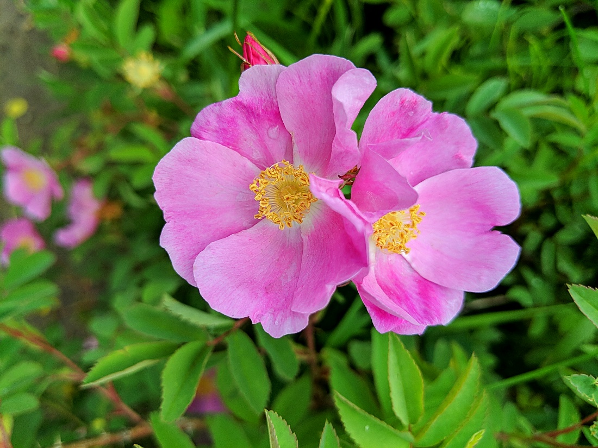

Wild rose (*Rosa acicularis*). Photograph courtesy of Scott Bischke.

Glossary

**adaptation —** Actions taken to help communities and ecosystems better cope with potential negative effects of climate change or take advantage of potential opportunities.

**adaptive capacity —** The inherent ability of a system (e.g., ecosystem or social system) to adapt to a changing environment; for example, a plant species that can survive a broader range of temperatures may have greater adaptive capacity compared to a plant that can only tolerate a narrow range of temperatures.

**agribusiness —** An industry engaged in the production operations of a farm, the manufacture and distribution of farm equipment and supplies, and the processing, storage, and distribution of farm commodities.

**agronomy —** The science of crop production and soil management.

**annual streamflow —** The cumulative quantity of water for a period of record, in this case a calendar year.

**anthropogenic —** Originating in human activity

**aquifer —** A body of permeable rock that can contain or transmit groundwater.

**atmospheric carbon dioxide (CO2) —** The amount of CO2 in Earth’s atmosphere; although the proportion of Earth’s atmosphere made up by CO2 is small, CO2 is one of the most potent greenhouse gases and directly related to the burning of fossil fuels; atmospheric carbon dioxide levels in Earth’s atmosphere are at the highest levels in an estimated 3 million years and these levels are projected to increase global average temperatures through the greenhouse effect

**attribution —** Identifies a source or cause of something

**basis —** The difference between the futures market price and the local price for an agricultural commodity, measured in dollars per bushel.

**base flow —** The portion of streamflow that is not runoff and results from seepage of water from the ground into a channel slowly over time. The primary source of running water in a stream during dry weather.

**basin —** A drainage basin or catchment basin is an extent or an area of land where all surface water from rain, melting snow, or ice converges to a single point at a lower elevation, usually the exit of the basin, where the waters join another body of water, such as a river, lake, reservoir, estuary, wetland, sea, or ocean**.**

**biocontrol —** Short for biological control; the reduction in numbers or elimination of pest organisms by interference with their ecology (as by the introduction of parasites or disease).

**biodiversity —** The variety of all native living organisms and their various forms and interrelationships.

**biomass —** The total amount of organic matter present in an organism, population, ecosystem, or given area.

**bushel —** A unit for measuring an amount of fruit and grain that is equal to about 35.2 liters in the US.

**C3 and C4 plants —** Plants use different photosynthetic pathways (termed *C3 photosynthesis* or *C4 photosynthesis*). C4 plants evolved as an adaptation to high-temperature, high-light conditions. C4 plant growth rates increase more under hot, high-CO2 conditions than that of C3 plants and exhibit less water loss.

**climate versus weather** — The difference between weather and climate is a measure of time. Weather is what conditions of the atmosphere are over a short period of time, and climate is how the atmosphere "behaves" over relatively long periods of time (i.e., multiple decades).

**climate change —** Changes in average weather conditions that persist over multiple decades or longer. Climate change encompasses both increases and decreases in temperature, as well as shifts in precipitation, changing risk of certain types of severe weather events, and changes to other features of the climate system.

**climate oscillation** — See teleconnections.

**commercial crops —** Agricultural crops that are grown for sale to return a profit, purchased by parties separate from a farm (note: not all commercial crops are commodity crops).

**commodity crops —** Crops that are traded, and typically include crops that are non-perishable, easily storable, and undifferentiated.

**commodity futures —** Buying or selling of a set amount of a commodity at a predetermined price and date.

**confined aquifer** — A confined aquifer is an aquifer below the land surface that is saturated with water. Layers of impermeable material are both above and below the aquifer, causing it to be under pressure so that when the aquifer is penetrated by a well, the water will rise above the top of the aquifer.

**cow-calf operations —** Livestock operations in which a base breeding herd of mother cows and bulls are maintained. Each year’s calves are sold between the ages of 6 and 12 months, along with culled cows and bulls, except for some breeding herd replacements.

**crop rotation —** System of cultivation where different crops are planted in consecutive growing seasons to maintain soil fertility.

**cultivar —** A contraction of *cultivated variety*. It refers to a plant type within a particular cultivated species that is distinguished by one or more characteristics.

**direct effect —** A primary impact to a system from shifts in climate conditions (e.g., temperature and precipitation), such as direct mortality to species from increased heat extremes

**direct runoff** — The runoff entering stream channels promptly after rainfall, exclusive of base flow. Direct runoff equals the volume of rainfall excess (e.g., total precipitation minus losses).

**disturbance regime —**The frequency, severity, and pattern of events that disrupt an ecosystem or community; for example, a forest’s fire disturbance regime may be the historical pattern of frequent, low-intensity fires versus infrequent, high-severity fires

**drought** — Dought is generally categorized in three ways: 1) *meteorological* drought, defined as a deficit in precipitation, 2) *agricultural* drought, commonly understood as a deficit in soil moisture, and 3) *hydrological* drought, characterized by reduced water levels in streams, lakes, and aquifers.

**dryland farming —** A system of producing crops in semiarid regions (usually with less than 20 inches [0.5 m] of annual rainfall) without the use of irrigation.

**El Niño-Southern Oscillation (ENSO) —** A periodic variation in wind and sea-surface temperature patterns that affects global weather; El Niño (warming phase where sea-surface temperatures in the eastern Pacific Ocean warm) generally means warmer (and sometimes slightly drier) winter conditions in Montana. In contrast, La Niña (cooling phase) generally means cooler (and sometimes wetter) winters for Montanans.The two phases each last approximately 6-18 months, and oscillate between the two phases approximately every 3-4 yr.

**ensemble of general circulation models (GCMs)** — *Succinctly:* When many different forecast models are used to generate a projection, and outputs are synthesized into a single score or average. This type of forecast significantly reduces errors in model output and enables a level of certainty to be placed on the projections. *More broadly:* Rather than relying on the outcome of a single climate model, scientists run ensembles of many models. Each model in the ensemble plausibly represents the real world, but as the models differ somewhat they produce different outcomes. Scientists analyze the outputs (e.g., projected average daily temperature at mid century) over the entire ensemble. Those analyses provide both the projection of the future resulting from the ensemble of models, and define the level of certainty that should be placed on that projection.

**ephemeral stream** — A stream that flows only briefly during and following a period of rainfall in the immediate locality.

**evaporation** — The change of a liquid into a vapor at a temperature below the boiling point. Evaporation takes place at the surface of a liquid, where molecules with the highest kinetic energy are able to escape. When this happens, the average kinetic energy of the liquid is lowered and its temperature decreases.

**evapotranspiration —** The combined effect of evaporation and transpiration (by plants) of water, which is one of the most important processes driving the hydrologic cycle. Evapotranspiration is often analyzed in two ways, as potential evapotranspiration, which is a measure of demand for water from the atmosphere regardless of how much water is available, and actual evapotranspiration, which is how much water is actually used by plants and evaporated from water surfaces. Generally, actual evapotranspiration is driven by water availability, solar radiation, and plant type, but also affected by wind and vapor pressure. Transpiration is affected by vegetation-related factors such as leaf area and stomatal conductance, the exchange of CO2 and water vapor between leaves and the air.

**fallow —** Cultivated land that is allowed to lie idle during the growing season; or to plow, harrow, and break up (land) without seeding to destroy weeds and conserve soil moisture.

**feeder cattle —** Growing beef cattle between the calf stage and sale to finishing operations.

**fire behavior —** The manner in which wildfire ignites and spreads, and characterizing the burning conditions within a single fire.

**fire regime —** The frequency, severity, and pattern of wildfire.

**fire risk —** The likelihood of a fire ignition.

**fire severity —** The magnitude of effects from a fire, usually measured by the level of vegetation or biomass mortality or the area burned.

**flood** — An overflowing of a large amount of water beyond its normal confines, especially over what is normally dry land.

**flood plain** — An area of low-lying ground adjacent to a river, formed mainly of river sediments and subject to flooding..

**frost days —** The annual count of days where daily minimum temperature drops below 32°F (0°C).

**futures trading** — An agreement between two people, one who sells and agrees to deliver and one who buys and agrees to a certain kind, quality, and quantity of product to be delivered during a specified delivery month at a specified price. More simply, a contract to buy specific quantities of a commodity at a specified price with delivery set at a specified time in the future.

**general circulation models (GCMs)** — Numerical models representing physical processes in the atmosphere, ocean, cryosphere, and land surface. They are the most advanced tools currently available for simulating the response of the global climate system to increasing greenhouse gas concentrations.

**grain filling** — The period of wheat development from pollination to seed production.

**greenhouse gas** — A gas in Earth’s atmosphere that absorbs and then re-radiates heat from the Earth and thereby raises global average temperatures. The primary greenhouse gases in Earth's atmosphere are water vapor, carbon dioxide, methane, nitrous oxide, and ozone. Earth relies on the warming effect of greenhouse gases to sustain life, but increases in greenhouse gases, particularly carbon dioxide from the burning of fossil fuels, can increase average global temperatures over historical norms

**greenhouse gas emissions —** The discharge of greenhouse gases, such as carbon dioxide, methane, nitrous oxide and various halogenated hydrocarbons, into the atmosphere. Combustion of fossil fuels, agricultural activities, and industrial practices contribute to the emissions of greenhouse gases.

**green manure —** Crops grown to be incorporated into the soil to increase soil quality, fertility and structure.

**global warming —** The increase in Earth’s surface air temperatures, on average, across the globe and over decades. Because climate systems are complex, increases in global average temperatures do not mean increased temperatures everywhere on Earth, nor that temperatures in a given year will be warmer than the year before (which represents weather, not climate). More simply: *Gobal warming* is used to describe a gradual increase in the average temperature of the Earth's atmosphere and its oceans, a change that is believed to be permanently changing the Earth's climate.

**groundwater** — Water held underground in the soil or in pores and crevices in rock.

**growing degree-days —** A weather-based indicator for assessing crop development. It is a calculation used by crop producers that is a measure of heat accumulation used to predict plant and pest development rates such as the date that a crop reaches maturity.

**hardiness zone —** A geographically-defined zone in which a specific category of plant life is capable of growing, as defined by temperature hardiness, or ability to withstand the minimum temperatures of the zone. The zones are based on the average annual extreme minimum temperature during a 30-yr period in the past, not the lowest temperature that has ever occurred in the past or might occur in the future.

**human agency** — The capacity possessed by people to act of their own volition.

**hydrograph** — A hydrograph is a graph showing the rate of flow (discharge) versus time past a specific point in a river, or other channel or conduit carrying flow. The rate of flow is typically expressed as cubic feet per second, CFS, or ft3/s (the metric unit is m3/s).

**hydrologic cycle** — The sequence of conditions through which water passes from vapor in the atmosphere through precipitation upon land or water surfaces and ultimately back into the atmosphere as a result of evaporation and transpiration.

**hydrology —**  The study of water. Hydrology generally focuses on the distribution of water and interaction with the land surface and underlying soils and rocks.

**indirect effect —** A secondary impact to a system from a change that was caused by shifting climate conditions, such as increased fire frequency, which is a result of drier conditions caused by an increase in temperature.

**infiltration** — The movement of water from the land surface into the soil.

**interception** — The capture of precipitation above the ground surface, for example, by vegetation or buildings.

**IPCC SRES —** Intergovernmental Panel on Climate Change Special Report on Emissions Scenarios

**irrigation —** Application of water to soil for the purpose of plant production.

**legume —** Any of a large family (Leguminsoae syn. Fabaceae, the legume family) of dicotyledonous herbs, shrubs, and trees having fruits that are legumes or loments, bearing nodules on the roots that contain nitrogen-fixing bacteria, and including important food and forage plants (as peas, beans, or clovers).

**metrics —** Quantifiable measures of observed or projected climate conditions, including both primary metrics (for example, temperature and precipitation) and derived metrics (e.g., projected days over 90°F [32°C ] or number of consecutive dry days)

**microclimate —** The local climate of a given site or habitat varying in size from a tiny crevice to a large land area. Microclimate is usually, however, characterized by considerable uniformity of climate over the site involved and relatively local when compared to its enveloping macroclimate. The differences generally stem from local climate factors such as elevation and exposure.

**mitigation —** Efforts to reduce greenhouse gas emissions to, or increase carbon storage from, the atmosphere as a means to reduce the magnitude and speed of onset of climate change

**model** — A physical or mathematical representation of a process that can be used to predict some aspect of the process.

**organic —** A crop that is produced without: antibiotics; growth hormones; most conventional pesticides; petroleum-based fertilizers or sewage sludge-based fertilizers; bioengineering; or ionizing radiation. USDA certification is required before a product can be labeled *organic*.

**oscillation** — A recurring cyclical pattern in global or regional climate that often occurs on decadal to sub-decadal timescales. Climate oscillations that have a particularly strong influence on Montana's climate are the El Nino Southern Oscillation (ENSO) and the Pacific Decadal Oscillation (PDO).

**Pacific Decadal Oscillation (PDO) —** A periodic variation in sea-surface temperatures that is similar to El Niño-Southern Oscillation, but has a much longer duration (approximately 20-30 yr). When the PDO is in the same phase as El Niño-Southern Oscillation, weather effects are more pronounced. For example, when both are in the warming phase, Montanans may experience an extremely warm winter, whereas if PDO is in a cooling phase, a warm phase El Niño-Southern Oscillation may have a reduced impact.

**Palmer Drought Severity Index (PDSI)** — A measurement of dryness based on recent precipitation and temperature. The Palmer Drought Severity Index is based on a supply-and-demand model of soil moisture.

**Palmer Z Drought Index —** One of the Palmer Drought Indices; it measures short-term drought on a monthly scale. The Z-value is also referenced to the specific location, climate, and time of year.

**parameter** — A variable, in a general model, whose value is adjusted to make the model specific to a given situation.

**pathogen —** Microorganisms, viruses, and parasites that can cause disease.

**peak flow** — The point of the hydrograph that has the highest flow.

**permeability** — A measure of the ability of a porous material (often, a rock or an unconsolidated material) to allow fluids to pass through it.

**phenology** — The study of periodic biological phenomena with relation to climate (particularly seasonal changes). These phenomena can be used to interpret local seasons and the climate zones.

**physiography** — The subfield of geography that studies physical patterns and processes of the Earth. It aims to understand the forces that produce and change rocks, oceans, weather, and global flora and fauna patterns.

**primary productivity —** The total quantity of fixed carbon (organic matter) per unit area over time produced by photosynthesis in an ecosystem.

**pulse crop —** Annual leguminous crops yielding from 1-12 grains or seeds of variable size, shape, and color within a pod. Limited to crops harvested solely for dry grain, thereby excluding crops harvested green for food, oil extraction, and those that are used exclusively for sowing purposes.

**radiative forcing —** The difference between the amount of sunlight absorbed by the Earth versus the energy radiated back to space. Greenhouse gases in the atmosphere, particularly carbon dioxide, increase the amount of radiative forcing, which is measured in units of watts/m2. The laws of physics require that average global temperatures increase with increased radiative forcing.

**rangeland —** Land on which the historical climax plant community is predominantly grasses, grasslike plants, forbs, or shrubs. This includes lands re-vegetated naturally or artificially when routine management of the vegetation is accomplished through manipulation of grazing. Rangelands include natural grasslands, savannas, shrublands, most deserts, tundra, alpine communities, coastal marshes, and wet meadows

**RCP (representative concentration pathways) —** Imagined plausible trends in greenhouse gas emissions and resulting concentrations in the atmosphere used in climate projection models. This analysis uses the relatively moderate and more severe scenarios of RCP4.5 and 8.5. These scenarios represent a future with an increase in radiative forcing of 4.5 or 8.5 watts/m2, respectively. The RCP4.5 scenario assumes greenhouse gas emissions peak mid century, and then decline, while the RCP8.5 scenario assumes continued high greenhouse gas emissions through the end of the century

**resilience** — In ecology, the capacity of an ecosystem to respond to a disturbance or perturbation by resisting damage and recovering quickly.

**resistance —** In ecology, the property of populations or communities to remain essentially unchanged when subject to disturbance. Sensitivity is the inverse of resistance.

**resistance gene —** A gene involved in the process of resistance to a disease or pathogen; especially a gene involved in the process of antibiotic resistance in a bacterium or other pathogenic microorganism.

**ruminants —** Mammals that have four stomachs and even-toed hooves.

**runoff** — Surface runoff (also known as *overland flow*) is the flow of water that occurs when excess stormwater, meltwater, or other sources flows over the Earth's surface.

**scenario —** Climate change scenarios are based on projections of future greenhouse gas (particularly carbon dioxide) emissions and resulting atmospheric concentrations given various plausible but imagined combinations of how governments, societies, economies, and technologies will change in the future. This analysis considers two plausible greenhouse gas concentration scenarios: a moderate (*stabilized*) and more severe (*upper-bound*) scenario, referred to as RCP4.5 and RCP8.5, respectively

**shallow aquifer** — Typically (but not always) the shallowest aquifer at a given location is unconfined, meaning it does not have a confining layer (an aquitard or aquiclude) between it and the surface. The term *perched* refers to ground water accumulating above a low-permeability unit or strata, such as a clay layer.

**silage —** Any crop that is harvested green and preserved in a succulent condition by partial fermentation in a nearly airtight container such as a silo.

**specialty crop —** Fruits and vegetables, tree nuts, dried fruits and horticulture and nursery crops, including floriculture.

**spring wheat —** A general term for wheat sown in the early spring and harvested in the late summer or early autumn of the same year.

**Snow Water Equivalent (SWE)** — A common snowpack measurement that is the amount of water contained within the snowpack. It can be thought of as the depth of water that would theoretically result if you melted the entire snowpack instantaneously.

**soil moisture** — A measure of the quantity of water contained in soil. Soil moisture is a key variable in controlling the exchange of water and energy between the land surface and the atmosphere through evaporation and plant transpiration.

**storage** — The volume of water contained in natural depressions in the land surface, such as a snowpack, glaciers, drainage basins, aquifers, soil zones, lakes, reservoirs, or irrigation projects.

**streamflow (also known as channel runoff)** — The flow of water in streams, rivers, and other channels. It is a major element of the water cycle.

**teleconnection —** A connection between meteorological events that occur a long distance apart, such as sea-surface temperatures in the Pacific Ocean affecting winter temperatures in Montana. Also referred to as *climate oscillations* or *patterns of climate variability*.

**test weight —** A measure of grain bulk density, often used as a general indicator of overall quality and as a gage of endosperm hardness to alkaline cookers and dry millers.

**tillage —** The traditional method of farming in which soil is prepared for planting by completely inverting it with a plow. Subsequent working of the soil with other implements is usually performed to smooth the soil surface. Bare soil is exposed to the weather for some varying length of time depending on soil and climate conditions.

**transpiration** — The passage of water through a plant from the roots through the vascular system to the atmosphere.

**unconfined aquifer —** A groundwater aquifer is said to be unconfined when its upper surface (water table) is open to the atmosphere through permeable material.

**velocity —** The rate of climate changes occurring across space and time.

**warm days —** percentage of time when daily maximum temperature >90th percentile.

**warm nights —** percentage of time when daily minimum temperature >90th percentile.

**water quality** — The chemical, physical, biological, and radiological characteristics of water. It is a measure of the condition of water relative to the requirements of one or more biotic species and/or to any human need or purpose.

**watershed** — An area characterized by all direct runoff being conveyed to the same outlet. Similar terms include basin, subwatershed, drainage basin, catchment, and catch basin.

**water year** — The surface-water supply defined as the 12-month period October 1, for any given year through September 30, of the following year.

**weather versus climate** — See climate versus weather.

**winter wheat** — A general term for wheat sown in the fall, persisting through the winter winter as seedlings, and harvested the following spring or summer after it reaches full maturity.

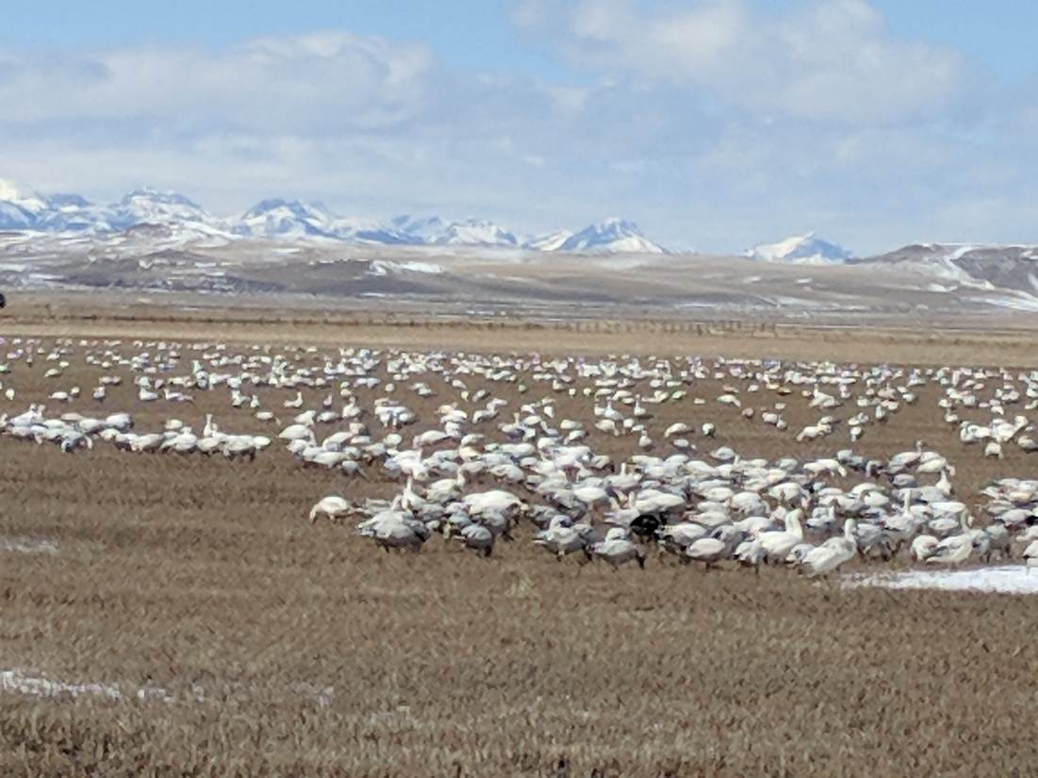

Snow geese near Fairfield, Montana. Photograph courtesy of Scott Bischke.

List of Contributors

**Scott Bischke** of MountainWorks Inc. served as Science Writer for this report, as well as for the 2017 Montana Climate Assessment. Scott is a BS (Montana State University), MS (University of Colorado) chemical engineer who has worked as an engineering researcher at three national laboratories: the National Bureau of Standards (now National Institute of Science and Technology), Sandia, and Los Alamos. He worked for roughly 11 yr as lead environmental engineer for a Hewlett-Packard business unit. Scott has authored, co-authored, or edited two environmental impact statements, book chapters, technical papers, five popular press books, and successful proposals totaling multiple millions of dollars.

**Madison Boone** graduated from Hendrix College with degrees in Biology and Environmental Studies. She has worked for Heifer International's Heifer Farm in Rutland, MA where she was a livestock steward and led educational programs. Madison moved to Bozeman, MT in January 2016 to serve with the Big Sky Watershed Corps, through which she worked for the non-profit One Montana on their Resilient Montana program. She is now serving a second term of the Big Sky Watershed Corps program in 2017, during which she will continue to work with One Montana as well as MSU-Extension on their Climate Science Team.

**Lori G Byron**, MD, of Hardin MT, received a BS and BA from Kentucky Wesleyan College, her MD from University of Louisville, and completed a pediatric residency. She practiced pediatrics for 27 years on the Crow Indian Reservation.  She is a past-president of the Montana Academy of Pediatrics. She co-chairs the Citizen’s Climate Lobby Health Team and chairs Montana Health Professionals for a Healthy Climate. Lori is on the Children’s Health Advisory Committee to EPA and the Executive Committee of the Environmental Health Council at the American Academy of Pediatrics.  She recently earned a MS in Energy Policy and Climate from Johns Hopkins.

**Dr. Robert Byron** is an internist from Hardin, Montana. After receiving his undergraduate degree from Vanderbilt University, he served in the US Navy. Obtaining his medical degree from the University of Louisville School of Medicine, he then completed an internal medicine residency, later earning a master’s in public health through the University of Washington. Dr. Byron worked on the Crow Indian Reservation for over 20 yr, then later helped start Bighorn Valley Health Center in Hardin. A former governor of the Montana Chapter of the American College of Physicians, he also served on the Montana Board of Environmental Review. He is vice-chair of the Montana Health Professionals for a Healthy Climate and co-chairs the Citizen’s Climate Lobby Health Team.

**Susan Higgins**, MS has a long background in water planning, and now works to connect health researchers with rural Montana communities for the Center for American Indian and Rural Health Equity and Montana INBRE. Prior, Sue was water planner for the State of Montana, and for The Tributary Fund where she facilitated research exchanges in Mongolia and Montana. She was also director for water research communications at Montana University System Water Center and a founding director for the Montana Watercourse. A trained facilitator, Sue has been active in community collaborations, and has authored guides for educators and landowners on topics such as streambank stabilization and wetlands management. She was consultant for the Crown of the Continent Roundtable and the Montana National Drought Resiliency Project. A past board member to the Society for Conservation Biology’s Religion and Conservation Working Group, Sue co-developed best practices for scientists working internationally in faith and indigenous communities.

**Bruce Maxwell** is Professor of Agroecology and Applied Plant Ecology in the Department of Land Resources and Environmental Science (LRES) at Montana State University. Maxwell was instrumental in the formation of the Department of LRES and has received national awards for outstanding teaching, best peer reviewed papers and outstanding graduate student from the Weed Science Society of America. He has published over 100 scientific journal articles and book chapters, chaired and been a member of numerous agricultural and ecological research grant review panels and been a member of two National Academy of Science National Research Council Committees on Agriculture. He was a Fulbright Fellow in Argentina in 2007. His research has historically straddled the disciplines of invasion biology and agroecology.

**Nick Silverman** is a Research Scientist at the University of Montana. His academic interests include mountain landscape hydroclimatology, remote sensing, land surface modeling, and hydroeconomics. Nick has received an MS from the University of Washington and a PhD from the University of Montana in Regional Hydroclimatology. Nick is passionate about making connections between science, people and policy. He spends his free time speaking to farmers, ranchers, government agencies, and water resource professionals throughout Montana about impacts and adaptations related to climate and water interactions.

**Cathy Whitlock** is Professor of Earth Sciences and co-Director of the Montana Institute on Ecosystems. She is recognized nationally and internationally for her scholarly contributions and leadership activities in the area of long-term environmental and climate change. Whitlock has published over 180 scientific papers on this topic and her research has been supported by grant-funding from the National Science Foundation, Joint Fire Sciences Program, National Park Service, USDA Forest Service, and Department of Energy. She is a Fellow of the American Association for the Advancement of Science and received the international EO Wilson Biodiversity Technology Pioneer Award in 2014 and Professional Excellence Award in Academic/Research, Association of Women Geoscientists in 2015.

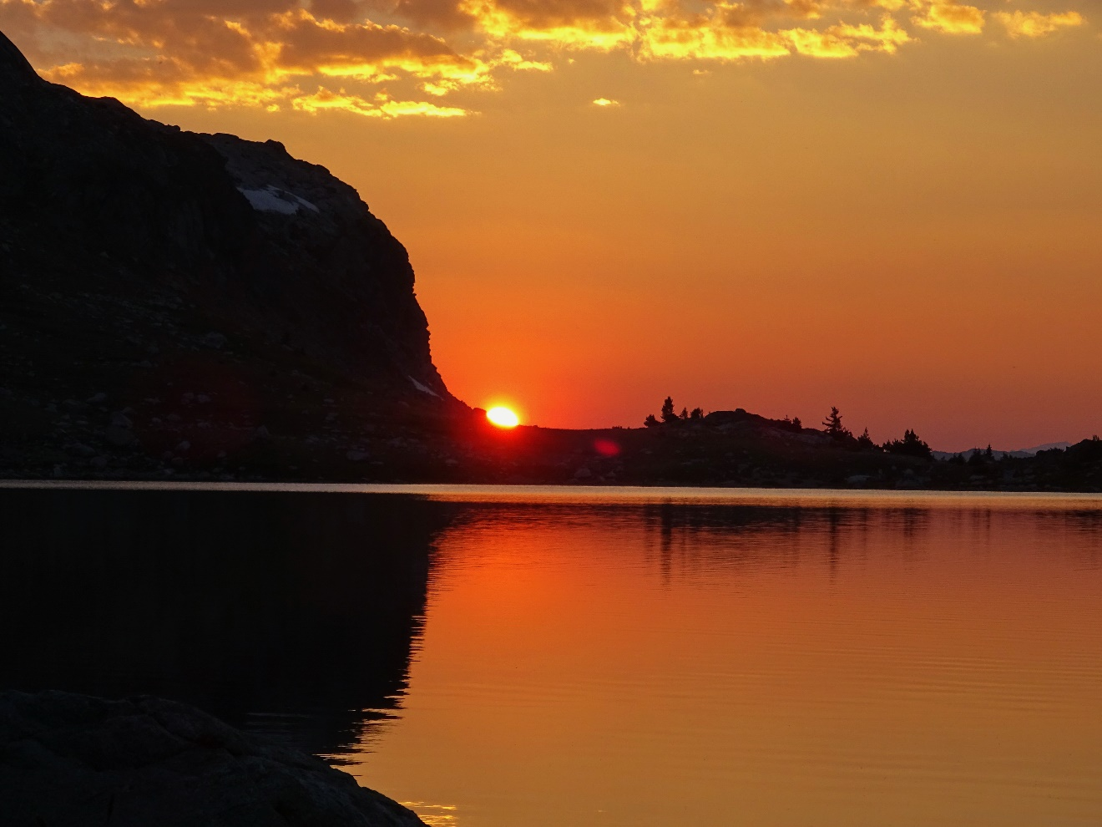

Sunset in the Beartooth Mountains of southeast Montana.

Photograph courtesy of Scott Bischke.

1. This report uses “MCA” in discussing the overall Montana Climate Assessment program. To avoid excessive redundancy, we provide the reference (Whitlock et al. 2017) only when speaking of specific results published in the 2017 Montana Climate Assessment report, not the overall program.
2. A new report by the Union of Concerned Scientists indicates as many as 50 days over 105°F in eastern Montana by the end of the century under the upper-bound emission projection (UCS 2019).
3. With acknowledgement for input on the Montana Health Profile subsection from Sue Higgins, Eliza Webber, and Mari Eggers.
4. It is important to remember that the frequency and severity of these extreme heat events in the future depends on the level of greenhouse gases in the atmosphere and our ability to reduce those levels (UCS 2019).
5. Heat index includes direct temperature but also humidity, which can make it feel much hotter.
6. A *frontier area* is defined as having fewer than 7 people/mile2 (Rural Health Data undated).
7. Dehydration, or the excessive loss of body water, can have many causes, including heat exposure, kidney disease, and diseases of the gastrointestinal tract that cause vomiting or diarrhea.
8. Those categories are: above +114.8oF: extreme heat stress; +100.4 to +114.8oF: very strong heat stress; +89.6 to +100.4oF: strong heat stress; +78.8 to +89.6oF: moderate heat stress; +48.2 to +78.8oF: no thermal stress; +48.2 to 32oF.
9. Section authors Maxwell and Silverman conducted this analysis.
10. According to the US Environmental Protection Agency (USEPA undated): “Heat islands occur on the surface and in the atmosphere. On a hot, sunny summer day, the sun can heat dry, exposed urban surfaces, such as roofs and pavement, to temperatures 50–90°F (27–50°C) hotter than the air, while shaded or moist surfaces—often in more rural surroundings—remain close to air temperatures. Surface urban heat islands are typically present day and night, but tend to be strongest during the day when the sun is shining.”
11. The report is based on data collected from 2014-2016. The eight Montana counties are Fergus, Flathead, Lewis and Clark, Lincoln, Missoula, Phillips, Ravalli, and Silver Bow.
12. CMIP5 stands for “Coupled Model Intercomparison Project 5”. It is a collection of general circulation models scoped at understanding the response of the global climate system to increasing greenhouse gas concentrations (Whitlock et al. 2017).
13. This work completed by authors Silverman and Higuera.
14. This statement derived from media reports as the federal government does not track this data.
15. These projections were made without consideration of the net decrease in primary production of ocean systems envisaged by the IPCC in its recent report looking at the ocean and cryosphere in a changing climate (IPCC 2019).
16. A mosquito pool is s a collection of mosquitoes (usually about 50) of any given species or group (e.g., *Culex mosquitoes*) that are likely to carry and potentially transmit a virus.
17. Mobile homes are defined by the Montana Department of Revenue as any trailer, house trailer, or trailer coach that is over 8 ft wide or 45 ft long and designed to be moved by connecting to another vehicle, or under 8 feet wide or 45 feet long and used as a principle residence (MDR undated).
18. The Supplemental Nutrition Assistance Program (SNAP) was previously known as *food stamps*. SNAP provides benefits to people who are elderly, homeless, unemployed, have low or no income, or are disabled with low incomes. Recipients can purchase groceries with SNAP benefits.
19. Supplemental Security Income (SSI) gives financial assistance to people who are disabled, aged, or blind and of limited income. SSI benefits are not determined by the recipient’s lifetime earnings, as with Social Security benefits.
20. According to the airnow.gov website, “The U.S. Environmental Protection Agency, National Oceanic and Atmospheric Administration, National Park Service, tribal, state, and local agencies developed the AirNow system to provide the public with easy access to national air quality information.”
21. <https://www.cdc.gov/climateandhealth/BRACE.htm>
22. <https://www.cdc.gov/climateandhealth/climate_ready.htm>
23. <https://deq.mt.gov/Portals/112/Water/PWSUB/Documents/docs/EmergencyResponseFactSheet.pdf>
24. https://www.mtpca.org/programs-and-services/emergency-preparedness/
25. https://dphhs.mt.gov/publichealth/PHEP
26. http://readyandsafe.mt.gov
27. <https://www.cdc.gov/nceh/information/state_factsheets/montana.htm>
28. <https://www.aphis.usda.gov/aphis/home/>
29. https://dphhs.mt.gov/HealthInThe406/HealthInThe406Archive/CommunicableDisease
30. As of this writing these continuing education programs can be found online:

    Yale program at <https://publichealth.yale.edu/cchcert/>

    Minnesota program at <https://www.health.state.mn.us/communities/environment/climate/resources.html>
31. https://www.nctsn.org/treatments-and-practices/psychological-first-aid-and-skills-for-psychological-recovery/about-pfa
32. https://www.cdc.gov/climateandhealth/effects/default.htm
33. https://www.who.int/health-topics/climate-change#tab=tab_1
34. <https://unfccc.int/news/climate-change-impacts-human-health>
35. <https://19january2017snapshot.epa.gov/climate-impacts/climate-impacts-human-health_.html>
36. <https://www.niehs.nih.gov/research/programs/geh/climatechange/index.cfm>
37. https://www.nihb.org/docs/10102019/Climate%20Change%20&%20Tribes%20Article.pdf
38. <https://www.hhs.gov/climate/index.html>
39. <https://www.apha.org/topics-and-issues/climate-change/tribal-and-indigenous>
40. <https://www.niehs.nih.gov/health/topics/agents/climate-change/index.cfm>
41. <https://climatehealthaction.org/cta/climate-health-equity-policy/>